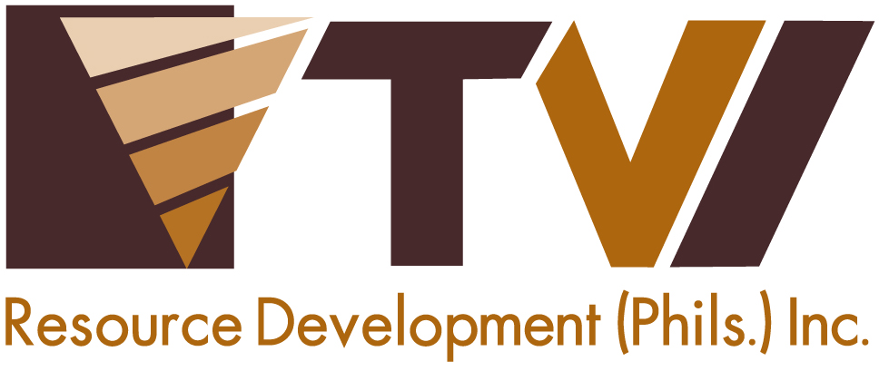
N E W S R E L E A S E

Agata Mining Signs-up
for Bombo Radyo’s Nationwide Blood Donation Drive
Employees join thousands of blood donors nationwide

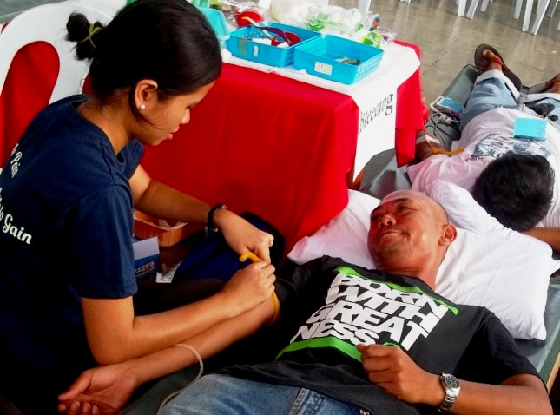
Hand-in-hand. In an unusual pairing of a mining company and a radio station, AMVI partners with Bombo Radyo in the latter’s blood donation drive – which aims to benefit thousands nationwide.

Butuan City, Agusan del Norte / November 2014 – Adding significance to Bombo Radyo’s nationwide blood donation drive, Agata Mining Ventures Inc. (AMVI) mobilized both its on-site and field-based employees to support the Dugong Bombo 2014 in Butuan City Central Elementary School last 15 November 2014. The annual event is a charitable initiative of Bombo Radyo (DXBR 981) – a leading news and public affairs radio station broadcasting in Agusan del Norte province – providing a considerable life-saving donation to thousands of beneficiaries across the country.

“Agata Mining commends Bombo Radyo for its relevant and timely advocacy as well as the opportunity it provides the people to participate in an admirable cause. The company likewise congratulates Station Manager Benjie Balansag for his organization’s sterling performance in upholding a high standard of journalistic excellence,” said Corporate Communications Director Kaycee Crisostomo.

A common advocacy
Bombo Radyo is a media partner of AMVI – a mining company operating in the municipalities of Tubay, Jabonga and Santiago of this province. Aside from its major sponsorship for the recent activity, employee-volunteers also supported through blood donations. Represented at the blood donation drive were the company’s medical, mines, IT, community relations and public affairs departments.

“We are deeply heartened that Bombo Radyo’s thrust for public health runs parallel with that of Agata’s health and sanitation program – which is a vital component of the company’s overall social development plan,” according to Crisostomo.

The AMVI delegation joined other volunteers and organizations that supported the event, including the provincial government, Armed Forces of the Philippines (AFP), local government units, non-government units and the Philippine Red Cross.

Over 3 million cc collected
“AMVI’s participation has helped Bombo Radyo in Butuan City to record a total of 73,350 cc of blood donated, which adds to Bombo Radyo’s nationwide overall total record of 3,317,250 cc – or an equivalent of 16 drums of blood collected”, according to Balansag.

Donors were advised to be well-rested and to have eaten prior to donating blood. They were also screened prior to extraction – a measure that is in line with safe practices required by the Department of Health (DOH) and the World Health Organization (WHO). Blood collected during the activity are also examined for known transfusion-transmissible diseases like HIV, Malaria, Syphillis, Hapatitis B and C.

AMVI’s participation in the event is inspired by TVI Resource Development Philippines Inc. (TVIRD), which operates the Agata Mining Project. During its operations in Canatuan, Zamboanga del Norte, TVIRD was been acknowledged on several occasions by the Philippine National Red Cross for its strong support for the latter’s blood donation drives. It is also the single largest organization to shore-up the most number of employee-volunteers in the region.

Along with joint venture partner, Mindoro Resource Ltd. (MRL), both companies hold established track records for both social and environmental programs that contribute to the overall sustainability of its host communities. AMVI draws confidence from both companies and continues to engage the community in meaningful activities that promote responsible mining practices.

*******
Press photos:
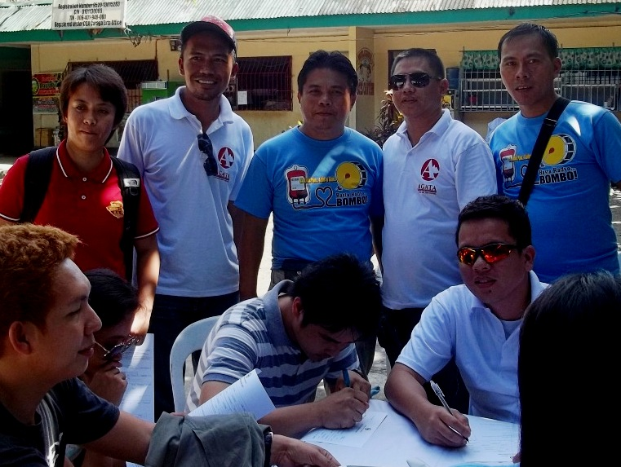
- AMVI employee-volunteers – joined by Bombo Radyo (DXBR 981) Station Manager Benjie Balansag (center) – register for Dugong Bombo 2014 at the Butuan City Central Elementary School.
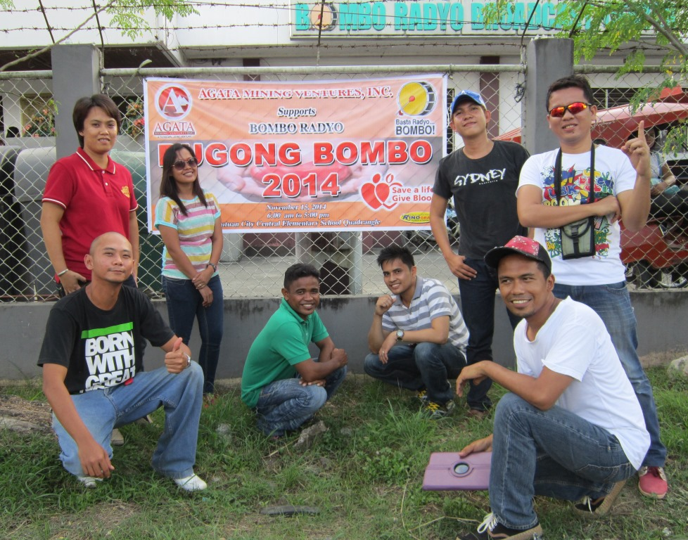

- Successful conclusion. The AMVI-supported Dugong Bombo 2014 collected over 3.3 million cc of blood from donors nationwide.

About TVI in the Philippines
TVI Resource Development Philippines Inc. (“TVIRD”), is the local affiliate of TVI Pacific Inc. (TSX: TVI), a publicly-listed Canadian mining company focused on the exploration, development and production of precious and base metals from district-scale, large-system, high-margin projects located in the Philippines. Concurrent ownership of ventures is shared with partner company, Prime Resource Holdings Inc.

The commercial operations of Agata Mining Ventures Inc. (AMVI) marks the third successful mining project that TVIRD brought on-stream in the past 10 years. The company is committed to exploration and mining practices that promote transparency, responsible stewardship of the environment, and the inalienable rights to life, dignity, and sustainable development of its host communities.
www.tviphilippines.com

Contact:

Kaycee Crisostomo
Corporate Communications Director
TVI Resource Development Philippines Inc.

Email: kaycee.crisostomo@tvipacific.com.ph
Phone: +63 2 728-8491 ext. 103
Mobile: +63 917 579-1528
Fax: +63 2 728-8515

