N E W S R E L E A S E

Mining Firm and Spanish Foundation
Conclude Successful Medical Mission in Tubay
Provide medical assistance to over 550 beneficiaries in Barangays Tinigbasan and Lawigan

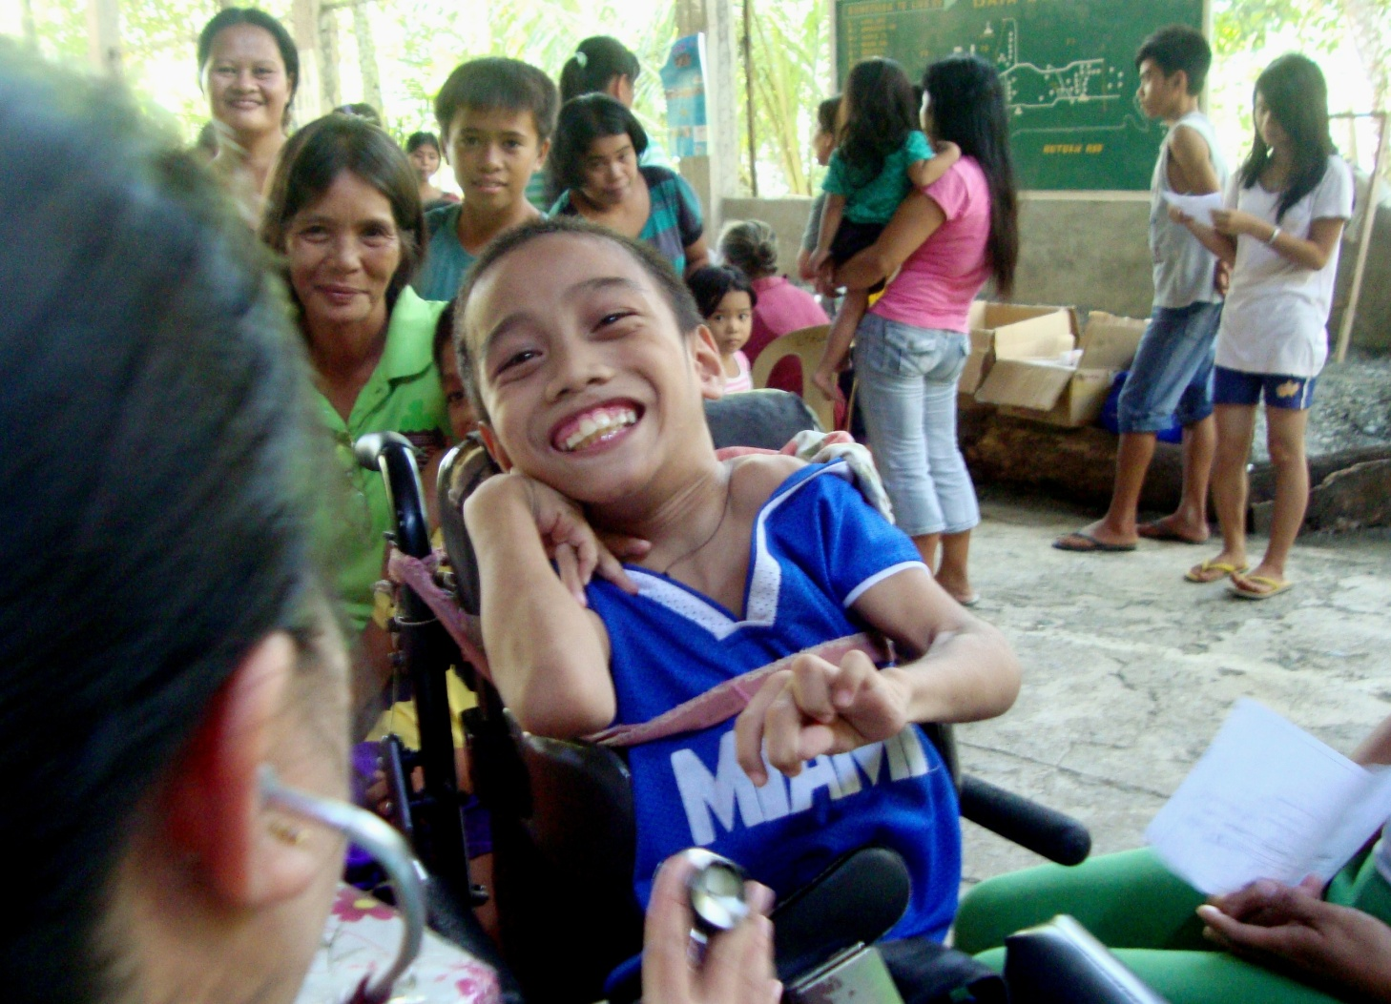
Healthcare as a means for social justice. Agata Mining believes that the private sector should do its share in preserving the dignity of the disadvantaged and the marginalized in society – a thrust that it shares with medical mission partner, Sociedad Española de Beneficencia.

Tubay, Agusan del Norte / November 2014 – Agata Mining Ventures Inc. (AMVI), a joint venture of TVI Resource Development Philippines Inc. (TVIRD), in partnership with Sociedad Española de Beneficencia Inc. (SEB-Manila), a charitable institution dedicated to the care of both Spanish and Filipino indigents in the country, conducted a joint medical mission in the coastal barangays of Tinigbasan and Lawigan in Tubay Municipality, Agusan del Norte. Last November 6 and 7, the combined medical team comprised of AMVI medical personnel, volunteers and doctors from the Philippine National Police (PNP) provided check-ups, consultation and medicines to some 554 beneficiaries in the mining company’s host communities.

The two-day activity, which was coordinated with the respective barangay councils, likewise received the strong support and participation of Tubay Municipal Mayor Fidel Garcia, the PNP and the Tubay Women’s Federation.

“We are overwhelmed by the support and assistance constantly being provided to us by AMVI,” expressed Lawigan Barangay Captain Nilo Mordeno during the event. He also noted that – owing to AMVI’s operations - the area has experienced an increasing trend in its economic activity as well as employment opportunities reaching his constituents.

Providing access to healthcare
Prior to AMVI’s entry, both barangays sourced their livelihood primarily from fishing and had limited access to social services and adequate health care. Apart from implementing its efforts towards responsible Coastal Resource Management, AMVI is actively rolling-out its Health and Sanitation initiatives in the area – this, as a vital component of its overall Social Development and Management Program (SDMP). It also draws best practices from TVIRD’s flagship Canatuan project where the company’s lying-in clinic received a yearly 14 thousand consultations and admissions during the height of its operations.

“Sociedad Española de Beneficencia welcomes the opportunity to complement TVIRD’s healthcare program for communities at its Agata mining project. Similarly, we are heartened to play an active role in directly addressing specific issues like respiratory tract infection, which we recorded as the highest occurring illness in the area,” said SEB Executive Director Laura Hidalgo-San Jose.

Other health issues addressed by the mission include urinary tract infection, hypertension, skin diseases, tension headaches, muscle spasms, arthritis and various gastro-intestinal problems, among others.

The foundation provided all the required medicines for the medical mission, including vaccines, antibiotics and vitamins for children who comprise more than 50 percent of the beneficiaries. Following the success of its joint medical mission, San Jose pledged another shipment of medicines for Barangay E. Morgado in Jabonga Municipality - in line with SEB’s monthly barangay medicine assistance program.

Responding to the community’s needs
To date, and since its days of early exploration, the company has been conducting supplemental feeding programs to reduce the occurrence of malnutrition. It likewise supports the repair and construction of school buildings, churches and public infrastructure – all of which aims to foster long-term development in the area.

“Our recent medical mission is testament to AMVI’s ongoing commitment to its host and neighboring communities. The company is glad to have been able to help Barangay Tinigbasan and Barangay Lawigan since both coastal barangays have limited access to medicines and medical personnel. This (medical mission) is just the beginning of other similar efforts the company will conduct in its MPSA area,” according to AMVI Community Relations Superintendent Bon Clarabal.

Apart from social programs, the company is also engaged in various environmental management programs that are geared towards maintaining a healthy and stable ecosystem for the overall sustainability of its immediate and neighboring communities.

AMVI holds the 4,995-hectare Mineral Processing Sharing Agreement (MPSA) area that spans the municipalities of Tubay, Santiago and Jabonga. Ownership of the TVIRD-operated joint venture is shared with Mindoro Resources Ltd. (MRL) and Minimax Mineral Exploration Corporation. It is the third successful mining project that TVIRD brought on-stream in the past 10 years, directly succeeding the Canatuan gold-silver and copper-zinc projects in Zamboanga del Norte.

*******

Press photos:

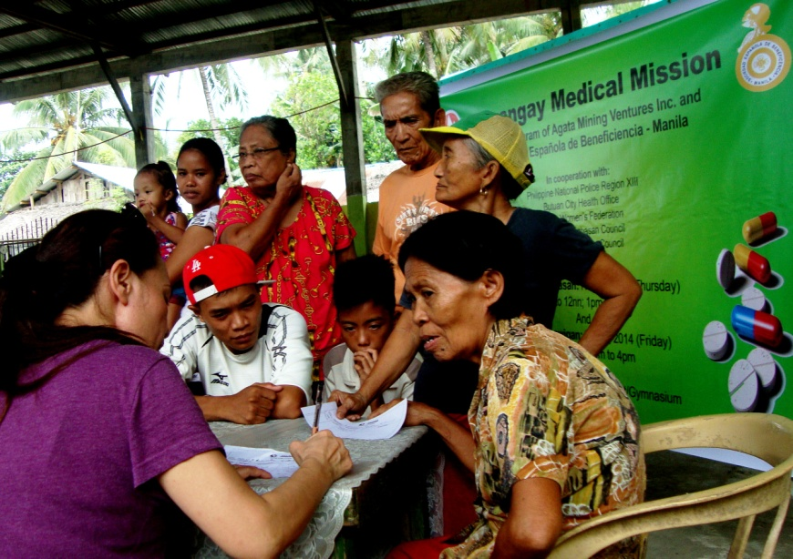
- The joint medical mission accommodated a significant number of elderly beneficiaries who are experiencing a variety of health issues, including respiratory ailments.
- Miss Tubay and concurrent Agata Goodwill Ambassador, Maritoni Catapang, lends a hand in distributing medicines to her fellow Tubaynons.

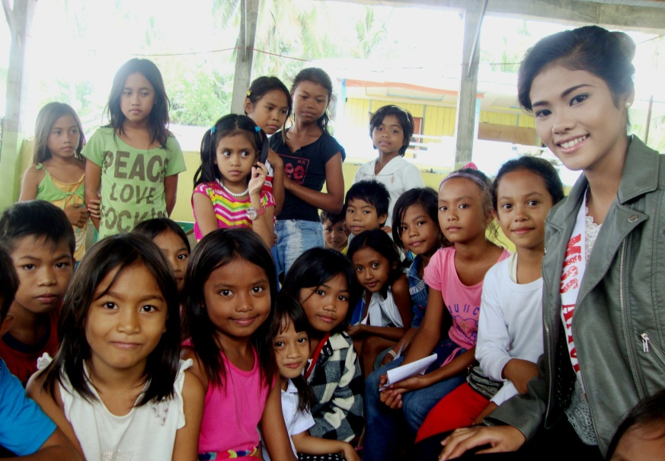
- Children, who comprise over 50 percent of the beneficiaries, gather around Agata Goodwill Ambassador Maritoni Catapang on the sidelines of the joint medical mission.

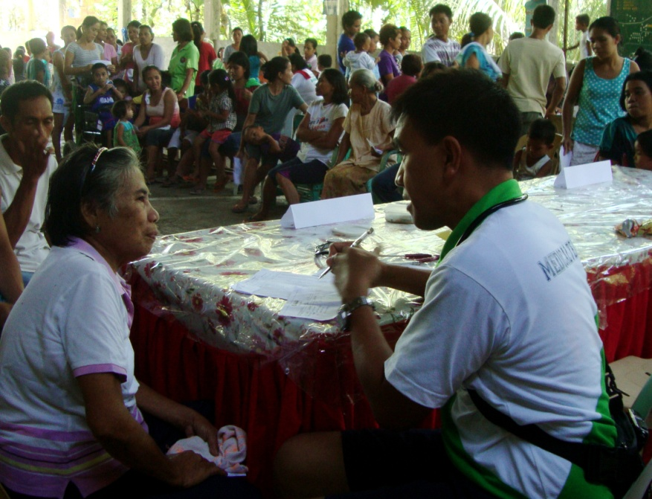
- PNP Medical Officers Dr. Ritche Lou Palma (in photo) and Dra. Jean Llenares from the City Health Office of Butuan volunteered their support for the mission, which served some 554 beneficiaries.

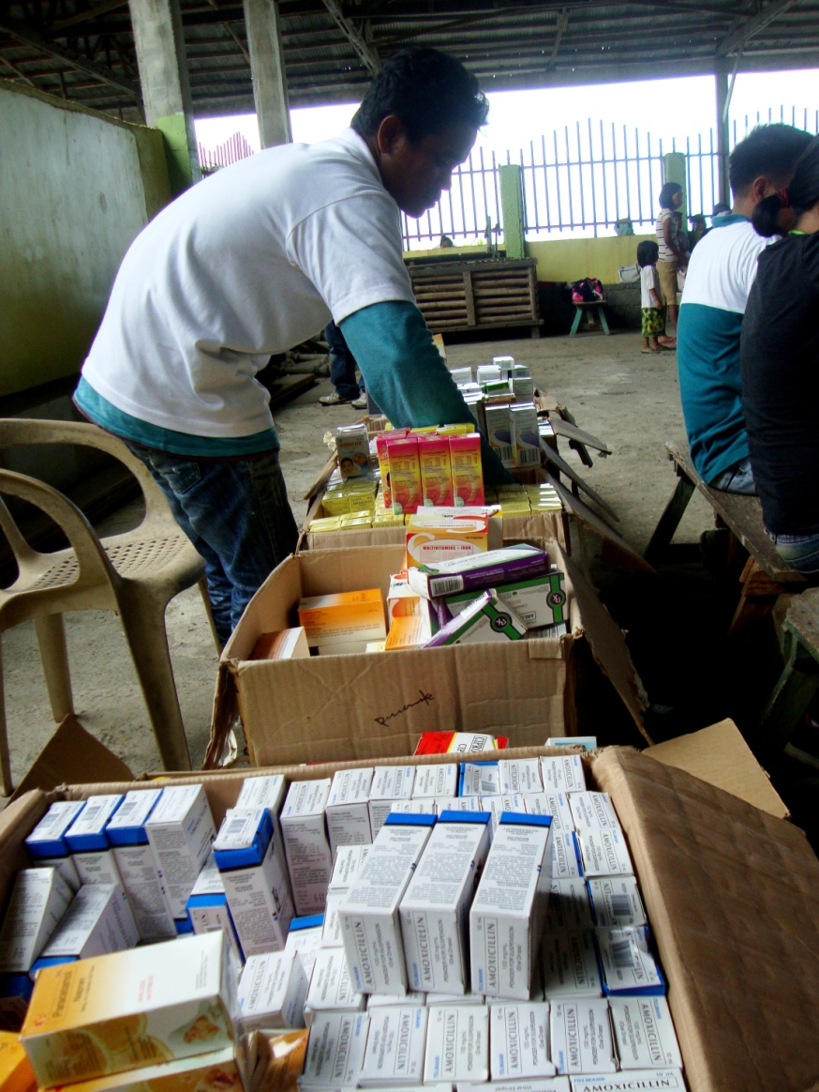
- Well stocked. The generosity of Sociedad Española will continue to benefit other “sitios” in Tubay as well as its neighboring communities.

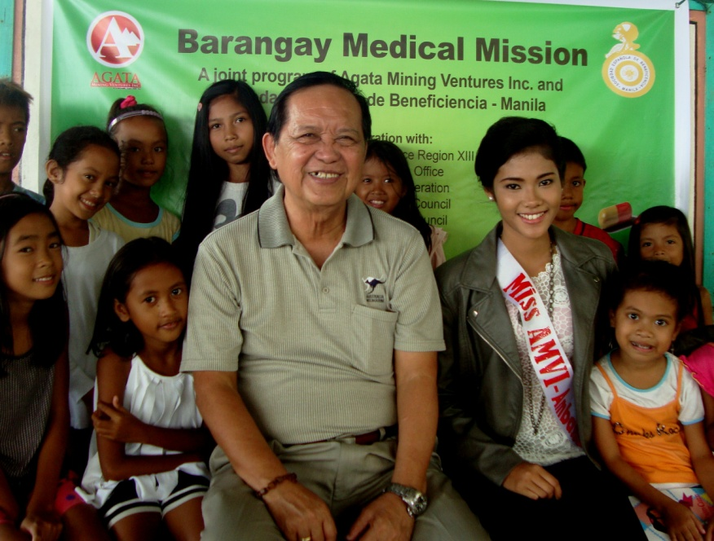
- Strong support. Tubay Municipal Mayor Fidel Garcia and Agata Goodwill Ambassador Maritoni Catapang provided an extra push for the success of the medical mission.

About TVI in the Philippines
TVI Resource Development Philippines Inc. (“TVIRD”), is the local affiliate of TVI Pacific Inc. (TSX: TVI), a publicly-listed Canadian mining company focused on the exploration, development and production of precious and base metals from district-scale, large-system, high-margin projects located in the Philippines. Concurrent ownership of ventures is shared with partner company, Prime Resource Holdings Inc.

The commercial operations of Agata Mining Ventures Inc. (AMVI) marks the third successful mining project that TVIRD brought on-stream in the past 10 years. The company is committed to exploration and mining practices that promote transparency, responsible stewardship of the environment, and the inalienable rights to life, dignity, and sustainable development of its host communities.
www.tviphilippines.com

About Sociedad Española de Beneficencia - Manila
Sociedad Española de Beneficencia (SEB) is a private charitable institution founded in 1948. Its primary goal is to protect indigent Spanish citizens and their families in the Philippines. It provides financial and healthcare assistance, hospitalization and funeral expenses, as approved by its Board of Trustees.

With the decline in the number of indigent Spanish citizens living in the Philippines, SEB has broadened its scope towards improving the living conditions of disadvantaged Filipino children and elderly across the country.

http://www.sociedadespanoladebeneficencia.org

Contact:

Kaycee Crisostomo
Corporate Communications Director
TVI Resource Development Philippines Inc.

Email: kaycee.crisostomo@tvipacific.com.ph
Phone: +63 2 728-8491 ext. 103
Mobile: +63 917 579-1528
Fax: +63 2 728-8515

