N E W S R E L E A S E

AMVI Backs Successful Attempt to Set New Tree-Planting World Record
Supports the DENR’s aggressive 3.2-million tree effort

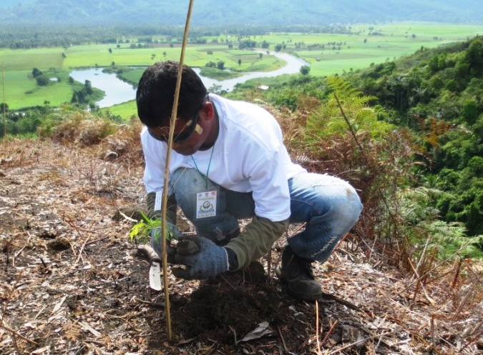
Joining hands for the environment. Tribal and Non-Tribal local community volunteers join AMVI Employees in supporting TreeVolution: Greening MindaNOW – a massive tree-planting activity spearheaded by the DENR.

Jabonga, Agusan Del Norte / September 2014 – Making good on its strong ongoing commitment to the Department of Natural Resources’ (DENR) National Greening Program (NGP), Agata Mining Ventures Inc. (AMVI) joined thousands of volunteers in TreeVolution: Greening MindaNOW – a massive tree-planting activity conducted simultaneously across six regions in Mindanao last 26 September 2014. Spearheaded by the agency and organized by the Mindanao Development Authority (MinDA), the activity successfully planted 3.2 million tree seedlings, beating India for the most number of trees planted in one hour. This is in line with the NGP’s target of planting 1.5 billion trees in 1.5 million hectares by 2016.

Local officials said that a new world record for the most trees planted in an hour was achieved, with 3.2 million seedlings sown as part of a national forestation program. While the Guinness World Records has yet to validate the information, government officers are confident that TreeVolution has exceeded India’s 1.9 million trees planted in 2011.

During the activity, the AMVI team of volunteers planted 1,000 trees across a 2-hectare area in Sitio Coro, Barangay Colorado, Municipality of Jabonga – which is within the company’s Mineral Processing Sharing Agreement (MPSA) area.

‘Greening’ untapped areas
“AMVI selected Sitio Coro because it is the only area where the company has not attempted to plant trees due to its difficult terrain,” according to the company’s environment manager, Jesalyn Guingguing, also signifying the start of active reforestation activities in the area.

“From the beginning, AMVI has strongly supported the DENR’s mandate, especially its initiatives to protect water sources and its National Greening Program (NGP). Presently, the 1,000 trees planted here today adds to the 100 thousand trees planted by the company since its exploration days under its joint venture partner, Mindoro Resource Limited (MRL),” continued Guingging who led the activity along with a combined team consisting of AMVI employees as well as local tribal and non-tribal community volunteers.

The activity posed a few challenges, given the natural terrain and lay of the land, which was angled at approximately 45 to 50 degrees. Added to that, the heat and humidity taunted to slow down the volunteers, but despite these, the AMVI team was able to hit its target in just 28 minutes and 16 seconds.

“Today, through its operating partner, TVI Resource Development Philippines Inc. (TVIRD), AMVI is able to scale-up its environment protection and preservation programs, given its solid track record in Sitio Canatuan, town of Siocon, Zamboanga del Norte,” said Guingging.

Environmental track record
AMVI is a 60/40 joint venture between TVIRD and MRL – and which aims to move forward, initially with high iron laterite direct shipping ore (DSO) operations, followed by the construction of Agusan Del Norte’s first nickel processing plant. Both companies are distinguished for their commitment to the health and safety of workers as well as responsive environmental protection programs.

TVIRD has been consistently recognized by both public and private award-giving bodies for its progressive environmental programs that made Canatuan five times ‘greener’ than before the company operated in the area. Likewise in 2012, the DENR’s Mines and Geosciences Bureau (MGB) conferred a citation on MRL for its active participation in the Environment Month activities.

The following year, the Caraga Mine Environment Management Council (CMEMC) together with the MGB conferred the Best Mining Forest Award (exploration category) on the AMVI joint venture. To date, and prior to beginning operations, the company has planted over 100 thousand trees across 100 hectares within its MPSA.

More than a green thumb
Aside from tree-planting and reforestation activities, AMVI is also engaged in waste segregation for Vermiculture, cultivating worms that process food wastes into compost material, which in turn, is used for fertilizers.

The company also recycles paper, plastic, cans and bottles – some of which can be used as pots for seedlings or sold commercially. Drawing from these responsible practices, the company continues to educate its host communities on additional livelihood programs as well as engage them on a common direction towards a healthier environment.

*******

Press photos:

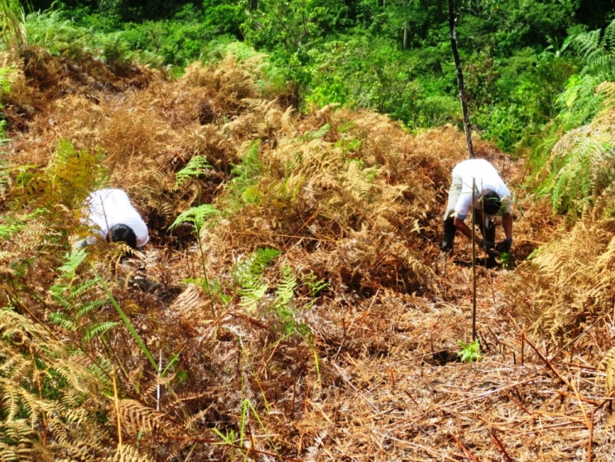
- AMVI employees and tribal volunteers plant tree seedlings side by side, working together towards ‘greening’ Mindanao.

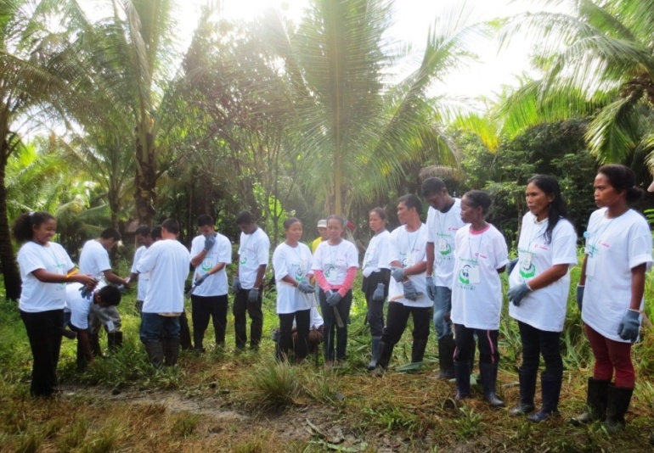
- Community volunteers and AMVI employees alike support a united Mindanao through MinDA and DENR’s 3.2-million tree effort.

About TVI Philippines
TVI Resource Development Philippines Inc. (“TVIRD”), is the local affiliate of TVI Pacific Inc. (TSX: TVI), a publicly-listed Canadian mining company focused on the exploration, development and production of precious and base metals from district-scale, large-system, high-margin projects located in the Philippines. Concurrent ownership of ventures is shared with partner company, Philippine Resource Holdings Inc.

TVIRD is committed to exploration and mining practices that promote transparency, responsible stewardship of the environment, and the inalienable rights to life, dignity, and sustainable development of its host communities.
www.tviphilippines.com

Contact:
KayceeCrisostomo
Corporate Communications Director
TVI Resource Development Philippines Inc.

Email: kaycee.crisostomo@tvipacific.com.ph
Phone: +63 2 728-8491 ext. 103
Mobile: +63 917 579-1528
Fax: +63 2 728-8515

