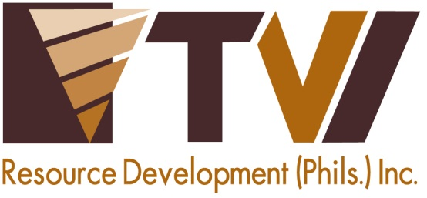
N E W S R E L E A S E

AMVI Celebrates Kahimonan with Mamanwas and Manobos
Agata Mining receives tribal blessing from a respected Baylan of the Mamanwa Tribe
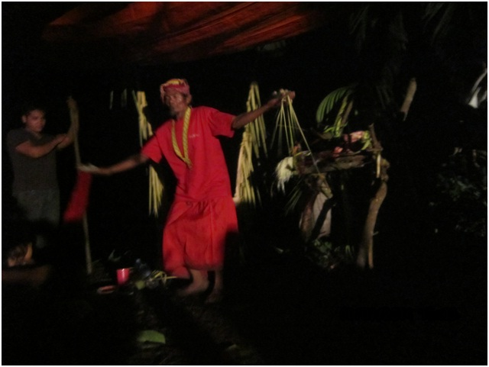
Counting their blessings. AMVI’s indigenous hosts, Manobo and Mamanwa tribes, celebrate “Kahimoan” – a ritual to ask the Diwatas’ blessing on the company’s forthcoming operations.

Tubay Agusan Del Norte/September 2014 – Key officers and staff of Agata Mining Ventures Inc. (AMVI) celebrated the “Kahimonan” with the host Indigenous Cultural Community of the Mamanwas and Manobos last 08 July 2014 in Sitio Payong-Payong, Barangay Tinigbasan of this municipality. Lumads from Barangays Corro, E. Morgado, La Paz and Binuangan, Barangay Officials of Tinigbasan, Payong-Payong villagers participated in the event.

Datu Joseph Purugoy, a respected Baylan of the Mamanwa Tribe, led and officiated the Kahimonan ceremony which is a tradition of the Mamanwas and Manobos to ask the Diwatas’ blessing on the company’s forthcoming mining operation. The ceremony also offers prayers and praises to Magbabaja (A single all-powerful god on top of a hierarchy of ruling spirits in Higaunon religion, which is deeply-rooted in Manobos) in order for both the tribes and AMVI to be successful in pursuing their mutual development.

The Kahimonan ceremony promotes and preserves the tribes’ customs and traditions. Once AMVI’s operations come on-stream, the company will be able to provide employment opportunities and sustainable development programs to tribal and non-tribal communities in its host municipality of Tubay as well as neighboring Santiago and Jabonga – both of which are within its Mineral Processing Sharing Agreement (MPSA) area.

“For a long time, we have aspired for the company’s operation to start because the people witnessed AMVI’s commitment to the welfare and equality of tribal and non-tribal communities,” said Rolito “Datu Mapaso” Moron.

“Celebrating Kahimonan speaks of deep respect to cultural beliefs. Moreover, it manifests respect for each individual and expresses value and support to the company’s project,” said AMVI General Manager Engr. Victoriano C. Nuñez.

AMVI is currently engaged in various collaborative social and community development programs together with local government agencies. These programs are focused on both the indigenous and local communities within the area of its mining operations.

AMVI is a joint venture between Mindoro Resources Ltd. (MRL) and TVI Resource Development Philippines Inc. (TVIRD), which operates the Agata Project. The joint venture aims to move forward, initially with high iron laterite direct shipping ore (DSO) operations, followed by the construction of Agusan del Norte’s first nickel processing plant.

*******

Press photos:
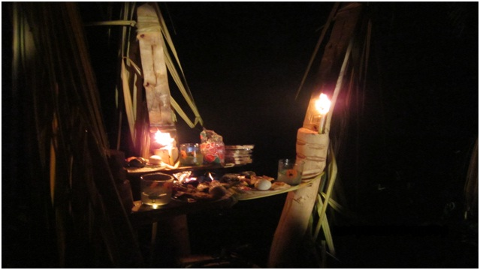

- Both tribes prepare to stage the celebration, which is in line with their indigenous customs and traditions.

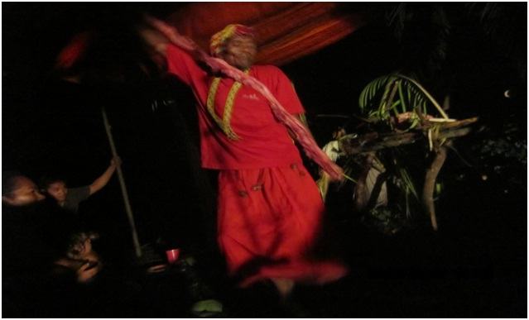
- A traditional dance is performed by Datu Joseph Purugoy, who was joined by AMVI employees in the Kahimoan ritual celebration.

About TVI Philippines
TVI Resource Development Philippines Inc. (“TVIRD”), is the local affiliate of TVI Pacific Inc. (TSX: TVI), a publicly-listed Canadian mining company focused on the exploration, development and production of precious and base metals from district-scale, large-system, high-margin projects located in the Philippines. Concurrent ownership of ventures is shared with partner company, Philippine Resource Holdings Inc.

TVIRD is committed to exploration and mining practices that promote transparency, responsible stewardship of the environment, and the inalienable rights to life, dignity, and sustainable development of its host communities.
www.tviphilippines.com

Contact:

Kaycee Crisostomo
Corporate Communications Director
TVI Resource Development Philippines Inc.

Email: kaycee.crisostomo@tvipacific.com.ph
Phone: +63 2 728-8491 ext. 103
Mobile: +63 917 579-1528
Fax: +63 2 728-8515

