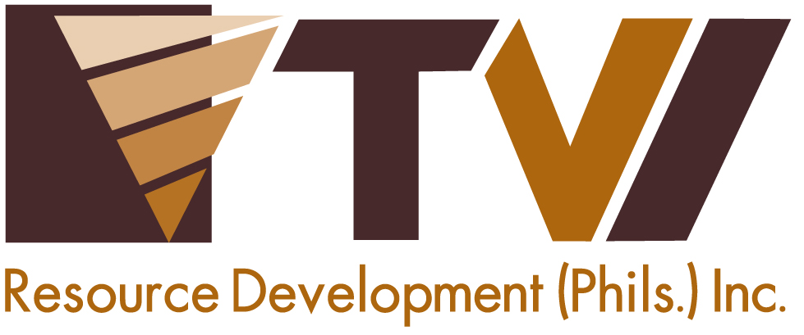
N E W S R E L E A S E

Unified Subanens Exercise Rights,
Approve Balabag Mining Project
Sign MOA for sustainable development and give their free, prior and informed consent

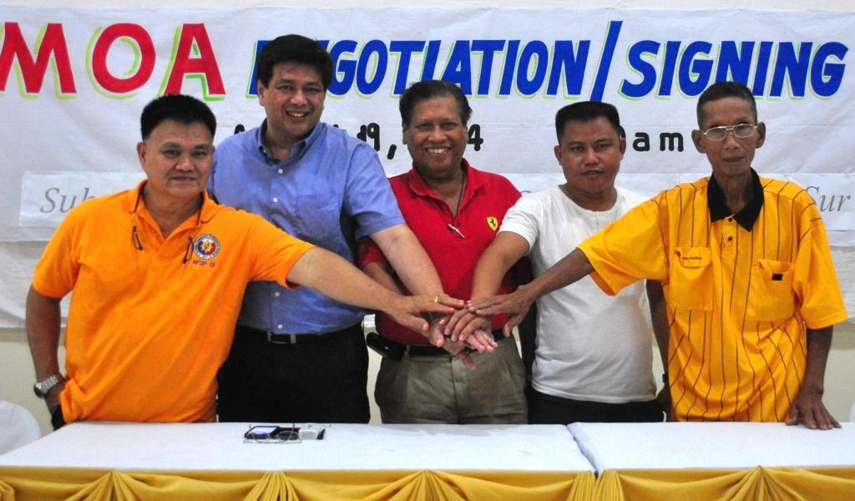
The right to self determination. Subanen Timuays Lucenio Manda and Casiano Edal (4th and 5th from Left, respectively) both from Bayog, Zamboanga del Sur, recognized ancestral domain representatives, sign an agreement supporting TVIRD’s gold and silver project in the municipality. The MOA signing is witnessed by Regional Director of NCIP-9, Timuay Woy Lim Wong, and co-signed by TVIRD Board Member Michael Regino and President Atty. Eugene Mateo (2nd and 3rd from Left, respectively).

Pagadian, Zamboanga del Sur / August 2014 – Culminating two months of exhaustive public consultation supervised by the National Commission on Indigenous People (NCIP), Subanen leaders Lucenio Manda and Casiano Edal entered into a memorandum of agreement with TVI Resource Development Philippines Inc. (TVIRD) on August 19, 2014 in Dao, Pagadian City, Zamboanga del Sur. Both leaders represent the collective Subanen tribe in the Municipality of Bayog of the same province, including the company’s Mineral Production Sharing Agreement (MPSA) area covering 4,779 hectares in Sitio Balabag, where it is primed to bring its gold and silver project on stream.

Nearly two years after the dismantling of illegal mining operations in the area – an initiative spearheaded by Provincial Governor Antonio Cerilles – the tribe now has clear reason to hope for the remediation of prior environmental destruction from exploitive artisanal mining and a transparent roadmap for mutual development with TVIRD.

“On behalf of my people, I thank Governor Tony Cerilles and Mayor Jun Babasa for their political will and unrelenting support to the development of the Subanens and the communities in Bayog. Today, we exercise our right to keep illegal mining from returning to our town,” said Timuay Lucenio Manda, who is also a Sangguniang Bayan (SB) Member of the municipality.

Sitio Balabag of Barangay Depore has been the center of disaccord between the illegal miners and the tribal leaders who support TVIRD. The agreement signed by the Subanens is a prerequisite for a Certification Precondition to be issued by the NCIP Commission En Banc in order for the company to operate its Balabag Mining Project.

Priority, precedence and transparency
“Based on its success in Canatuan, we believe in TVIRD’s capability to implement development (in Bayog),” said Manda, who succeeded his father, Rosendo, as one of the leaders of the ancestral domain. He also referred to the company’s flagship gold and silver project that came on stream in the town of Siocon, Zamboanga del Norte in 2004. In the beginning of 2014, the company concluded its successful 10-year run in Canatuan with its final copper and zinc concentrate shipments.

Timuay Manda places priority on his people above all else and that consultation with his tribe will always take precedence. He explained that while various NGOs do not support mining, he believes in transparency and maintaining a critical balance between the tribe and the government that he serves.

“We want the TVIRD-Subanen partnership to be a model for development – a testament that securing the tribe’s free, prior and informed consent is a transparent process that can bring social and economic benefits. And by consulting with everyone involved, each will have ownership over the process,” he explained, citing the consultative relationship he shares with his contemporary, Timuay Casiano Edal, and the development of a consensus over the past two months.

Last June 18, the NCIP held a conference to explain the process of securing free, prior and informed consent (FPIC) to Subanen tribal leaders, key TVIRD personnel and representatives from the Municipality of Bayog. The agency coordinated with all stakeholders before proceeding with the FPIC process.

A Community Consultative Assembly was then conducted from July 08-11 in which TVIRD explained all the necessary components of the Balabag Mining Project, namely: Company Profile, Mining and Milling Process, Environmental Enhancement and Protection Plan (EPEP), and the Social Development Management Plan (SDMP). At the same congregation, the DENR-MGB presented the Philippine Mining Act (RA7942) and its implementing rules and regulations, while the NCIP presented the IPRA Law and the FPIC Process itself.

On July 23 and July 28, the Ancestral Domain Council and the NCIP were engaged in Consensus Building, which is one of the final parts of the consultation process prior to unanimously deciding to pursue TVIRD’s Balabag Mining Project. While the law requires consultation among the four affected barangays, the process nonetheless engaged the Subanen leadership in all their 22 barangays.

Mutual development
Timuay Lucenio Manda maintains a dual responsibility as Bayog Municipal Councilor as well as a leader trusted with the future of the tribe. He believes that the country’s present legislation, the Mining Act, is a catalyst for development through responsible mining.

“The Local Government Code, the Mining Act of 1995 and the IPRA Law – all these are harmonized towards long-term development. And while proceeds from royalty and SDMP are things that government does not provide, we are confident that the law can usher-in tangible developments that other municipalities can see,” he said.

Given its mineral-rich environment, the Subanens of Bayog are likewise confident that mining will enhance economic activity in the town while royalties are direct benefits that they can invest in the tribe’s future. Similarly, they look forward to prosperity experienced by their fellow lumads in Siocon who witnessed its rise from a fourth-class municipality to first-class status.

“The MOA signing is significant to us. Employees (of TVIRD) may change, but the commitment on both sides would remain. That is legacy-building. When mining is done, there will still be sustainable development – there will be infrastructure left behind to support local trade and economy,” Manda concluded.

*******

Press photos:

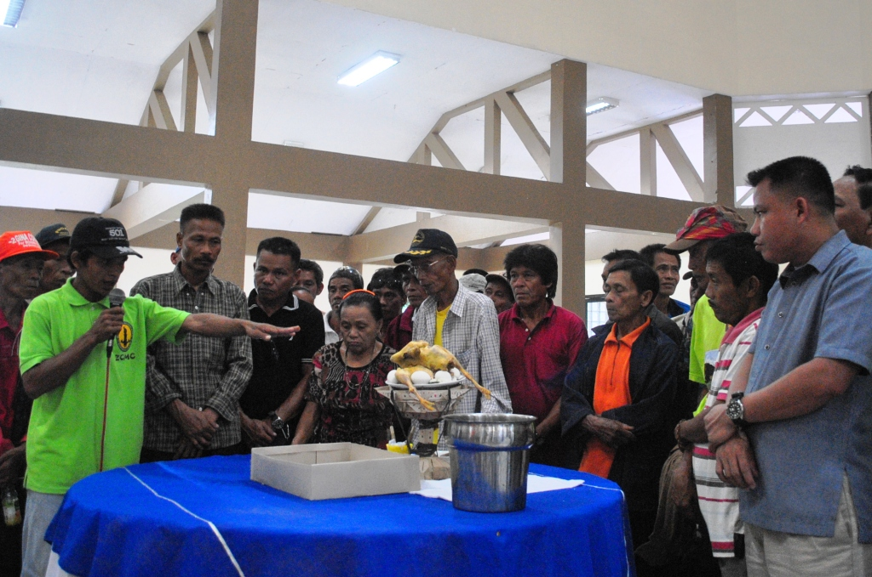
- Respect for customs and traditions. Tribal leaders perform a cleansing ritual at the Subanen Hall in Dao, Pagadian City. The ceremony was conducted in anticipation of the MOA signing that followed.


- A common vision. TVIRD Board Member Michael Regino: “We are no longer two different groups on opposite sides of the table. We are now united by a common roadmap for development.”
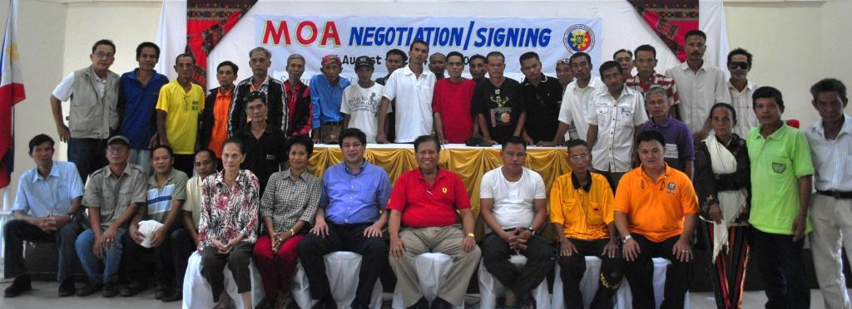
- Hail to the chiefs. The MOA is witnessed by tribal chiefs representing the collective Subanen leadership in the municipality of Bayog.

About TVI Philippines
TVI Resource Development Philippines Inc. (“TVIRD”), is the local affiliate of TVI Pacific Inc. (TSX: TVI), a publicly-listed Canadian mining company focused on the exploration, development and production of precious and base metals from district-scale, large-system, high-margin projects located in the Philippines. Concurrent ownership of ventures is shared with partner company, Philippine Resource Holdings Inc.

TVIRD is committed to exploration and mining practices that promote transparency, responsible stewardship of the environment, and the inalienable rights to life, dignity, and sustainable development of its host communities.
www.tviphilippines.com

Contact:

Kaycee Crisostomo
Director - Public Affairs
TVI Resource Development Philippines Inc.

Email: kaycee.crisostomo@tvipacific.com.ph
Phone: +63 2 728-8491 ext. 103
Mobile: +63 917 579-1528
Fax: +63 2 728-8515

