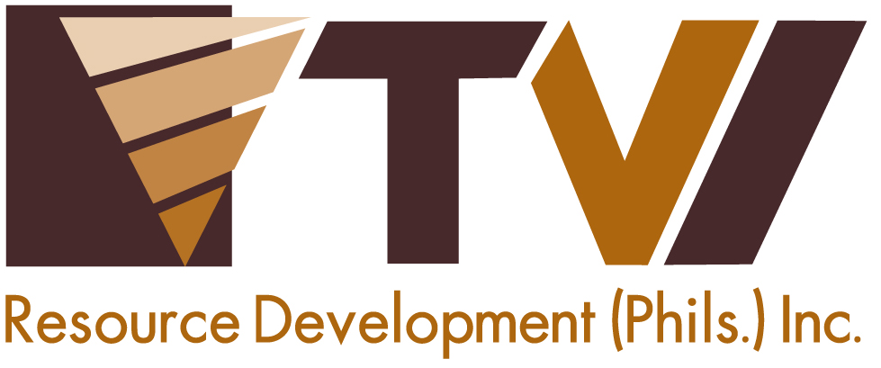
N E W S R E L E A S E

Soldiers for the Environment
TVIRD and the AFP’s Special Forces replant slash-and-burn area

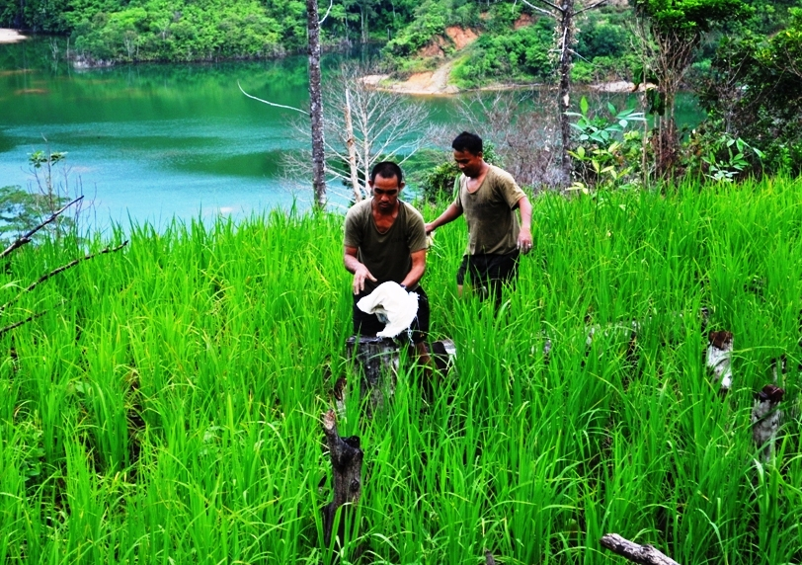Recovery from ‘kaingin.’ SF Soldiers who patrol TVIRD facilities in Canatuan join reforestation efforts above the company’s sulphide dam. The area was recently troubled by ‘kaingeros’ who cut down 50 full-grown trees.

Canatuan, Zamboanga del Norte / July 2014 – Adding significance to the country’s observation of Philippine Environment Month, TVI Resource Development Philippines Inc. (TVIRD) and trained personnel of the Armed Forces of the Philippines (AFP) Special Forces planted 2,375 rubber tree seedlings at the northwest part of the company’s tailings impoundment facility or sulphide dam. The reforestation initiative is conducted as a recovery effort to replace some 50 full-grown Falcatta trees that were felled by slash-and-burn farmers (Kaingineros) across an eight hectare area in the company’s Canatuan mine site.

The Special Forces, detailed by the AFP to maintain peace and order in the town of Siocon and adjacent municipalities, volunteered to continue the tree-planting activity along with the company’s Environment, Community Relations, Indigenous People Affairs and Human Resources Departments. They are joined by Civilian Active Auxiliary (CAA) trainees who will actively participate in the effort until their graduation.

To date, TVIRD has planted over 380 thousand trees in and around its Canatuan mine site. Along with its Agata Project joint venture partner, Mindoro Resources Ltd. (MRL), it has also planted some 110 thousand trees prior to ramping-up operations in Tubay, Agusan del Norte.

Protecting the environment
By practice, slash-and-burn or kaingin is most prevalent in agricultural communities as well as upland farms. It is, however, an ecologically destructive technique for creating open fields for planting, especially in thick woodlands like TVIRD’s Mineral Processing Sharing Agreement (MPSA) area.

In addition to ongoing reforestation efforts, the company discourages the local community from engaging in slash-and-burn, which presents not only the risk of forest fires but also negatively affects soil quality and rendering it inadequate for supporting crops and other vegetation.

TVIRD security personnel in Canatuan are constantly monitoring the area in order to prevent destructive practices like kaingin from creating damage to the environment.

Protecting human rights
At the height of its operations, TVIRD conducted mandatory training on the Voluntary Principles on Security and Human Rights among its detailed security personnel. The set of principles was adapted by companies in the extractive sector, including TVIRD, and are designed to guide organizations in maintaining safety and security within a framework of respect for human rights.

“Apart from adapting the same successful Canatuan business model to its succeeding projects, TVIRD will sustain the same guiding principles in maintaining peace and order in its Balabag (Zamboanga del Sur) and Agata projects,” stressed Security Director (Ret) Brigadier General Emmanuel Cayton, who is also an agriculturist by discipline.

“The company maintains constant dialogue with its communities, whom it also protects and with whom it continues to build greater understanding, support for human rights and an appreciation for sustainable development through responsible mining,” he concluded.

*******
Press photos:
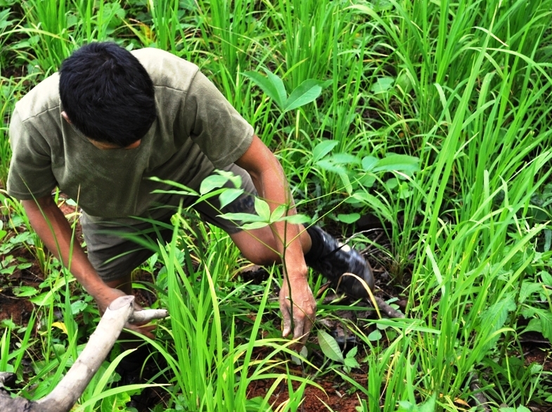

- An SF soldier plants one of 2,375 rubber tree seedlings in the area affected by ‘kaingin.’ Long-term benefits of rubber trees include livelihood through the production of industrial rubber material.

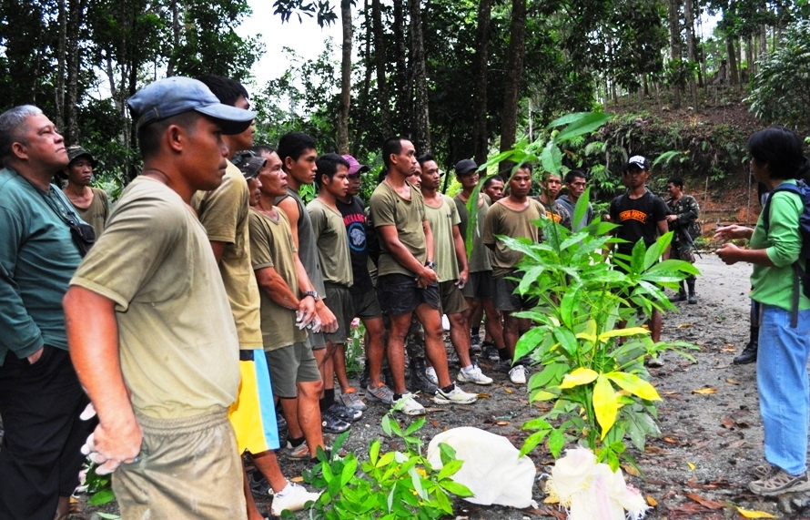

- TVIRD’s Col. Nolito Navarro (extreme left) joins the orientation for SF soldiers as well as CAA trainees prior to the actual tree-planting activity.

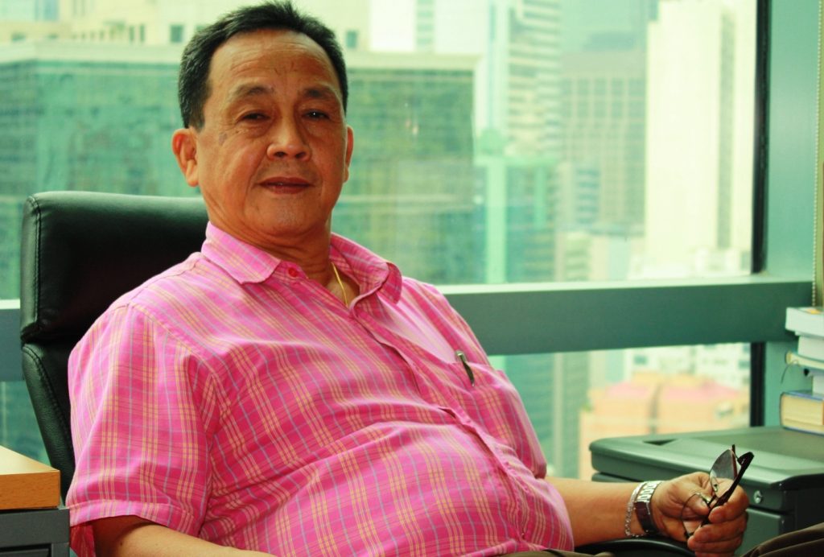

- (Ret) BGen. Emmanuel Cayton: “Apart from adapting the same successful Canatuan business model to its succeeding projects, TVIRD will sustain the same guiding principles in maintaining peace and order in its Balabag and Agata projects.”

About TVI Philippines
TVI Resource Development Philippines Inc. (“TVIRD”), is the local affiliate of TVI Pacific Inc. (TSX: TVI), a publicly-listed Canadian mining company focused on the exploration, development and production of precious and base metals from district-scale, large-system, high-margin projects located in the Philippines. Concurrent ownership of ventures is shared with partner company, Philippine Resource Holdings Inc.

TVIRD is committed to exploration and mining practices that promote transparency, responsible stewardship of the environment, and the inalienable rights to life, dignity, and sustainable development of its host communities.
www.tviphilippines.com

Contact:

Kaycee Crisostomo
Director - Public Affairs
TVI Resource Development Philippines Inc.

Email: kaycee.crisostomo@tvipacific.com.ph
Phone: +63 2 728-8491 ext. 103
Mobile: +63 917 579-1528
Fax: +63 2 728-8515

