
P H O T O R E L E A S E

Canatuan National High School Commemorates
Turning Point in Philippine History
Siocon, Zamboanga Del Norte, The Philippines / February 2014

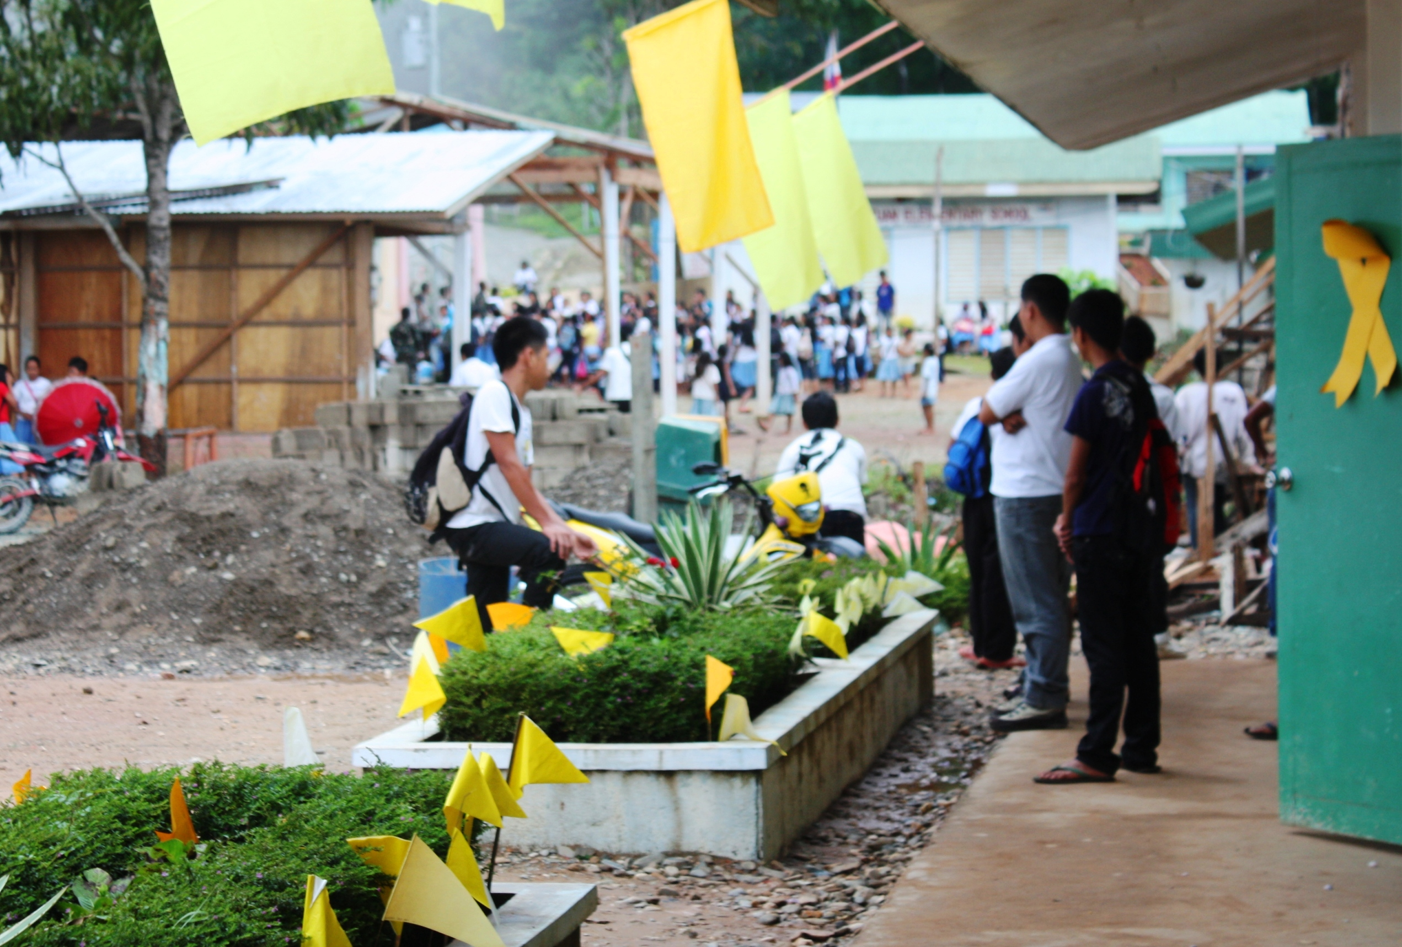
Honoring the Day. Students of Canatuan National High School in Zamboanga Del Norte commemorate the People Power I anniversary in the upland mining community of Siocon Town. The historic milestone underscores a significant turning point for the island nation – one that is said to have propelled the Philippines into the global front and inspired similar peaceful movements for freedom and democracy in other countries. Located in the hinterland village some 500 feet above sea level, Sitio Canatuan’s public school is home to a growing population of over 850 students. (Photo courtesy of TVI Resource Development Philippines Inc., 2013)

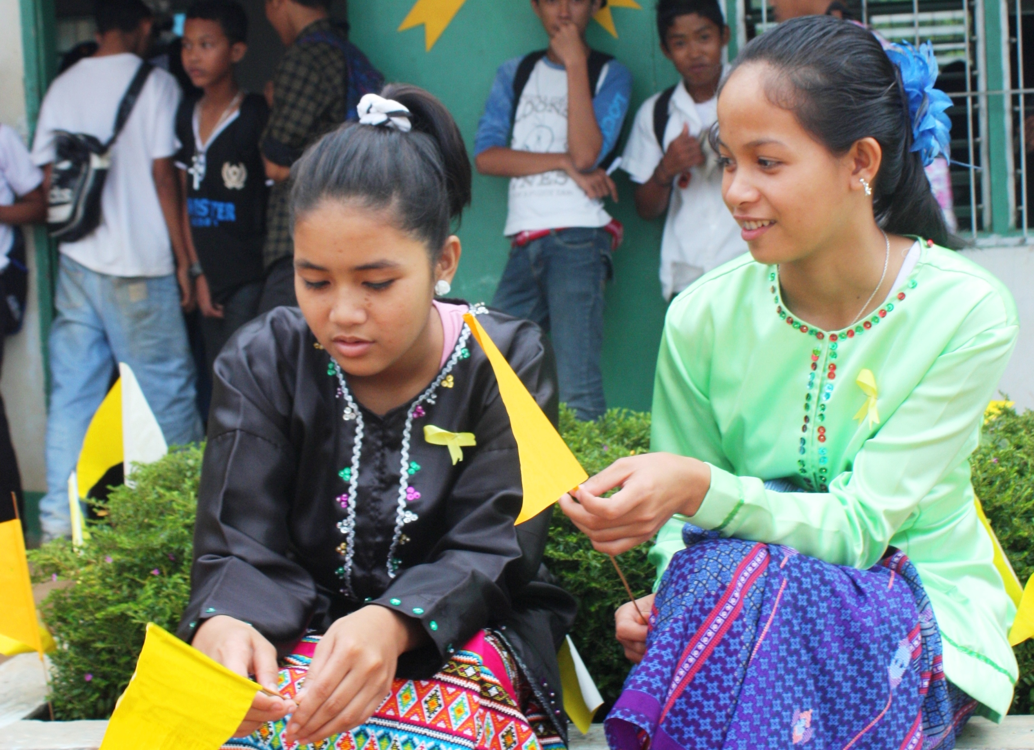
Subanon students relive EDSA. Clad in their traditional Subanon garb, students of Canatuan National High School in Siocon, Zamboanga del Norte prepare for the school’s commemoration of People Power I - the historic milestone that is said to have propelled the Philippines into the global front and inspired similar peaceful movements for freedom and democracy in other countries. Children of various indigenous and religious cultures in the surrounding mining community receive primary and secondary education at CNHS, which is supported by TVI Resource Development Philippines, Inc. (TVIRD). (Photo courtesy of TVIRD, 2013)

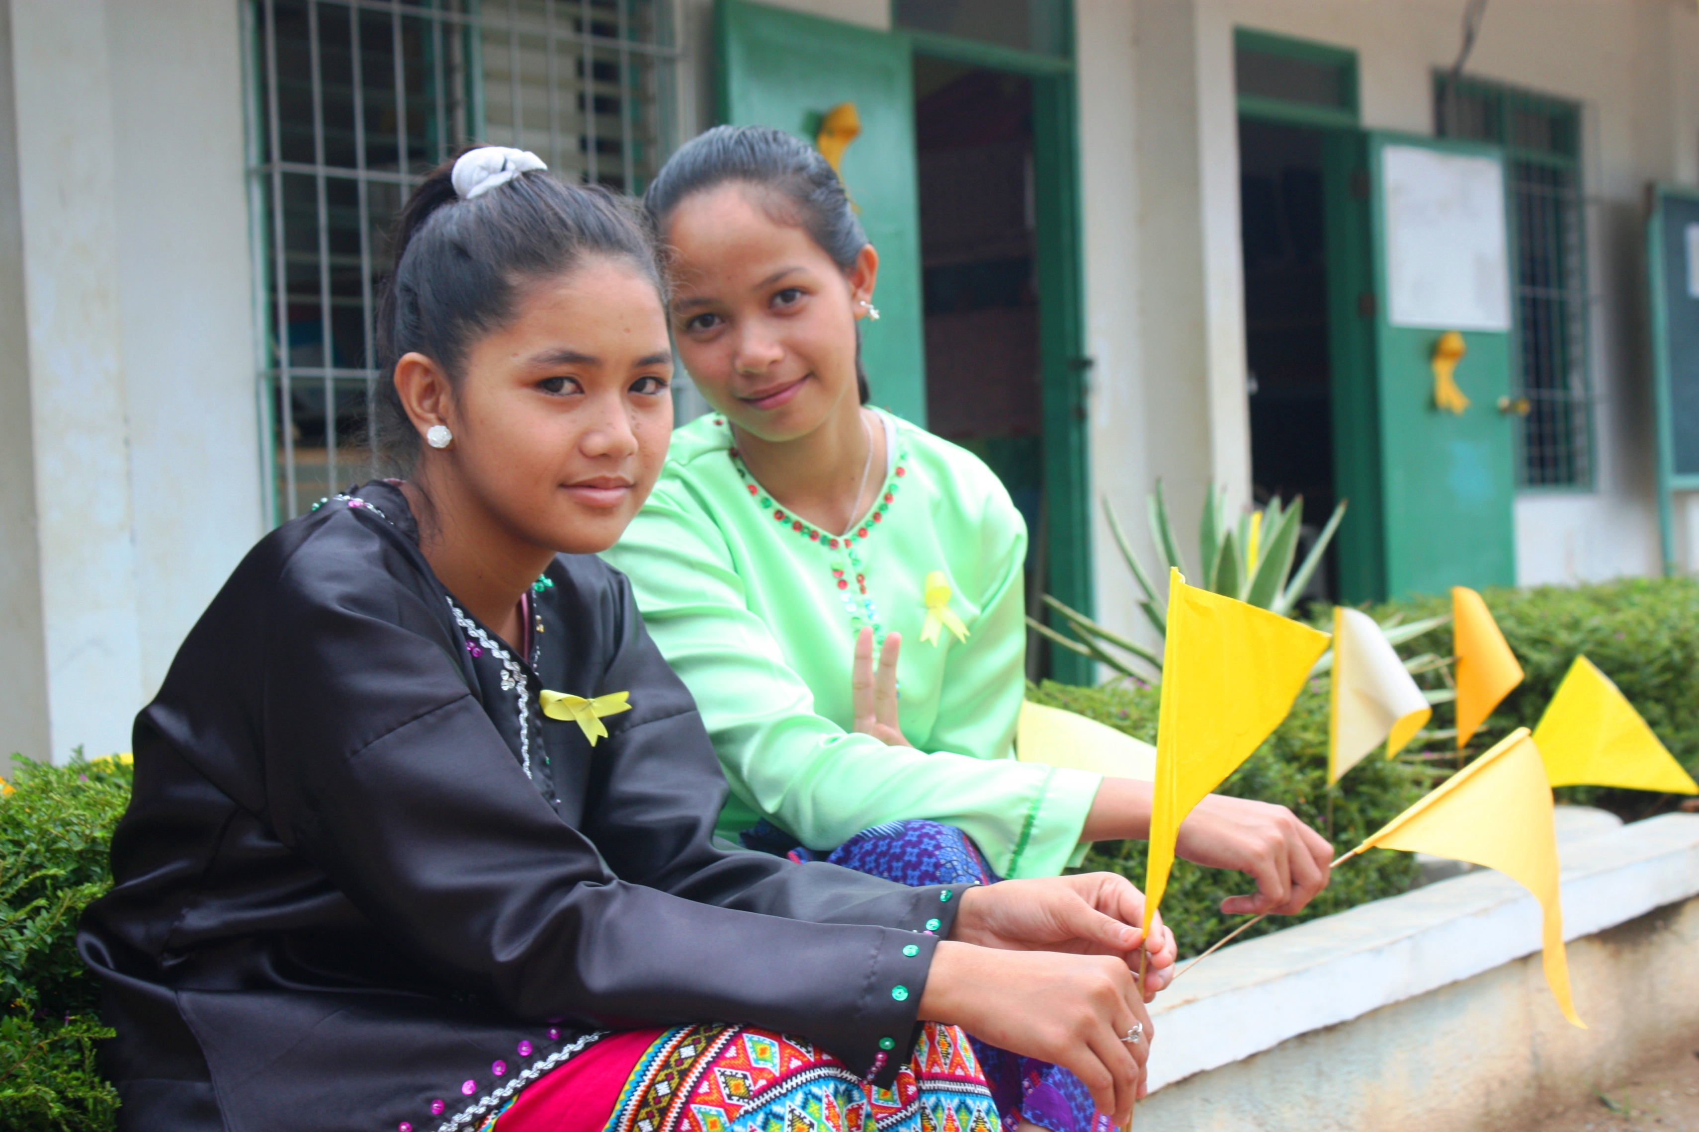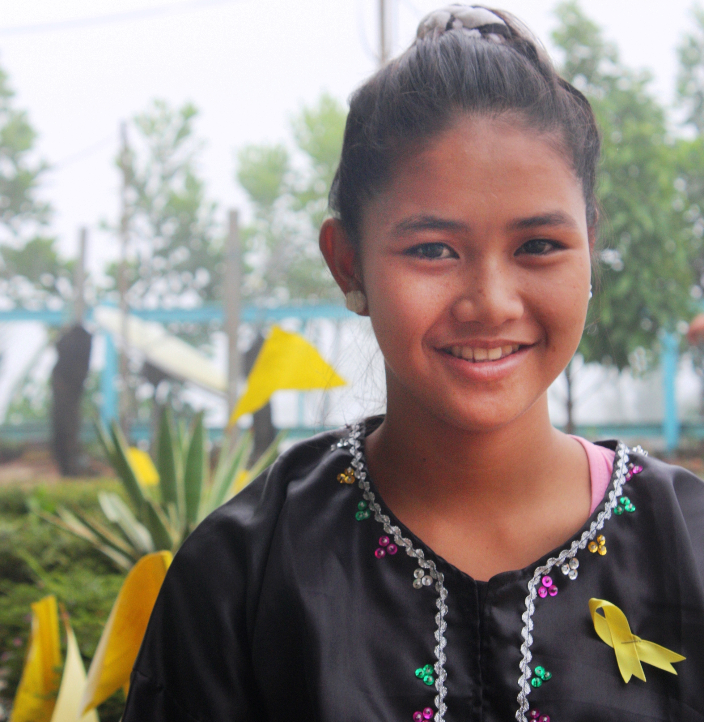
Indigenous culture and education. Subanon students in upland Siocon, Zamboanga del Norte receive primary and secondary education in Canatuan National High School, which is supported by mining company, TVI Resource Development Philippines Inc. (TVIRD). The school is equipped with sufficient classrooms, learning materials and internet facilities in order to foster computer literacy. Its curriculum also includes a deep appreciation for indigenous history, which dovetails with the preservation of Subanon culture. (In photo): Subanon teens prepare for People Power I commemoration activities in their campus. In the region, TVIRD supports 10 schools with a population of 4,000 students. This includes Sitio Canatuan Public School’s growing population of over 850. (Photo courtesy of TVIRD, 2013)

*******

About TVI
TVI Resource Development (Phils.) Inc., is the Philippine affiliate of TVI Pacific Inc. (TSX: TVI), a publicly-listed Canadian mining company focused on the exploration and production of precious and base metals from district scale large system, high margin projects located in the Philippines.
We are committed to exploration and mining practices that promote transparency, responsible stewardship of the environment, and the inalienable rights to life, dignity, and sustainable development of our host communities.
Connect with us: www.tviphilippines.com

Contact:

Kaycee Crisostomo
Director - Public Affairs
TVI Resource Development Philippines Inc.

Email: kaycee.crisostomo@tvipacific.com.ph
Phone: +63 2 728-8491 ext. 103
Mobile: +63 917 579-1528
Fax: +63 2 728-8515

