
N E W S R E L E A S E

TVIRD and LGU Repair Pisawak Spillway,
Restore Siocon’s Access to Zamboanga Peninsula
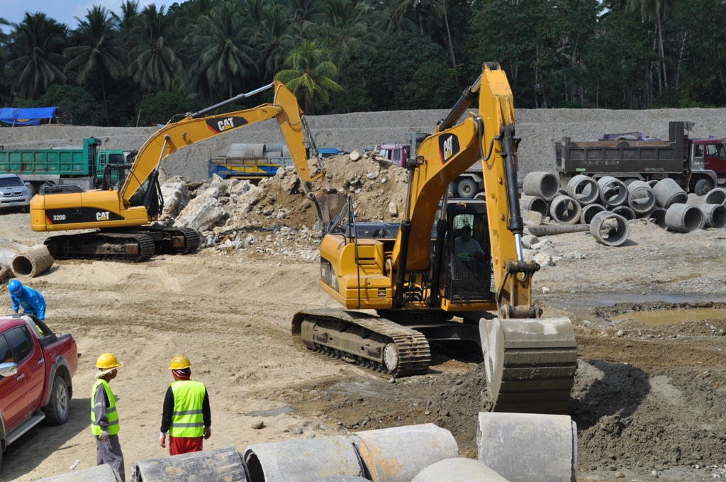
Reconnecting Siocon. TVIRD Civil Engineering Services personnel commence the restoration of the damaged Pisawak Spillway after massive rainfall battered Siocon town in October 2013. During the interim, the company ensured that the temporary detour road constructed below the Pisawak Spillway was passable to all types of vehicles.

Siocon, Zamboanga del Norte / February 2014 – Following the wreckage left by an Intertropical Convergence Zone that battered the municipality of Siocon – forcing the evacuation of nearly 3,000 residents and causing landslides that isolated the town – TVI Resource Development Philippines Inc. (TVIRD) mobilized its resources to repair the damaged Pisawak Spillway that links the town to the rest of the Zamboanga Peninsula. The 158-meter structure sustained heavy damage during the incessant rains that triggered the swelling of Pisawak River, which is one of the biggest rivers of the municipality.

“Without the spillway, fish cars from Pagadian, Dipolog and Zamboanga Cities cannot enter my town to purchase our famous Lupoys and Tamban (fish varieties made into bottled sardines). It is being used by rice traders in the Peninsula too,” according to town Mayor Julius Lobrigas, stressing that the structure is the only access point for both businessmen and ordinary citizens in transporting goods and people to and from Siocon.

By virtue of a Memorandum of Agreement, both the local government of Siocon and TVIRD, represented by Mayor Lobrigas and General Manager Germidas Las Piñas, respectively, entered into a partnership to repair the structure. The Php3.5 million project is scheduled for completion by the end of the month.

Since 2004, the mining firm has been operating at Sitio Canatuan – a sub-village of Barangay Tabayo, which is 20 kilometers from Barangay Pisawak. The company and its Canatuan facilities remained intact despite the catastrophe.

“I laud TVIRD for this project. I am happy that it partnered with the local government to repair the spillway, which is vital for the town’s trade and commerce,” said Lobrigas after the MOA signing.

Aside from tax revenues and increased economic activity generated from local mining, agriculture also continues to drive Siocon’s economy. It was proclaimed one of Zamboanga del Norte’s Best Rice Producers in 2009 by the Department of Agriculture – some four years after TVIRD ramped-up mining operations in the area.

Mobilizing progress, keeping the peace
“I am very happy with the project. Once repaired, the Pisawak Spillway will not only help the government sustain the economic activity of Siocon but also preserve the town’s peace and order,” said Pisawak Barangay Chairman Mario Obungen who was one of the witnesses in the MOA signing.

Since the onslaught of the ITCZ in October last year – and after a major landslide damaged the existing road – TVIRD’s Civil Engineering Services personnel constructed a bypass route near its detachment area. The company also ensured that the temporary detour constructed below the spillway is passable to all types of vehicles.

In addition, Obungen and his constituents will also receive a Thresher and a Hand Tractor from the company as part of the latter’s Social Development Management Program (SDMP) and in response to the recommendation of the barangay’s Community Technical Working Group. Also through its SDMP, the company was able to provide fishing vessels to both the MNLF and MILF’s non-combatants who wish to live in peace with their families.

Life after mining
“The tax revenues, the employment and livelihood of Subanons and Siocon residents, and SDMP projects we are receiving are difficult to lose. Like its workers, I wish TVIRD will continue mining in Canatuan,” said Chairman Obungen.

Obungen also acknowledged that TVIRD has been an effective partner of the government in delivering basic social services to the remotest barangays where social services are ‘hardly felt.’

Las Piñas on his part reiterated that TVIRD will continue to rehabilitate the areas disturbed during the company’s mining operations Canatuan. It also has plans to convert key areas into plantation-scale agricultural land intended for the long-term sustainability of the Subanons.

“With this project, we want to show the people that mining and agriculture can go together. And we have proven it in Siocon,” he concluded.

TVIRD concluded its gold and silver production in 2008 while its copper and zinc operations came on-stream afterwards. At the height of its mining operations, it employed some 1,200 personnel. Its equipment contractors also employed local residents numbering 200. It was recognized as the country’s Safest Mining Operation and Best Mining Forest. Currently, the company is assessing various mine life extension and expansion opportunities that can potentially resume milling operations

*******

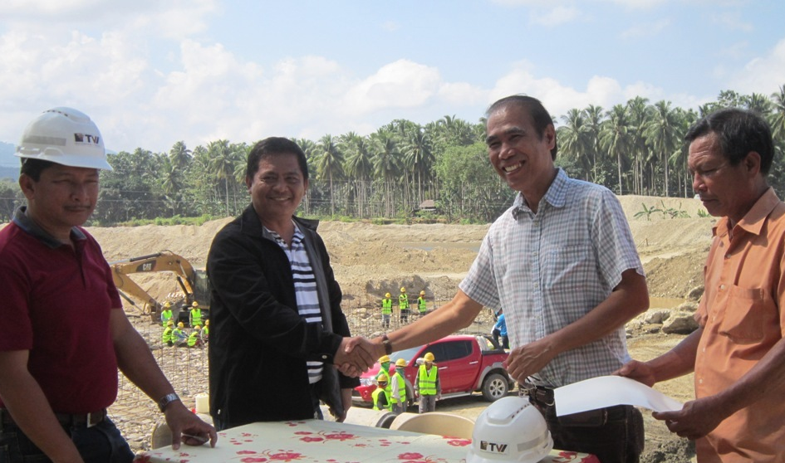

- Partners in Development. Mayor Julius Lobrigas (2nd from Left) and TVIRD General Manager Germidas Las Piñas sign a Memorandum of Agreement engaging Siocon and TVIRD in the joint undertaking for the Pisawak Spillway.

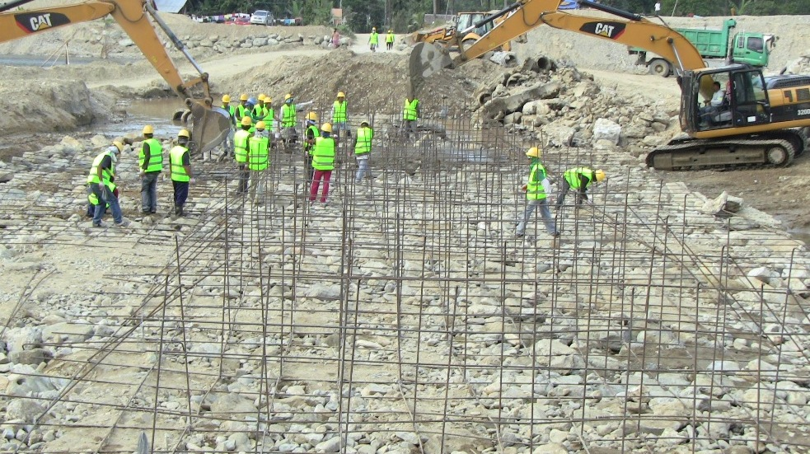
- TVIRD’s Civil Engineering Services group is in a hurry to finish the repair by the end of the month in order to avoid disruptions from the coming rainy season. An initial 60 workers, many of whom are from Pisawak, and heavy equipment were immediately mobilized for the project.

About TVI
TVI Resource Development (Phils.) Inc., is the Philippine affiliate of TVI Pacific Inc. (TSX: TVI), a publicly-listed Canadian mining company focused on the exploration and production of precious and base metals from district scale large system, high margin projects located in the Philippines.
We are committed to exploration and mining practices that promote transparency, responsible stewardship of the environment, and the inalienable rights to life, dignity, and sustainable development of our host communities.
Connect with us: www.tviphilippines.com

Contact:

Lullie A. Micabalo
Public Affairs Manager
TVI Resource Development (Phils) Inc.

Email: lullie.micabalo@tvipacific.com.ph
Mobile: +63 917 883-7074

