TVI Pacific Reports 33.9-M Tons of Resource in Agata Project
Independent report provides details on nickel laterite resource in Agusan del Norte

- Measured and Indicated resources increase to 33.9 million dry metric tons (dmt) at 1.1% nickel compared to the previous 31.8 million dmt at 1.05% nickel

- Inferred resources are 2.0 million dmt at 1.04% nickel
- Estimated contained nickel is 391 thousand tons
- At a cut-off grade of 44% iron, there are an estimated 7.0 million dmt or about 10 million wmt at 48.5% iron and 0.94% nickel – a DSO product grade currently much in demand in China
- The joint venture is fast-tracking DSO development and is targeting production in 2013

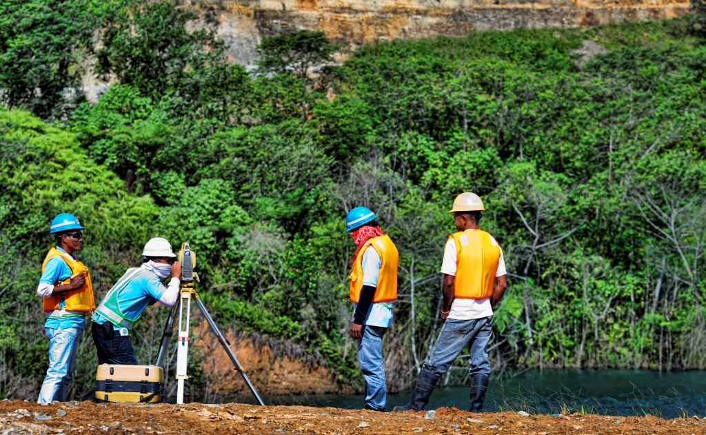
Eyes on the ground. TVIRD personnel survey the surrounding Canatuan tailings impoundment area to provide an update on the current elevation of the topography in order to create digital terrain models, which are also used for estimating resources and mine development plans. The company is set to bring the same successful Canatuan business model to its Agata North project in Agusan del Norte.

Manila / April 2013 – TVI Pacific Inc. (TSX:TVI) (OTCQX:TVIPF) announced today that it has filed an updated National Instrument 43-101 (NI 43-101) technical report that reflects an updated and reclassified resource estimate for the company’s Agata North nickel laterite resource, which is now approximated at 33.9 million dry metric tons (dmt) at 1.1% nickel. The independent report was prepared for TVI's local affiliate, TVI Resource Development Philippines Inc. (TVIRD), by Mark G. Gifford, MSc (Hons), FAusIMM, of Margaret River, Western Australia. It is available on TVI Pacific’s website and SEDAR (www.sedar.com), which provides access to most public securities documents and information filed by public companies and investment funds with the Canadian Securities Administrators.

The Agata Project, a joint venture with Mindoro Resources Ltd. (MRL) and operated by TVIRD, bears a robust foundation for moving forward, initially with high iron and limestone Direct Shipping Ore (DSO). TVI has the option to earn a 60% interest in the joint venture. TVI also currently holds a 14.4% interest in MRL and further opportunity to increase this interest to 22.7% of total issued and outstanding Common Shares if it were to exercise all Mindoro purchase warrants held by the Company.

Short / near-term opportunities
High iron and limestone DSO operations present near-term opportunities that have the potential to generate strong cash flow by late 2013, pending the timely issuance of permits. This development is projected to further mobilize the project until the nickel processing plant comes on-stream. Mineral deposits located within a 1-km proximity from the coast will also positively impact transportation costs and significantly reduce overhead expenditures.

The iron-rich deposit is expected to be developed as a surface mining operation with the high iron material targeted for sale to the Chinese market.

The high iron DSO operation already has an existing Environmental Compliance Certificate (ECC); however, other permits such as a port permit and a Declaration of Mining Project Feasibility are also required. Meanwhile, the limestone at Agata is expected to be of high quality and very high purity levels, initiating plans to construct an onsite production facility that will come online in 2015, pending the filing and receipt of all required permits and other requirements.

Medium-term opportunities
The Agusan del Norte Nickel processing plant is a medium-term growth opportunity, which is projected to come into production in mid-2015. It would initially be designed to have a 20-year life, and would be built in modules with the ability to add capacity over time to increase production. TVI’s foray into nickel is primed to further expand the Philippines’ leadership as the world’s largest producer of nickel.

The joint Project Execution and Technology Development team composed of senior management from both companies is expediting the establishment of this processing plant that utilizes cost-effective leaching technology, which is specifically suited to the extraction of nickel. This extraction method is proven to be commercially viable and has a low environment impact.

The lime produced would also be used in the nickel processing plant, offsetting the costs of imported lime while also creating potential for some to be sold.

Resource estimates
The previous Agata resource estimate was carried out in 2011. This current resource estimate gives a superior grade-tonnage distribution. Sufficient high-iron limonite has been defined for approximately 5 years of DSO production at approximately 2 million dmt per year. During this period it is expected that the nickel processing plant will be in operation.

Mark Gifford, who is a Fellow of the Australian Institute of Mining and Metallurgy (FAusIMM) and an independent qualified person, produced the mineral resource estimates in conjunction with Quantitative Group Pty Ltd (QG) in Perth, Australia. The Agata North estimates entailed 593 drill holes with depths of over 10 thousand meters, and 11,100 core samples. It is exclusive of the other regional nickel laterite deposits: Agata South, Bolo-bolo and Karihatag.

The resource estimation method applied was Ordinary Kriging while cut-off grades applied to the resource were 0.5% nickel within the limonite (upper) zone and 0.8% nickel within the saprolite (lower) zone. Mr. Gifford has indicated that the density of drilling and continuity of mineralization is sufficient to classify the estimated resource and has verified and authorized the technical information.

Sample preparation and assaying were performed by independent mineral testing laboratory, Intertek Testing Services Philippines Inc. (ITS). Each sample is analyzed for nickel, cobalt, iron, magnesium, aluminum, and silica, among other minerals, using X-ray Fluorescence (XRF), which determines total element concentrations.
*******

About TVI Pacific Inc. (TSX:TVI) (OTCQX:TVIPF)
TVI Pacific Inc. is a Canadian resource company focused on the production, development, exploration and acquisition of resource projects in the Philippines and Southeast Asia. The Company produces copper and zinc concentrates from its Canatuan mine and is advancing its Balabag Gold-Silver project towards production in 2014. TVI is a partner/operator in several joint venture projects in the Philippines and Papua New Guinea and also has an interest in an offshore Philippine oil property.

Yulo Perez, Chief Operations Officer, TVIRD, a qualified person as defined by NI 43-101, has approved the scientific and the technical information contained within this press release.

For media queries:

Kaycee Crisostomo
Senior Manager - Public Affairs
TVI Resource Development Philippines Inc.

Email: kaycee.crisostomo@tvipacific.com.ph
Phone: +63 2 728-8491 ext. 103
Mobile: +63 917 579-1528
Fax: +63 2 728-8515

