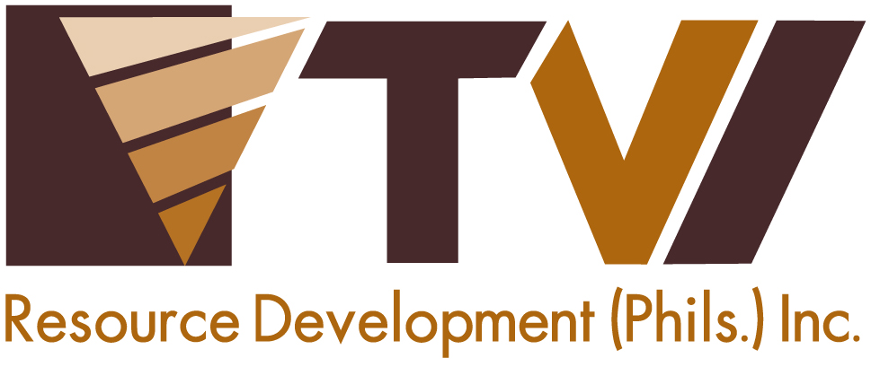.
N E W S R E L E A S E

Subanons, Siocon at the heart of TVIRD development programs
Development contributions of P700M, including taxes, royalties and community projects

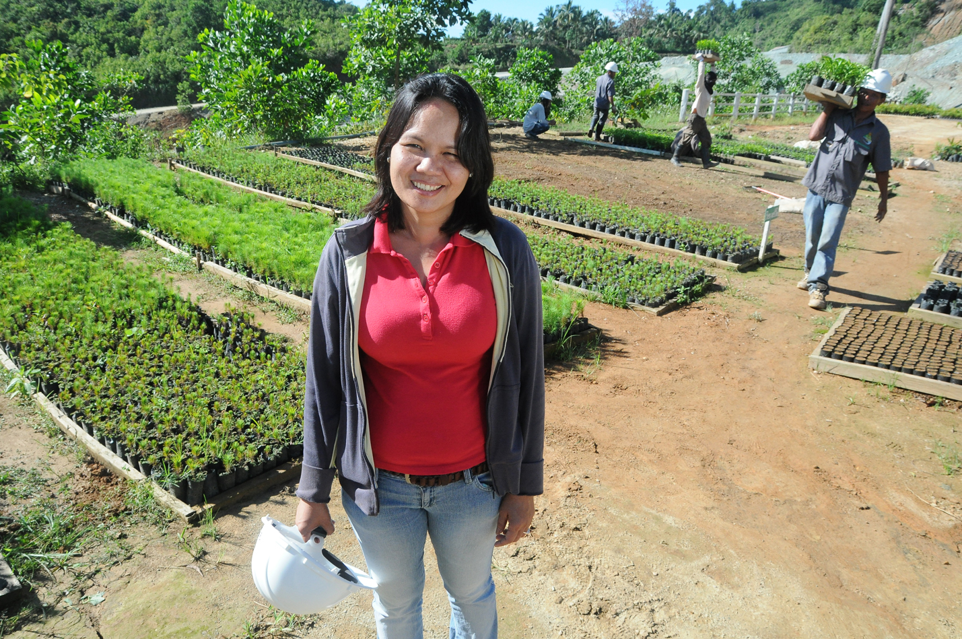
A healthy environment is key to sustainable development. Together with the Environment team, Subanon forester Gemma Dandana Tolentino is proud to have contributed to planting and growing more than 360 thousand trees within TVIRD’s mining concession area in Canatuan, Zamboanga del Norte. Tolentino is one of more than 280 Subanon employees working with the company.

Siocon, Zamboanga del Norte / April 2013 -- After more than nine years of operating the Canatuan gold-silver and copper-zinc mine, TVI Resource Development Philippines Inc. (TVIRD) remains a growth engine, bringing huge economic impact to the host Subanon indigenous cultural community and the people of this post-conflict town. Siocon has since been elevated to first-class status from being a 4th class municipality prior to the large-scale mine operations of the company.

“At the end of 2012, the Philippine affiliate of TVI Pacific Inc. has spurred local economy by contributing a total of Php727.6 million in the span of nine years,” according to TVIRD Chief Operating Officer Yulo E. Perez.

P347.1 million or nearly half of the total was remitted in the form of excise tax. Republic Act 7942, also known as the Mining Act of 1995 or Philippine Mining Law, requires all mining operators to pay a two-percent government share from the actual market value of its gross output. 40 percent of the excise tax is shared by the local governments – provincial, municipal and barangay.

“These tax payments provided a much-needed boost to the government’s efforts to balance the fiscal deficit in order to finance basic services such as education and infrastructure, particularly in the countryside,” said Perez.

The municipal government of Siocon, including nearby Baliguian town, likewise received business and real property taxes with a combined total of Php41.7 million, further boosting their local revenues.

More than taxes

“Another Php221 million in royalties was paid to the Subanon indigenous tribe of Siocon from 2004 to 2012,” Perez adds. The Mining Act likewise requires the payment of royalties amounting to one percent of the gross income to indigenous peoples where companies extract mineral resources. In the last four years of TVIRD’s copper-zinc operations, the tribe’s annual royalty reached an average of Php45.4 million from a previous annual average of Php8.0 million during the company’s gold-silver operations from 2004-2008. The associated increase is due to the company’s initiative to expand the rate of royalty payment to 1.5%. Under the Memorandum of Agreement for the development of Canatuan forged between the tribe and TVIRD, the indigenous people (IP) are given full liberty on investing and dispensing their royalty.

TVIRD continues to enhance economic activity in the Zamboanga Peninsula from the cost of operating the Canatuan mine, notably in the Zamboanga del Norte municipalities of Siocon and Baliguian to the west, and neighboring R. T. Lim town in Zamboanga Sibugay to the east. In the same nine-year period, TVIRD’s operational expenditures contributed significantly to the economic activity in the region. This is in addition to local purchases, employees’ wages and salaries, as well as capital expenditures.

Parallel to this, TVIRD’s social commitment initiatives for residents in and around Canatuan under its Social Development and Management Plan (SDMP) amounts to Php117.8 million, peaking in 2012 with actual annual project expenditure of Php48.1 million, or more than double the total expenses during the company’s 5-year gold-silver phase. The SDMP framework serves as the company’s guidepost for its host and impact communities in the areas of responsive education, sustainable livelihood, health and sanitation, and basic infrastructure, together with the communities’ socio-economic enhancement and sustainability beyond the mine life.

Among the sustainable livelihood undertakings of the company is a partnership with the fisherfolks association in the coastal village of Sta. Maria where TVIRD ships out its copper-zinc concentrate. These fisherfolks, mostly former members of the MNLF, were provided financing for a Php2.6 million fishing vessel, which is now providing a steady income stream to their families. The Company is financing the construction of the second, similar-sized fishing boat for the neighboring coastal Muslim community.

A good road network, spanning 79 kilometers from Siocon to R.T. Lim town, is being maintained by TVIRD. This allows fisherfolks and farmers alike to increase the volume of their produce as the movement of goods has improved significantly during TVIRD’s operations. Including the newly-constructed 45-kilometer Baliguian road and the 16-kilometer Paduan-Candiz-Tungawan road, TVIRD maintains a road network of 140 kilometers in the area at an annual cost of Php19 million.

Presidential merit, contributions to people and the environment

With a peak employment of more than 1,200 people, TVIRD is among the biggest private sector job generators in Zamboanga del Norte. The company was acknowledged by the Department of Labor and Employment as the Most Outstanding Employer in the province and in the entire Region IX for its excellent observance of good labor practices, and health and safety standards, aside from providing the most benefits to its employees.

Likewise in 2011 and 2012, the company was feted as the “Best of the Best” among mining companies for garnering the Platinum Presidential Mineral Industry Environment Award (PMIEA) conferred by the Department of the Environment and Natural Resources (DENR) on behalf of the President. The company’s established environmental management system, together with its progressive rehabilitation program has successfully planted and grown over 360 thousand trees within its mining concession area and is a testament to TVIRD’s commitment to environmental stewardship. The company also built a world-class Php850 million tailings impoundment dam to ensure that all mine tailings and water runoff from the mining area and peripheries are contained to avoid pollution and siltation of nearby bodies of water.

Moreover, in compliance with the requirement of the Philippine Mining Law and in keeping with good corporate citizenship, TVIRD has set aside a Php113 million environmental trust fund to be used for the final mine decommissiong and rehabilitation program to be implemented upon mine closure..

TVIRD is the first foreign-invested mine to have begun operations after the passage of the country’s 1995 Mining Law. While TVIRD is set to conclude its current operations in Canatuan by the end of 2013, the company is anticipating the approval of its APSA23 for a nearby mine in Malusok. The potential additional ore reserves can extend the life of the Canatuan operations. Malusok is within trucking distance from Canatuan, which allows for continued use of the exisiting infrastructure. TVIRD is also primed to bring the same successful business model to its Balabag Gold-Silver mine in Bayog, Zamboanga del Sur. This project is in pre-development stage and is awaiting issuance of the Environmental Compliance Certificate (ECC).

*******
Press photos:
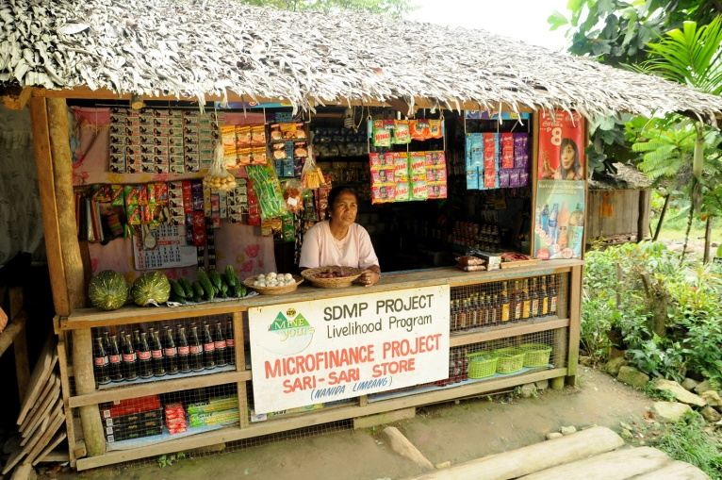
- Business and livelihood for the community. Nanida Limbang, a Subanon woman from nearby Baliguian, enjoys vending in her 'sari-sari' store, which is financed through TVIRD’s soft-loan project geared towards increasing household income.

- Education and health services for the future of Canatuan. A registered nurse and company scholar, Cynthia Comisas-Lacpao, currently works at the TVIRD lying-in clinic, which serves an estimated 5,000 people in the area. In 2012, the clinic received close to 14,000 consultations and admissions.

About TVI

TVI Resource Development (Phils.) Inc., is the Philippine affiliate of TVI Pacific Inc. (TSX: TVI), a publicly-listed Canadian mining company focused on the exploration and production of precious and base metals from district scale large system, high margin projects located in the Philippines.
We are committed to exploration and mining practices that promote transparency, responsible stewardship of the environment, and the inalienable rights to life, dignity, and sustainable development of our host communities.
Connect with us: www.tviphilippines.com

For media queries:

Kaycee Crisostomo
Senior Manager - Public Affairs
TVI Resource Development Philippines Inc.

Email: kaycee.crisostomo@tvipacific.com.ph
Phone: +63 2 728-8491 ext. 103
Mobile: +63 917 579-1528
Fax: +63 2 728-8515

