Canatuan basks in the moonlight
Subanons, TVIRD join millions worldwide in earth hour celebration

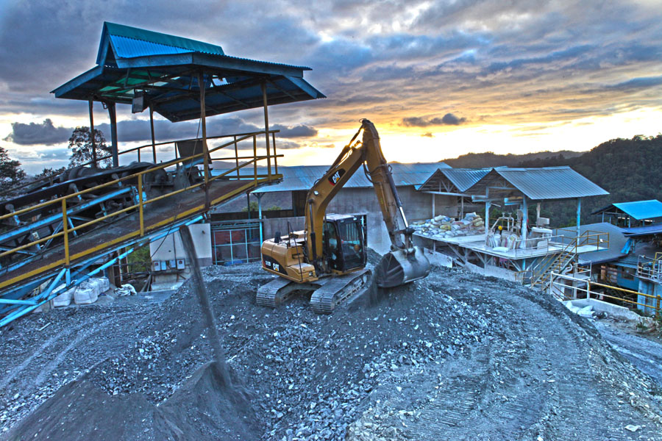
Operational efficiency. Dusk falls on TVIRD’s plant, which processed a total mill feed of close to 1 million tons in 2012. Save for the processing plant, the company shut-off its energy consumption, joining millions worldwide in commemorating Earth Hour.

Siocon, Zamboanga del Norte / April 2013 In a rare show of solidarity, the Indigenous Subanon people in Canatuan switch-off their electrical lights as they joined TVI Resource Development Philippines Inc. (TVIRD) and millions of people in more than 150 countries in the world in celebration of earth hour to fight the threat of global warming and raise awareness on climate change.
The celebration plunged into darkness in this tiny Subanon village for an hour-long symbolic show of support for conserving the planet’s energy resources.
“It was a collective action that showed heightened awareness on the over-consumption of electricity that environmentalists often said as one cause of global warming,” Nilda Callora, TVIRD’s manager for the Environment Department said.
Callora added it was the second time the people of Canatuan and TVIRD joined the activity started by the World Wide Fund for Nature in Australia seven years ago. During every earth hour celebration, households and businesses are encouraged to turn off their non-essential lights to conserve resources.
As darkness enveloped Canatuan, Assistant General Manager Germidas Laspinas along with several employees led by Callora and Human Resource Superintendent Joyce Palpal-latoc, together with businessmen from the province of Zamboanga del Sur and Pagadian City, gathered together around a bonfire and discussed issues affecting the environment.
“We are used to blackouts in Pagadian City. But this celebration calls for everyone to join and make a difference even in our small ways to protect our Planet,” Merlou Quisumbing, president of the Philippine Chamber of Commerce and Industries (PCCI)-Pagadian City and Zamboanga del Sur commented.
That very hour, only TVIRD’s Processing Plant and health Clinic were lighted.
Earlier, Callora said during a presentation to the visiting businessmen said her department has now planted more than 360 thousand trees as part of the company’s environmental protection program. This number is five times more than the number of trees affected by TVIRD’s operations, according to her.
Canatuan hosts TVIRD’s copper-zinc mining operations and was previously a haven of illegal miners who flocked to this once gold-rush area in the mid 90’s. Rampant cutting of trees denuded its forest while Lituban and Siocon rivers, two of Siocon town’s biggest rivers, were heavily contaminated with mercury and toxic chemicals.
“Canatuan is different from what it was five years ago. We did not see lines of trees standing like what we see today,” said Bonifacio Patoh, former barangay chair of Tabayo, mother barangay of Canatuan.
Progressive rehabilitation
Callora said that her department is adopting ‘progressive rehabilitation’ as a strategy to rehabilitate and re-green the areas affected by the mining operation.
“This means, mined out areas turned-over to us by the Mines Department are planted with trees. We have nurseries filled with seedlings of fast growing trees and the endemic species in the area,” she said.
She shared that the company’s mining concession area or the so-called Mineral Production Sharing Agreement (MPSA) area totaled only 508 hectares.
“However, TVIRD has only disturbed about 225 hectares and has rehabilitated151.43 hectares as of as of Jan. 2013,” she said.
Water quality monitoring
Callora also emphasized that her department is also looking after the quality of water bodies in the mine site, including tributaries to Siocon and Lituban rivers.
“Everyday we are monitoring it. We also have the Multi-partite Monitoring Team (MMT) that monitors the quality of waters in all our sampling stations. This government mandated body, which has Subanon members meets regularly and sends water samples to a third party laboratory so its result will not and cannot be influenced by other members of the team.”
She disclosed that one of the best features of the environmental protection program of the company is its Sulphide Dam Tailings and Impoundment facility, a structure built by the company at a cost of more than Php750 million.
“This tailings impoundment acts as a detention facility and designed to operate under a probable maximum flood event having a maximum rainfall of 1,635 millimeter in 24 hours. It also traps watershed sediment from disturbed areas and prevents it from continuing downstream. It is also designed to stand an 8.5 magnitude earthquake and equipped with instruments that detect seepage and movements inside the structure,” she said.
TVIRD is the first foreign invested mining firm that reaches production stage following the approval of the 1995 Mining Act. It is consistent recognized for environmental protection and in upholding the safety, health and rights of its employees and surrounding communities from government and private entities.
*******
Press photos:
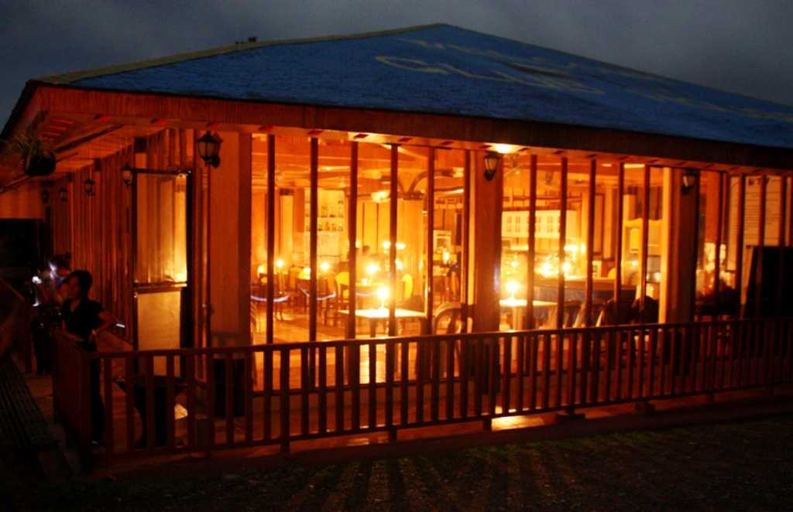
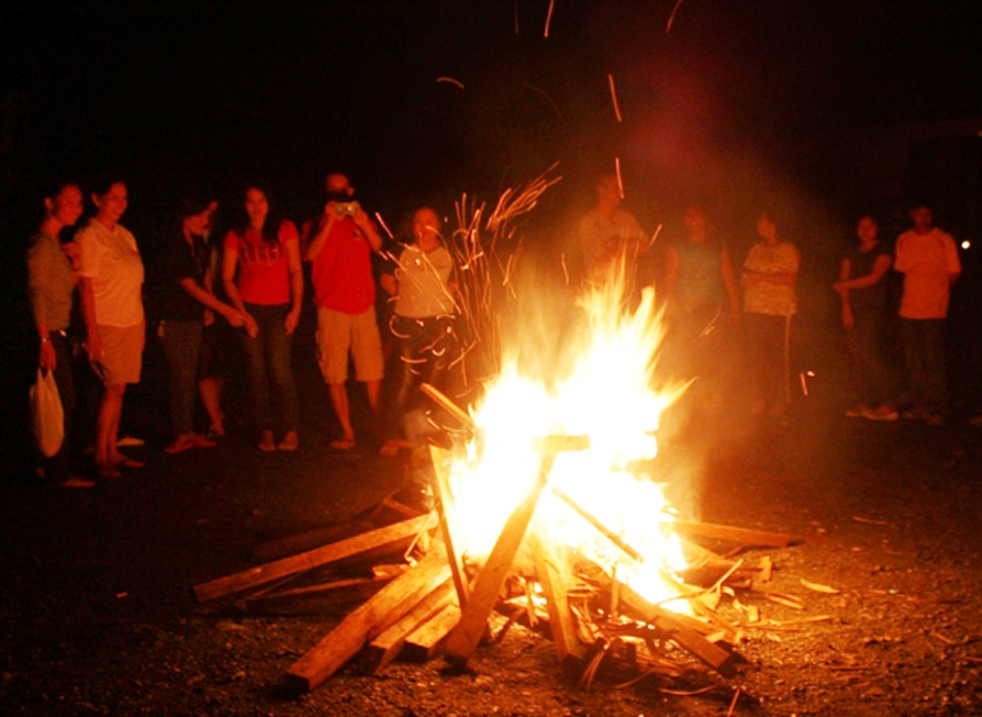
- (Top to Bottom): TVIRD's Clubhouse flickers in the darkness. The Earth hour celebration plunged the tiny Subanon village into darkness for an hour-long symbolic show of support for Mother Earth. Employees, together with businessmen from the province of Zamboanga del Sur and Pagadian City, gathered together around a bonfire and discussed issues affecting the environment.

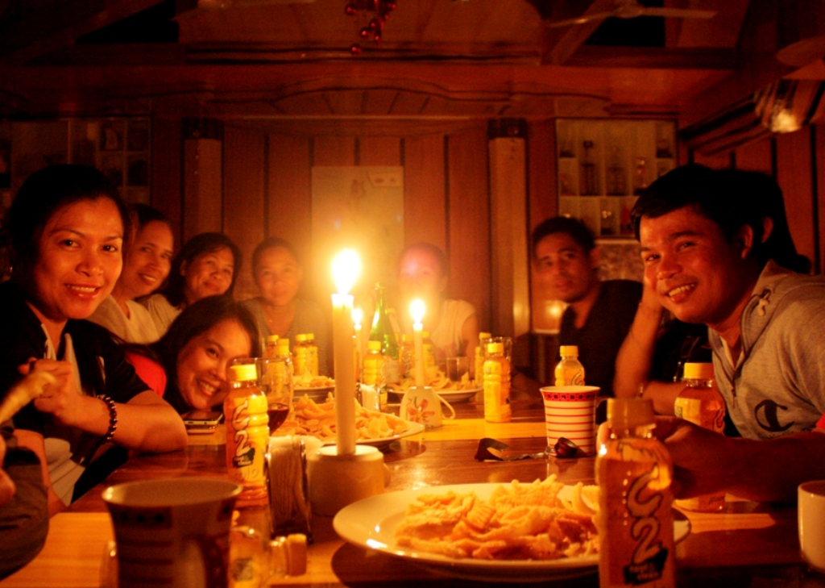

- Employees and guests share a candlelight dinner at the company's clubhouse.

About TVI
TVI Resource Development (Phils) Inc., is the Philippine affiliate of TVI Pacific Inc. (TSX: TVI), a publicly-listed Canadian mining company focused on the exploration and production of precious and base metals from district scale large system, high margin projects located in the Philippines and Papua New Guinea.
We are committed to exploration and mining practices that promote transparency, responsible stewardship of the environment, and the inalienable rights to life, dignity, and sustainable development of our host communities.
Connect with us: www.tviphilippines.com

For media queries:
Lullie A. Micabalo
Public Affairs Manager
TVI Resource Development (Phils) Inc.
Email: lullie.micabalo@tvipacific.com.ph
Mobile: +63 917 883-7074

