Good Roads for Peace and Progress
Revitalizes agricultural trade in the Municipality of Tungawan

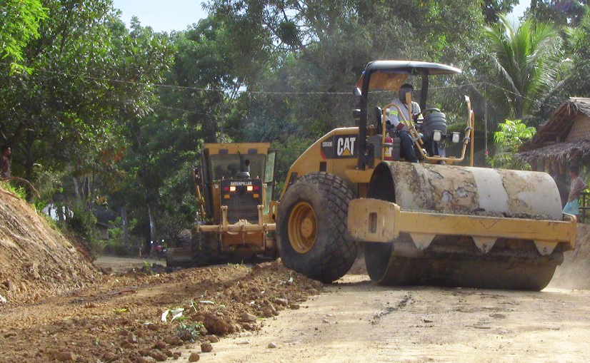Tungawan, Zamboanga Sibugay / March 2013 – “Good roads, like peace, are indispensable to humanity. These are pre-requisites for development! We sincerely thank TVI for these, our constituents are now benefiting from it.” With these words, Mayor Randy Climaco, of this town, ended his short speech in front of his barangay captains and several townsfolk who recently gathered in Gaycon, an upland village in Tungawan, Zamboanga Sibugay.
Tungawan is a neighboring town of Canatuan, in Siocon, Zamboanga del Norte – the copper-zinc mine site of TVI Resource Development Philippines Inc. (TVIRD), local affiliate of Canada’s TVI Pacific Inc. A 3rd class municipality, Tungawan is inhabited by Christians, Subanons, and Muslims.
The mayor, along with Vice Mayor Raup Arbison and several of his barangay captains were in Gaycon to inspect the almost completed 59.2-kilometer farm-to-market roads being repaired by the Civil Engineering Services group of TVIRD. The project was implemented through the Public-Private Partnership (PPP) scheme of President Aquino.
“Traders were apprehensive to come up and buy our vegetables and rubber latex because of our terrible roads,” according to Barangay Secretary Wilfredo Saldua, of Barangay San Isidro, which is a recipient of the project. The roads used to be narrow, rough and muddy with countless big and small potholes, he said.
The repair of Tungawan’s upland roads added to the already serviceable 66.6-kilometer farm-to-market roads in the municipality of Siocon and adjacent town of Baliguian town that are also rehabilitated by TVIRD during the first two months of the year.
Revitalizing local economy
“Our newly-repaired roads have made our barangays more accessible to traders from Zamboanga City in the South of the Peninsula and Dipolog City up in the North. It revitalizes our economy, especially our agriculture,” Mayor Climaco said.
The mayor disclosed that traders from the cities of Zamboanga, Dipolog and Ipil had begun flocking his hinterland barangays to purchase vegetables, bananas and rubber latex.
“Traders from Zamboanga and Dipolog come up twice a week, while Ipil traders come here once a week. These made our farmers happy. Of course, the brisk sales of farm produce are attributed to the rehabilitated roads,” he adds.
“For the past 25 years, my barangay has not experienced road repairs. It is only now that we have TVI as our neighbor that it (experienced) repairs and rehabilitation,” a visibly happy Barangay Captain Benjamin Sumbrana of Sisay reports.
Beaming with pride, the 3-time village chief added by saying, “If we have to thank God for the rains that make our plants and vegetables grow, we have to thank TVI 100% for these roads.”
Public-Private Partnership
Mayor Climaco also expresses appreciation to President Aquino’s PPP scheme.
“The partnership forged between the local government and TVI shows that more can be done for the community and much more if there is unity between the private sector and government. Thanks to TVI and many thanks to Engr. Nercuit for these.”
Last December, TVIRD through Community Relations and Development Manager Joel Alasco met with Mayor Climaco who then requested for assistance to repair the town’s farm-to-market roads. He also proposed the PPP as a scheme to implement the project.
According to the agreed scheme, TVIRD will shoulder the cost of fuel and labor while the local government will shoulder the rental of heavy equipment that will be used for the duration of the project. The barangay captains were tasked to facilitate in order that Nercuit’s construction crew will have easy access to the project site.
As of February, the company provided some Php6.3 million in support of the project, which started the previous month. The local government placed a counterpart Php5.0 million pesos for the joint project.
“Had the LGU spent for the repair alone, our Php11.0 million budget for road rehabilitation would surely not be enough,” the mayor said. “With the amount that we save, we can pour in more projects for our constituents.”
Mine life extension
By the end of 2013, TVIRD will conclude its mining operations in Canatuan. Just a few kilometers trucking distance from its current mine pit, however, is Malusok – property of the Subanons who already gave their consent for the company to mine the area. The said property is within the contract area of the Application for Mineral Production Sharing Agreement (APSA23) that TVIRD filed with the Mines and Geosciences Bureau (MGB) in December 1997. TVIRD subsequently requested the MGB to allow the company to expand its mining operations to the adjacent APSA23 in November 2012 in order for it to develop additional potential resources in the Malusok property. To date, the agency has yet to issue its approval.
Despite the impending end of mine life, Soliling Onsino Mato, one of the tribal leaders of the Subanons, is still hopeful that the company can continue its mining operation in his homeland.
“We are hopeful that mining will continue in our lands. Because as always, we will take an active role so government will hear our plea for TVI to continue its operation. We will not stop until government listens to us because it is our avowed duty to alleviate our tribe from poverty and this can be achieved only with TVI here.”
In view of the lifted government moratorium on new mining applications, TVIRD has reason to be optimistic that it will be able to tap additional mineralized prospects in Malusok which can potentially extend its mine life. This will also better ensure the continued delivery of social services as well as the company’s sustainability initiatives and environmental programs.

*******
Press photos:
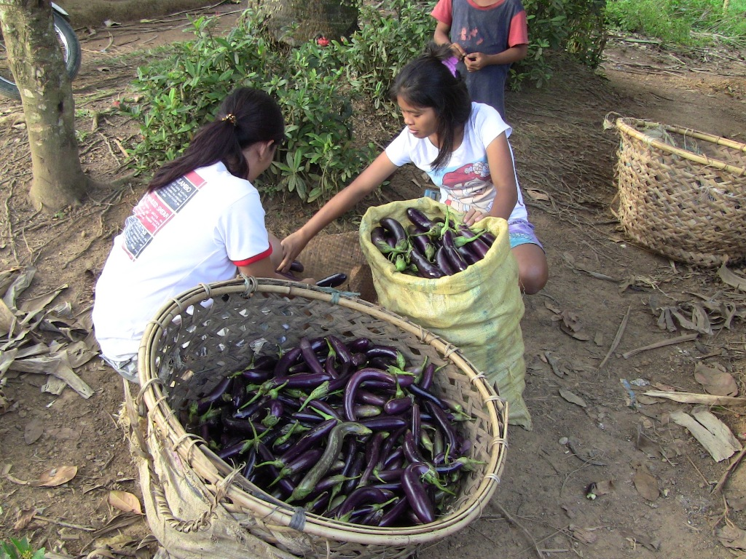
- Mobilizing livelihood. Tungawan women prepare vegetables for transport to the town's market. Farmers will greatly benefit from the rehabilitated roads as they can now conveniently bring their agriculture products to the town center.

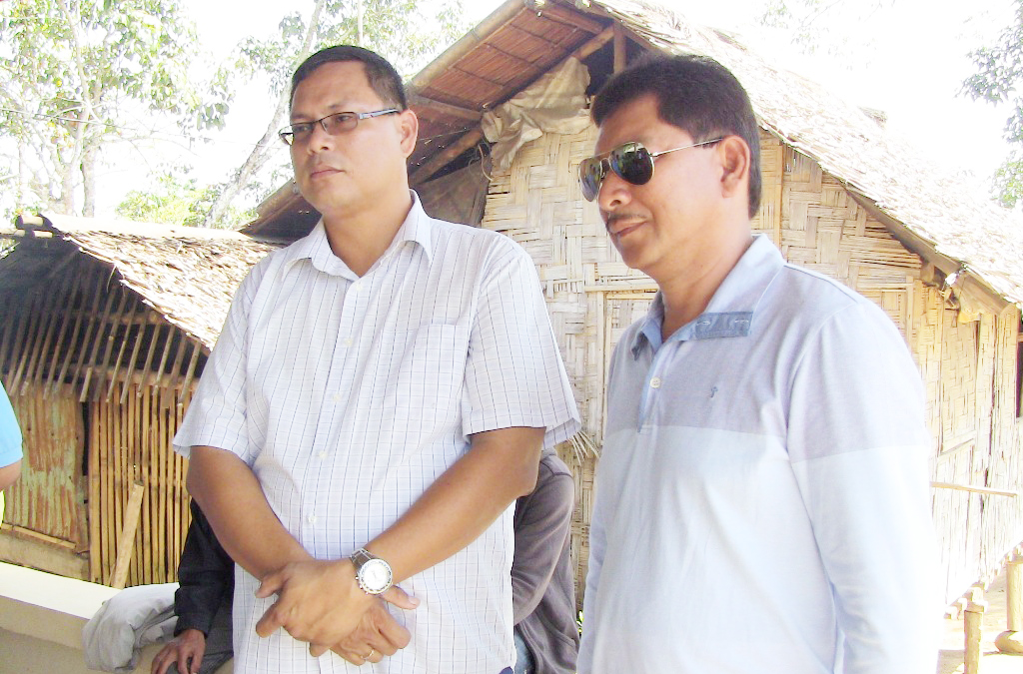
- Partners for peace and progress. (Left and Right, respectively): Tungawan Mayor Randy Climaco and TVIRD Engineering Services Manager Engr. Ed Nercuit. The partnership of the two will bring peace and progress to Tungawan. (Below): With local officials of the municipality and TVIRD crew moments before the road rehabilitation across Tungawan has formally began.

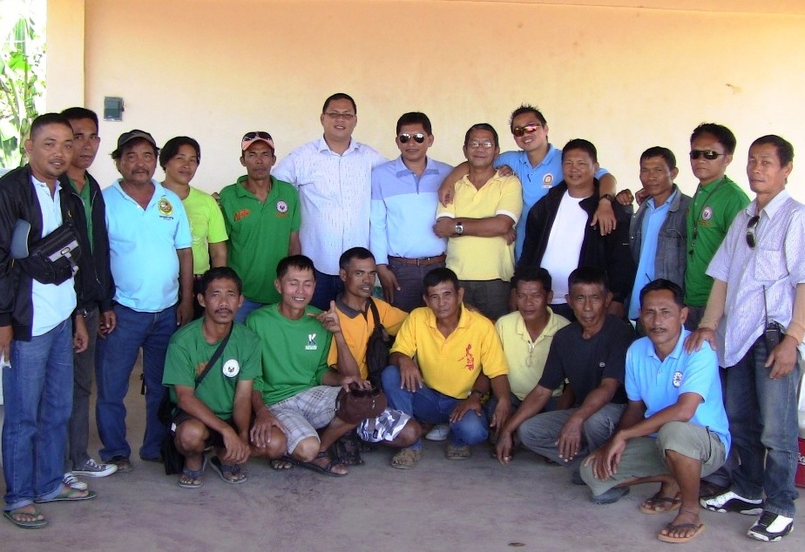

About TVI
TVI Resource Development (Phils) Inc., is the Philippine affiliate of TVI Pacific Inc. (TSX: TVI), a publicly-listed Canadian mining company focused on the exploration and production of precious and base metals from district scale large system, high margin projects located in the Philippines and Papua New Guinea.
We are committed to exploration and mining practices that promote transparency, responsible stewardship of the environment, and the inalienable rights to life, dignity, and sustainable development of our host communities.
Connect with us: www.tviphilippines.com

For media queries:

Lullie A. Micabalo
Public Affairs Manager
TVI Resource Development (Phils) Inc.

Email: lullie.micabalo@tvipacific.com.ph
Mobile: +63 917 883-7074

