TVI Pacific Announces 2012 Results at HK Mining Expo
Remains confident in the Philippine mining industry

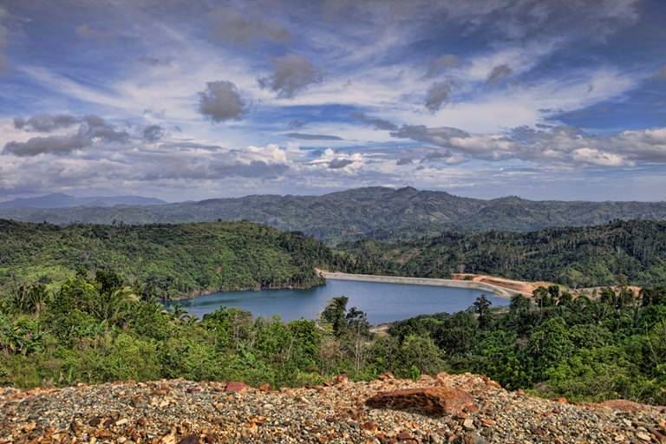
At the crest. The Canatuan mine tailings impoundment dam of TVIRD, Philippine affiliate of TVI Pacific Inc., took the company five years and over Php850 million to build in order to prevent harmful wastes from contaminating the vast rice lands of Siocon below. It is designed and built to withstand a tremendous amount of rainfall and seismic activity to safeguard the environment – testament to a world-class design coupled with the local ingenuity of its Filipino engineers. Chairman and CEO Clifford M. James provides an overview of the company’s 2012 results, which have been generated through the same collaborative synergy.

Hong Kong / March 2013 – TVI Pacific Inc. (“TVI”) Chairman and CEO Clifford M. James last week announced the company’s full-year 2012 financial and operational results to investors, entrepreneurs, brokers and investment analysts at the premier Mines and Money exhibit held at the Hong Kong Convention and Exhibition Center. The executive also segued into an overview of the company’s diverse portfolio of medium to long-term projects, primarily in the Visayas and Mindanao regions in the Philippines, and Papua New Guinea. He presented the company’s approach – through its local operating affiliate, TVI Resource Development Philippines Inc. (TVIRD) – to generating revenue from various commodity sources, particularly copper, zinc, high iron laterite, limestone, nickel and pyrite from mineral-rich deposits in the country. Held annually in Hong Kong, Mines and Money is a platform for mining companies worldwide to raise capital in Asia. This year, the exhibition received over 3,500 participants during its five-day run.
“TVI remains confident in the Philippines and the local mining industry,” according to James. “Testament to this is TVI’s strong corporate presence in the country through its local affiliate and its faith in the proven operational capability of its management team, which is almost entirely Filipino,” he said.
Given the government’s lifting of its two-year moratorium on new mining applications, James is confident as well that that it will be consistent in its implementation of the law. Recent developments have sent a positive signal to both local and foreign investors alike that the Philippine government intends not only to reorganize the industry but to also revitalize it.
Financial results
In accordance with International Financial Reporting Standards (IFRS) and Canadian securities regulations, James announced full-year net revenues of US $77.1 million generated through the company’s sale of copper and zinc concentrates from its Canatuan operations, of which net income before tax is $6.0 million. 2012 revenue was affected by a lower average copper price of US$3.60. After taxes, net income stands at US $5.3 million, up by 53.9 percent from the previous year.

The company’s cash balance for the year ended December 31, 2012 stands at $16.0 million; notwithstanding the settlement of the Rapu Rapu Net Smelter Return (NSR), which will further augment cash by a net minimum agreed $3.3 million due to TVIRD for the period through to December 31, 2012 but not yet collected, further strengthening the company’s position to invest in growth projects. Meanwhile, short term debts are at $9.9 million or a 38.9 percent reduction from the previous year’s $16.2 million.

Mining, milling and other expenses for the year were at $48.6 million, which were lower compared to the $48.8 million incurred in 2011. This, despite the 5 percent increase in the volume of copper shipped in 2012 versus previous year. Improved metal recoveries contributed to a 7% increase in metal production in 2012 and, combined with a lower consumption of chemicals required for processing, resulted in lower production cost per unit and expanded the Canatuan’s plant’s track record as a low cash cost producer.

2013 Outlook: a diverse portfolio of projects
Since 2004, the company has operated its Canatuan copper-zinc mine. This year, as it winds-up operations on its initial ore body, it also realizes potential discoveries - additional mineralized prospects in nearby Malusok which can potentially extend its mine life. Likewise, it is also set to implement the development of its Balabag gold-silver project in Zamboanga del Sur, pending the DENR’s issuance of its Environment Compliance Certificate (ECC) and on which it projects some 50,000 gold ounces per year beginning in 2014. This development is fortified by a nonbinding term sheet with Metrobank for a US $20 million term loan facility coupled by a $3.0 million letter of credit.

Joint venture projects with Mindoro Resources Ltd. (MRL) and Minerals Production Sharing Agreement (MPSA) holder, Minimax Mineral Exploration Corporation are also expected to come on-stream beginning in the second half of the year. These projects are geared towards the production of direct shipping ores (DSOs) high iron laterite, limestone and pyrite as well as the establishment of a nickel processing plant in Agusan del Norte by 2015. Plant construction is valued at less than $100 million. In all of the joint venture projects, TVIRD reserves the option to assume a majority 60% interest and will act as operator.

Finally, through its relationship with Foyson Resources Ltd., TVI Pacific Inc. also pursues the development of its Papua New Guinea assets, focusing primarily on Amazon Bay as a very large potential resource, particularly mineral sands containing iron, vanadium and titanium. TVI also has interests in copper, moly, gold porphyry and silver through its share ownership position in Foyson.

Press photos:
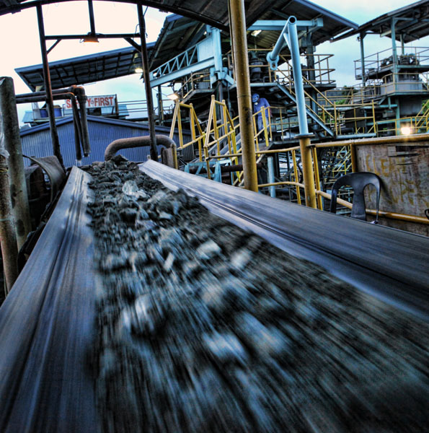
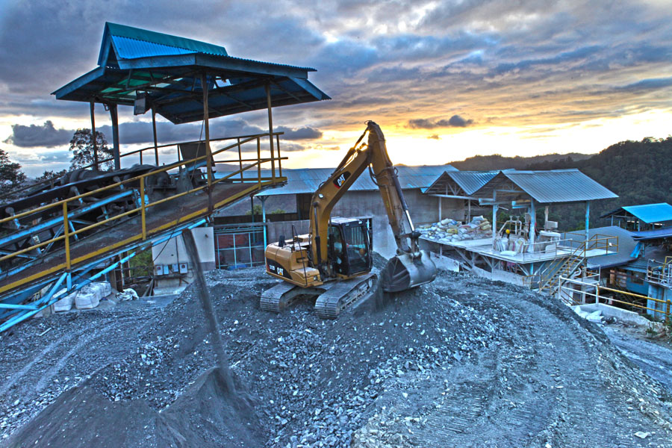
- Operational efficiency. The average daily throughput for the year ended December 31, 2012, was 2,645 dry metric tons for a total mill feed in the year of 968,069 tons. TVI is currently targeting through 2013 an average daily throughput of 2,600 dry metric tons.


- Sustainable development. Responsive education, health and sanitation, livelihood, and infrastructure comprise TVI’s four quadrants of development, which is guided by the United Nations Millennium Development Goals. These run parallel with Environmental Management and Protection and Human Resources Development programs. Canatuan Public Elementary and Secondary School, which is supported by TVI, presently has a growing population of over 850 students.

About TVI Pacific Inc. (TSX:TVI) (OTCQX:TVIPF)
TVI Pacific Inc. is a Canadian resource company focused on the production, development, exploration and acquisition of resource projects in the Philippines and Southeast Asia. The Company produces copper and zinc concentrates from its Canatuan mine and is advancing its Balabag Gold-Silver project towards production in 2014. TVI is a partner/operator in several joint venture projects in the Philippines and Papua New Guinea and also has an interest in an offshore Philippine oil property.

Yulo Perez, Chief Operations Officer, TVIRD, a qualified person as defined by NI 43-101, has approved the scientific and the technical information contained within this press release

For media queries:

Kaycee Crisostomo
Senior Manager - Public Affairs
TVI Resource Development (Phils) Inc.

Email: kaycee.crisostomo@tvipacific.com.ph
Phone: +63 2 728-8491 ext. 103
Mobile: +63 917 579-1528
Fax: +63 2 728-8515

