TVIRD, ZAMSURECO Lead Village Electrification
Lighting-up 520 households in nine villages that span three towns
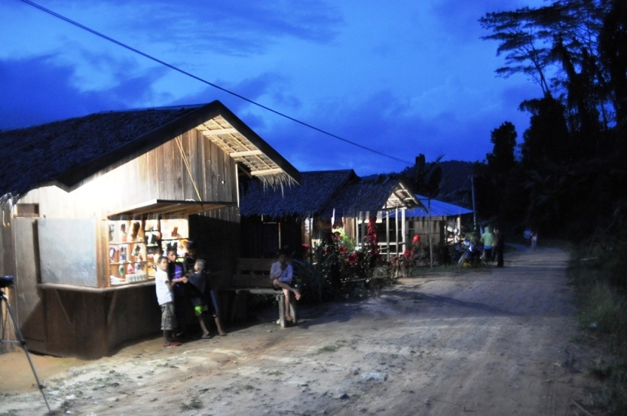
Households in Solonsangan village in the vicinity of TVIRD’s mine plant enjoyed electricity for the first time through the company’s generator sets. As the company is scheduled to conclude mining operations on its current orebody by the end of 2013, electricity will continue to be provided, but this time coming from power producer ZAMSURECO II (Zamboanga del Sur Electric Cooperative). Solonsangan is one of the 9 villages now provided with electrical power through President Aquino’s Sitio Electrification Program.

Siocon, Zamboanga del Norte / March 2013 - Residents of Canatuan, municipality of Siocon, Zamboanga del Norte and eight (8) neighboring villages, together numbering about 520 households, can now enjoy continued electricity as TVI Resource Development Philippines Inc. (TVIRD) and Zamboanga del Sur Electric Cooperative (ZAMSURECO II) light up the communities along the stretch of road linking the towns of RT Lim, Siocon and Baliguian. The thoroughfare itself will also finally be illuminated by lamps using electric power.
The electrification project was realized through the concerted effort of the Subanon leadership and TVIRD, and with the final stamp of approval and financial allocation of President Benigno Aquino III. The recent development finally delivered on the communities’ long anticipated wishes of having electricity in their isolated villages. The primary objective of the company to initiate the electrification of the villages near its mining plant was driven further by the President himself under his “Sitio Electrification Program.”
Beginning 2004, communities surrounding the company’s plant and offices have been provided with electricity by the company through its generator sets. As the company is expected to conclude mining operations on its current orebody by the close of the year, notwithstanding potential mineralized prospects in nearby Malusok, the air of uncertainty on the community’s power supply raised concern.
Switching-off from generators
In a ceremonial “switch-on” program attended by Subanon elders, company officials, LGU representatives and officials from ZAMSURECO II, Subanon residents in Canatuan expressed their gratitude for having received the benefits of electric power in their communities.
“We’ve been dreaming about this, considering that the company will soon leave and surely we’ll be back to darkness if there is no power from the electric cooperative,” said Zenaida Dandana, a Subanon resident of Canatuan.
“Everything wouldn’t have been possible without the help of the company TVIRD, who did all the groundwork to realize the project,” according to Barangay Tabayo Chairperson Susana Davi, in her speech during the switch-on ceremony. She likewise recognized the effort of Subanon Chieftain Timuay Jose Anoy who first sent a letter of request to President Aquino.
Spadework delivers results
Previously, TVIRD’s community relations office gathered all the data and surveys related to the project and likewise sought for the endorsements from Congress. It also facilitated the Free, Prior and Informed consent from the Subanons who reside in their ancestral domain.
”Ayaw naming mangangapa kayo sa dilim kung wala na kami,” (We don’t want you to be groping in the dark when we leave),” according to TVIRD Assistant General Manager Engr. Germidas Las Pinas, saying that one of the company’s legacies is to leave Canatuan and the surrounding communities a better place.
ZAMSURECO II Board of Director Edsel Sichon informed that the President has allocated PhP 23 million for the electrification of the said villages. These are Z-Gold, Mambong, Paduan, Solongsangan, Canatuan, Malusok, Sitio Ocho, Busicong and Nonoyan.

Since 2004, TVIRD has operated its gold-silver project in Canatuan, which eventually shifted to copper and zinc mining. It has since forged economic progress and community development through its sustainable livelihood and environmental management programs.
*******
Press photos:
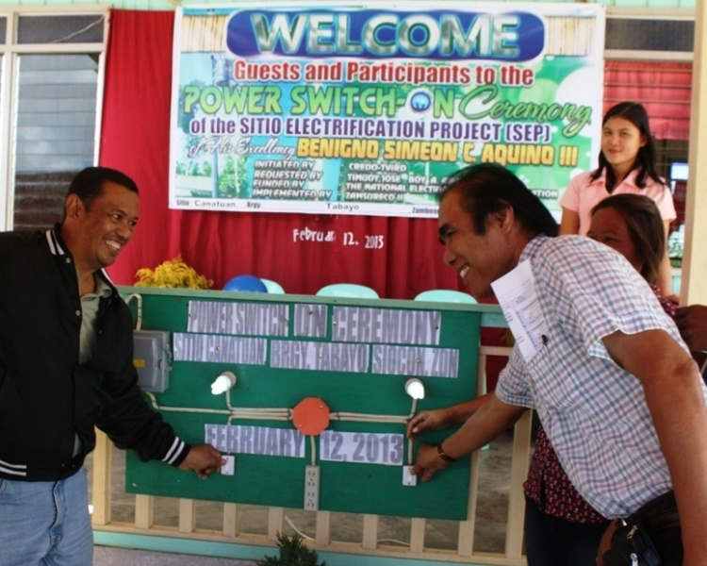

ZAMSURECO II Board of Director Edsel Sichon and TVIRD Asst. General Manager Germidas Las Pinas simultaneously switch-on the power switchboard symbolizing the electrification of Canatuan Village.

About TVI
TVI Resource Development (Phils) Inc., is the Philippine affiliate of TVI Pacific Inc. (TSX: TVI), a publicly-listed Canadian mining company focused on the exploration and production of precious and base metals from district scale large system, high margin projects located in the Philippines and Papua New Guinea.
We are committed to exploration and mining practices that promote transparency, responsible stewardship of the environment, and the inalienable rights to life, dignity, and sustainable development of our host communities.
Connect with us: www.tviphilippines.com

For media queries:

JOSEPH ARNEL C. DELIVERIO
Public Affairs Officer
TVI Resource Development (Phils) Inc.
Public Affairs Department
Canatuan Minesite
Canatuan, Siocon, Zamboanga del Norte

josepharnel.deliverio@tvipacific.com.ph
09177664205

