TVIRD Secures US$23M Financing for its Balabag Project

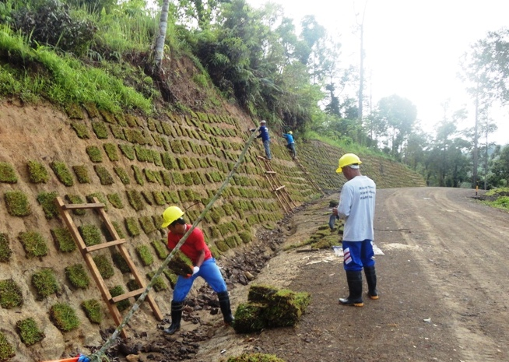
All set and ready. Crew under the TVIRD’s Civil Engineering Services Department conducts landscaping works in the area along the newly-constructed 10-kilometer all-weather access road to Sitio Balabag, town of Bayog in Zamboanga del Sur – site of TVIRD’s gold-silver project.

Manila / March 2013 - TVI Resource Development Philippines Inc (TVIRD), local affiliate of Canada-listed TVI Pacific Inc. (TSX:TVI), has signed a nonbinding term sheet with Metropolitan Bank and Trust Company (Metrobank) for a US $20 million term loan facility for its Balabag gold-silver project, located approximately 75 kilometers from the company’s Canatuan mine in Zamboanga del Norte. Metrobank previously provided debt financing to TVIRD for its Canatuan Mine, all of which has been fully repaid. Metrobank is the country’s second largest bank in terms of assets.

The purpose of the Facility is to support the development of the proposed Balabag Mine by providing TVIRD with additional working capital funding for construction and commissioning as well as mining and processing activities.

The Term of the Facility is three (3) years and provides for a one (1) year grace period before repayments are to commence, spread equally over eight quarterly periods, beginning at the end of the 5th quarter. The interest rate of the Facility is to be set at 90-day Libor plus 250 basis points (approximately 3%), to be fixed on a quarterly basis.

The Facility is accompanied also by an additional US $3 million Letter of Credit (LOC), available to TVIRD for a 180 day period at the prevailing market rate.

The Facility and LOC contemplate that the obligations of TVIRD under those instruments will be secured by the Balabag off-take agreement and Balabag Mining Production Sharing Agreement (MPSA), a Continuing Surety Agreement to be provided by the company, the equipment and facilities at Balabag, and a US $5 million deposit that will be releasable upon the Balabag mine site moving into operation.

"We are pleased to conclude these financing discussions with Metrobank and to be provided the opportunity to move forward with Balabag once the remaining required permits are received. With the Term Sheet, we have addressed a further integral step in our efforts to establish commercial production at our Balabag Gold project,” according to TVI Chairman and CEO Clifford M. James.

Balabag Project Status
TVIRD continues to be successful towards advancing its Balabag project and is now targeting plant construction by the second half of this year followed by its first dore production by the 1st quarter of 2014. Among the recent significant developments include the removal of all the remaining illegal miners from the property, following the government’s strong-willed multi-agency implementation of the Cease and Desist Order issued by the Department of Environment and Natural Resources (DENR) and enforced by the Provincial Government, the Mines and Geo-Sciences Bureau (MGB), the Environmental Management Bureau (EMB), the Philippine National Police (PNP), the National Bureau of Investigation (NBI) and the Armed Forces of the Philippines (AFP) in October last year.

This development was followed by a renewed and more massive manifestation of support from 26 out of 28 barangays – almost the entire town of Bayog, Zamboanga del Sur – together with leaders of indigenous Subanen residents. Presently, the company continues the mobilization of Community Relations and Development Programs.

The company resumed its exploration drilling program in January 2013, enabling it to continue its in-fill and extension assessment of the ore body. In February, the EMB technical review committee endorsed the company’s Environmental Impact Statement (EIS) to the DENR office for the approval and issuance of the Environmental Compliance Certificate (ECC). The Declaration of Mining Project Feasibility document package is expected to be completed by the second quarter 2013 following the approval of the ECC.

As part of its pre-development work, TVIRD completed a 10-km all-weather access road to the mine as well as plant design and equipment sizing, which was part of an update of the internal feasibility study that was previously submitted to the MGB.

TVIRD is MPSA holder of the 4,779-hectare Balabag property and is authorized by the government to operate its gold-silver project in the Sitio once overwhelmed by illegal mining operations for more than two decades. These illegal mining operations used environmentally-harmful methods, avoided paying taxes to the government, employed children as laborers and did not provide social development projects as required by the mining laws. Moreover, these have also created numerous geohazard areas with a high probability of potential landslides and continued soil erosion, which have caused a number of casualties.
The company is set to implement the roll-out of the same successful business model in Bayog as well as its sustainable social and environment programs, pending the DENR’s issuance of its ECC and the establishment of more viable mining policies.
*******

About TVI
TVI Resource Development (Phils) Inc., is the Philippine affiliate of TVI Pacific Inc. (TSX: TVI), a publicly-listed Canadian mining company focused on the exploration and production of precious and base metals from district scale large system, high margin projects located in the Philippines and Papua New Guinea.
We are committed to exploration and mining practices that promote transparency, responsible stewardship of the environment, and the inalienable rights to life, dignity, and sustainable development of our host communities.
Connect with us: www.tviphilippines.com

For media queries:

Kaycee Crisostomo
Senior Manager - Public Affairs
TVI Resource Development (Phils) Inc.

Email: kaycee.crisostomo@tvipacific.com.ph
Phone: +63 2 728-8491 ext. 103
Mobile: +63 917 579-1528
Fax: +63 2 728-8515

