TVI-Kennemer Partnership Shores up Livelihood in Canatuan, Zamboanga del Norte
Joint agri-enterprise aims to bolster sustainability of local mining community

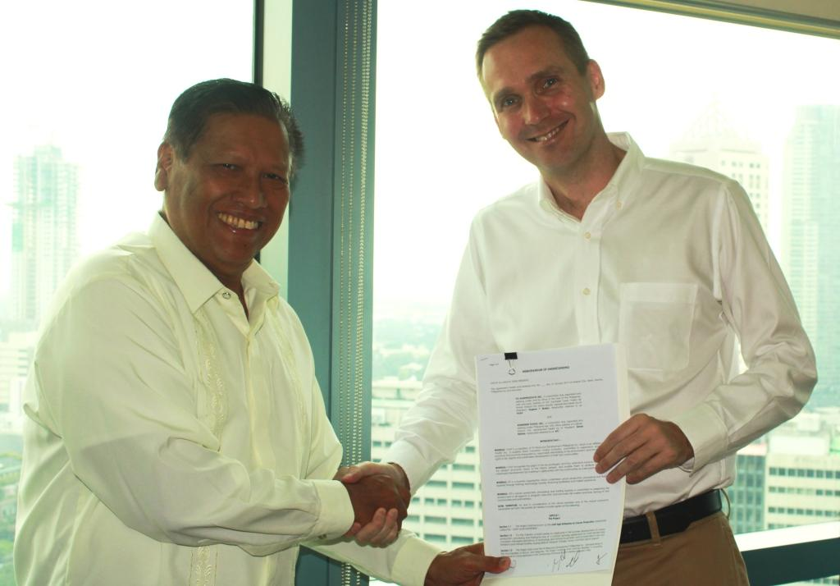
A new partnership. TVIRD President Atty. Eugene T. Mateo formalizes a Memorandum of Understanding with Kennemer Foods Inc. President Simon Bakker.
Manila / January 2013 – TVI Agriproducts Inc., wholly-owned subsidiary of TVI Resource Development Philippines Inc. (TVIRD), and contract farm operator Kennemer Foods International (KFI) recently signed a Memorandum of Understanding geared towards the creation and establishment of a joint agri-enterprise for Cacao production via company-managed plantations in the municipalities of Siocon and Baliguian in Canatuan, Zamboanga Del Norte. The 50:50 joint agri-enterprise is hinged on contract growing agreements for small farmers, technology and knowledge transfer, and capital investments for infrastructure and equipment. The memorandum of understanding was signed by both companies at TVIRD’s Makati headquarters.
“Our partnership with Kennemer comes at an opportune time that TVIRD is winding-up its mineral processing operations in Canatuan,” said TVIRD President Atty. Eugene T. Mateo. “We are confident that this cooperation will further improve the economic condition of our local community members who are also our key partners in this endeavor.”
As the first local company to operate under the Mining Act of 1995, TVIRD has introduced livelihood programs to the community as part of its corporate social commitments, which include skills development and capacity building. The recent joint agri-enterprise is its most aggressive initiative to date and is set to provide the immediate community with a sustainable enterprise beyond the life-of-mine. The company also has interests in neighboring Balabag and in Agusan Del Norte.
“Kennemer and TVI both believe in fostering partnerships. Our knowledge in the production and trade of Cacao also dovetails with TVI’s resolve to imbibe sustainable livelihood on its host community. I welcome this partnership,” according to KFI President Simon Bakker. Kennemer’s proven track record in Cacao production and processing via contract growing agreements with Filipino farmers merits its credibility in promoting fair market practices with host communities.
Under the agreement, both companies shall undertake the development of plantations through consolidated landholdings either through lease or revenue sharing agreements together with individual farmers and lot owners and recognized indigenous peoples communities. Each plantation will have a consolidated area of no less than 100 hectares within the ancestral domain of the Subanons – TVIRD’s indigenous hosts - and nearby areas. The agreement also specifies the development of contract growing agreements with the farmers wherein the Cacao produced from the plantations will be marketed and exported according to mutually-agreed terms of yield-sharing.
Knowledge and technology transfer
Based on a development roadmap culled from a study conducted by the University of Asia and the Pacific (UA&P), the subsequent project shall expand to a total of 1,600 hectares over four years, depending on available land, and at a financial internal rate of return of seven years.
Also according to the study, the project can generate close to 1,300 jobs for the local community or an additional 400 jobs if current TVIRD workers are absorbed by the joint venture company. It also projects to provide an estimated P100 million in wages annually.
The companies agree to combine resources, technology and knowledge on both trade and the local landscape: demographics, economic profiles, studies and other technical information that will contribute to achieving program objectives, which include conducting Information Education and Communication (IEC) programs to prepare and gain support and social license for the project. A key factor, according to the proponents, is continued dialogue with the local government from which it also aims to collaborate with.
Over the medium to long-term, earmarked capital expenditures include road construction, post-harvest facilities, buying stations, transport as well as storage and nursery facilities.
Protecting indigenous people, connecting industries
Given the territorial limits, the project undertakes to respect the inalienable rights of the indigenous Subanons that inhabit the area, particularly in the area of TVIRD’s Mineral Sharing Production Agreement (MPSA). The company has been operating for over a decade in Canatuan, the ancestral lands of the Subanon tribe, which is the biggest ethnic group in the Zamboanga Peninsula.
“TVIRD’s strategic foray into agribusiness with Kennemer underscores its corporate objective to sustain social services and job creation among its present beneficiaries. Moreover, it strengthens its social commitment - making good on a long-term promise made to the community,” said Atty. Mateo.

“Agribusiness is the natural direction given the geographic composition of the area. This is testament that mining, agriculture and other revenue-generating enterprises like tourism can coexist and actually support each other,” Mateo concludes.

*******

Press photos:
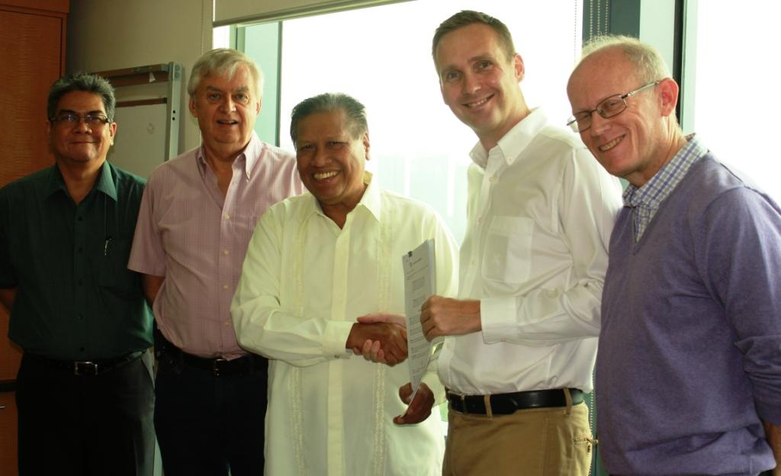
- Atty. Eugene Mateo and Simon Bakker are joined by (from L to R) TVIRD’s Corporate Social Commitments VP Renne Subido, Chairman Cliff James and Environment VP Jay Nelson.

- TVIRD Chairman Cliff James and Kennemer President Simon Bakker during the MOU signing at the former’s Makati headquarters.

About TVI
TVI Resource Development (Phils) Inc., is the Philippine affiliate of TVI Pacific Inc. (TSX: TVI), a publicly-listed Canadian mining company focused on the exploration and production of precious and base metals from district scale large system, high margin projects located in the Philippines.
We are committed to exploration and mining practices that promote transparency, responsible stewardship of the environment, and the inalienable rights to life, dignity, and sustainable development of our host communities.
Connect with us: www.tviphilippines.com

About Kennemer Foods International
Kennemer Foods International, Incorporated (KFI) is a producer and marketer of food and agricultural products. KFI specializes in growing and trading of high-quality agricultural crops, especially fermented cacao beans. KFI is committed to rural development by promoting market transparency, providing fair value pricing for produce and the implementation of sustainable farming practices. The Company’s products and programs encompass complete agricultural value-chain from planting materials, training, agri-technology to market.

For media queries:

Kaycee Crisostomo
Senior Manager - Public Affairs
TVI Resource Development (Phils) Inc.

Email: kaycee.crisostomo@tvipacific.com.ph
Phone: +63 2 728-8491 ext. 103
Mobile: +63 917 579-1528
Fax: +63 2 728-8515

