
N E W S R E L E A S E

Governor shuts down illegal mining operations,
supports TVIRD’s responsible mining

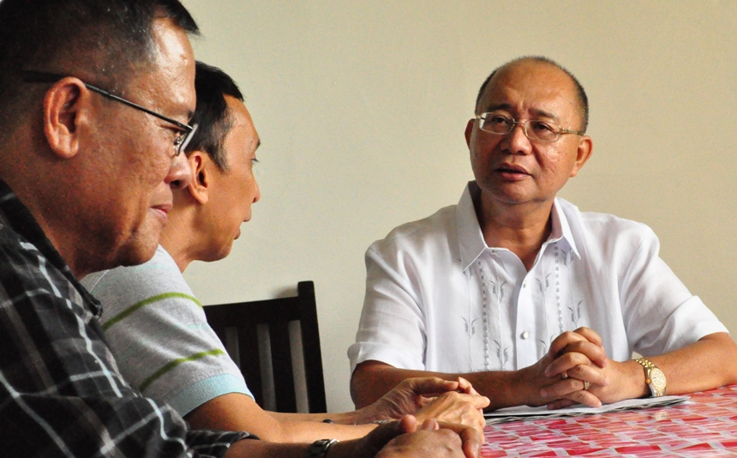
First order of business. Governor Palma (right) advises TVIRD Operations Vice President Jake Foronda and Canatuan General Manager Heliodoro Valmores (extreme left) that he suspended illegal mining operations in Diplahan, his hometown where he began his political career.

Ipil, Zamboanga Sibugay / July 2013 – Zamboanga Sibugay Provincial Governor Wilter Palma recently ordered the closure of all illegal mining operations in the province in a directive furnished to the provincial Environment and Natural Resources Office just a few days into Palma’s assumption as Sibugay’s highest official. The order stemmed from the unabated illegal mining operations in Barangay Guinoman in Diplahan town and Barangays Penaranda and Lacnapan in the municipality of Kabasalan. Provincial Administrator Nestor Gonzales said that the issuance of a comprehensive and permanent closure order is pending the governor’s consultation with all stakeholders in the province.

Palma told key officers of TVI Resource Development Philippines Inc. (TVIRD) that he has to stop illegal mining operations to protect the environment and Sibuguey River during the latter’s courtesy visit at the Provincial Capitol. The river is the source of water that irrigates thousands of hectares of rice lands in the towns of Imelda, Diplahan, Siay, Kabasalan, and Titay – the province’s rice granaries.
“I need to do it. I need to protect our river and seas for our farmers, fishermen and even fish pond owners,” Palma told TVIRD officials.
TVIRD, Philippine affiliate of Canada-based TVI Pacific Inc., has been operating its copper and zinc mine in Sitio Canatuan, town of Siocon in Zamboanga del Norte since 2004. This year, the company is winding down its current mining operations at the Sitio, which is home to more than 3,000 members of the Subanon tribe.
“The depletion of mineral ore by the last quarter of the year is the reason why the company is leaving Canatuan,” TVIRD Operations Vice President Jake Foronda told the governor. The executive also shared the company’s business roadmap for developing its gold-silver mine site in Bayog, Zamboanga del Sur – some 75 kilometers east-northeast of Canatuan.
TVIRD’s development in Sitio Balabag, town of Bayog, Zamboanga del Sur is already in its advance stage of exploration. The property spans the three provinces of the peninsula – Zamboanga del Norte, Zamboanga del Sur and Zamboanga Sibugay.
A pitch for responsible mining
“I am for responsible mining. In fact, I am supporting your activities in Balabag. My son even declined the illegal miners’ offer for him to lawyer them in the cases filed against them,” said the governor who is a lawyer by discipline.
Palma was visibly happy in meeting TVIRD officials and disclosed that illegal mining has endangered Sibuguey River and its tributary Guinoman Creek, which was made the ‘catch basin’ of tailings and chemicals for two decades. Water from the Creek that flowed directly into Sibuguey River found its way to the seas of Zamboanga Peninsula.
Social responsibility
Governor Palma said he was happy with what TVIRD accomplished in Bayog and even in Diplahan, his hometown where he previously served as mayor for three consecutive terms.
He likewise thanked the company for building a school in Sityo Malagak, a sub-village of Guinoman. TVIRD dedicated the project for the children of its resident farmers and Subanen lumads (native).
Prior to operating, TVIRD has invested some $25 million in exploration and pre-development work, including various community projects that benefitted barangay residents as part of its corporate social commitment. In 2012, it repaired farm to market roads, repaired drainage canals and entered into a public-private partnership agreement with the provincial government of Zamboanga del Sur for implementing a livelihood project for Bayog farmers. The company estimates an additional $25 million investment to bring its Balabag project to commercial operations.
*******
Press photos:

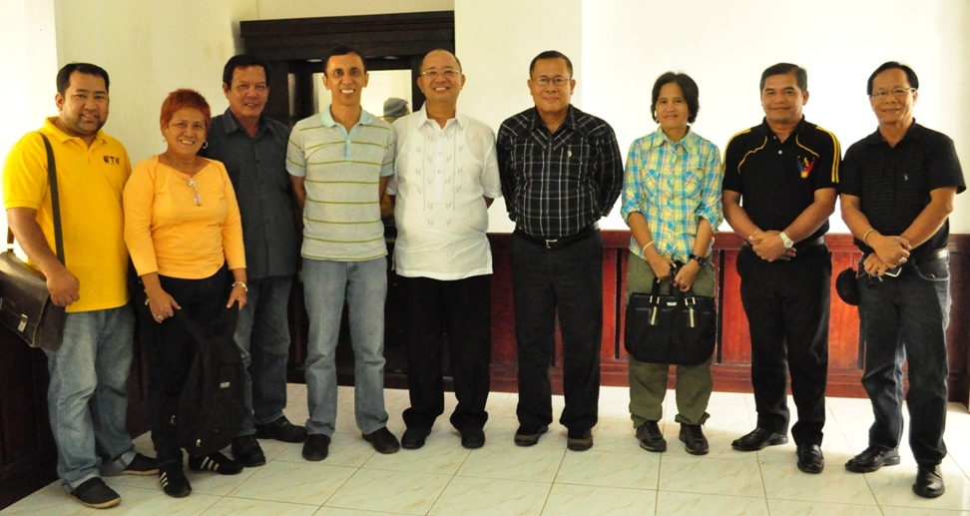

- Governor Palma is flanked by TVIRD’s VP Jake Foronda and GM Ely Valmores (left and right, respectively) as well as other key officers of the company.
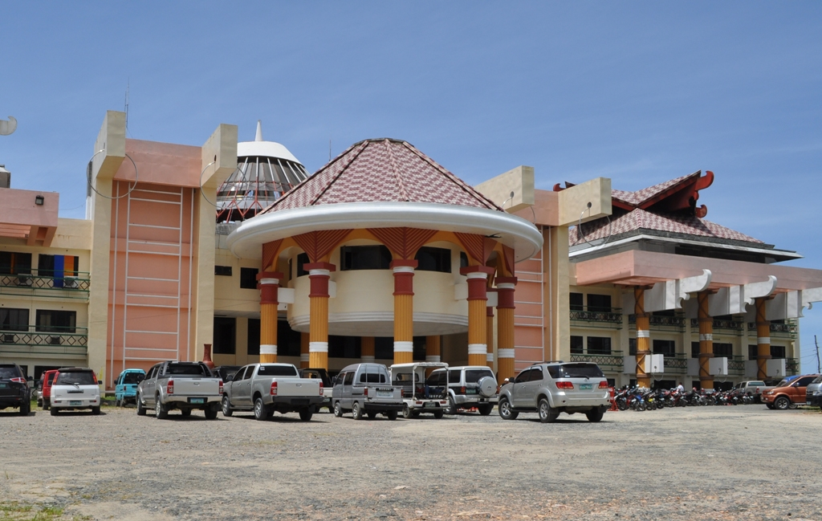

- Environment-conscious province. Zamboanga Sibugay’s provincial capitol, the seat of leadership of the youngest province in the Zamboanga Peninsula. In building the capitol, former Governor George Hofer was inspired by the cultures of its inhabitants – a mixture of Subanen lumads, Christians and Muslims.

About TVI
TVI Resource Development (Phils.) Inc., is the Philippine affiliate of TVI Pacific Inc. (TSX: TVI), a publicly-listed Canadian mining company focused on the exploration and production of precious and base metals from district scale large system, high margin projects located in the Philippines.
We are committed to exploration and mining practices that promote transparency, responsible stewardship of the environment, and the inalienable rights to life, dignity, and sustainable development of our host communities.
Connect with us: www.tviphilippines.com

For media queries:

Kaycee Crisostomo
Senior Manager - Public Affairs
TVI Resource Development (Phils) Inc.

Email: kaycee.crisostomo@tvipacific.com.ph
Phone: +63 2 728-8491 ext. 103
Mobile: +63 917 579-1528
Fax: +63 2 728-8515

