TVIRD Proclaimed Most-Awarded Metal Mining Company
A round-up of four major accolades conferred upon a Filipino-owned mining company

- TITANIUM AWARD – Surface Mining Category
- WINNER, Safest Mineral Processing – Concentrator Category
- WINNER, Safest Exploration (for Agata Nickel Project) – Category A
- 2nd RUNNER-UP, Best Mining Forest Award – Metallic Category
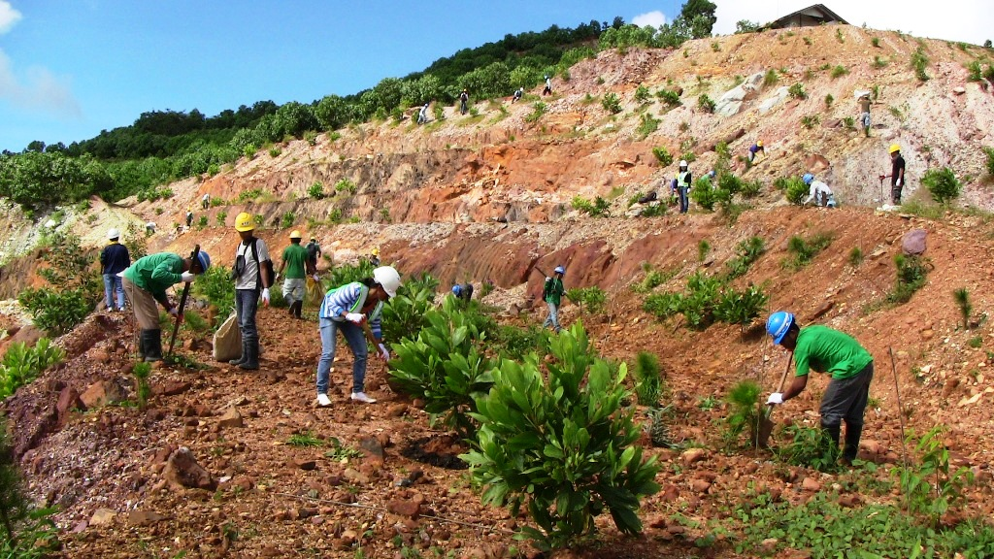
Back to life. TVIRD Environment personnel plant trees in the mine pit after meticulous soil conditioning. To date, the company has planted a total of 380 thousand trees within and outside its mine concession area.

Baguio City / November 2013 - TVI Resource Development Philippines Inc. (TVIRD) continues to espouse professionalism and the highest regard for the mining industry’s safety and environmental standards, as witnessed by delegates from all parts of the country at the recently-concluded Annual National Mine Safety and Environment Conference in Baguio City.

The Philippine affiliate company of Canadian mining firm TVI Pacific Inc. emerged as top recipient of four major awards – the most received by a metal mining company during the recognition program.

The yearly summit organized by the Philippine Mine Safety and Environment Association (PMSEA) and the DENR’s Mines and Geosciences Bureau (MGB) returned to the historic summer capital to mark a milestone “60 Years of Giving Back” – the chosen theme for 2013 – which is notably given more significance in light of the mining industry’s consistent support to various affected communities during the recent Bohol earthquake and Typhoon Haiyan.

Round-up
PMSEA President Louie R. Sarmiento conferred on TVIRD this year’s Titanium Award in the surface mining category, recognizing the company’s uncompromising implementation of its environmental management, safety and health, and social development programs in its Canatuan project site. This is the second year that the company bagged the award for exemplary performance. In 2011 and 2012, the company bagged the Safest Mining Operations Award and the Platinum Award for excellence in environmental management.

For the second consecutive year, TVIRD also garnered the Safest Mineral Processing Award in the concentrator category as well as second runner-up for the Best Mining Forest Award – one notch above its third runner-up win in 2012 under the metallic category.

Finally, the company’s joint venture partner, Mindoro Resources Ltd. (MRL) also earned the Safest Exploration Award (category A) for its Agata Nickel Project in Agusan del Norte.

TVIRD Operations Vice President Jake Foronda and General Manager Germidas Las Pinas received the awards at the recent industry pageant. MRL’s Operations Vice President Edsel Abrasaldo received the award for the Agata Nickel Project. In light of economic and environmental challenges confronting the Philippines, TVIRD continues its tradition of “solidarity with the local mining industry and in facing the future of the industry head-on,” according to Foronda.

A future beyond borders
Established in 1994, TVIRD’s gold and silver production in Canatuan, Zamboanga del Norte came on-stream and made it the first local company to operate under the current Philippine Mining Law. In spite of early challenges, the company has successfully engaged its Subanon indigenous hosts and the local government in a partnership for sustainable development.

To date, it has also developed mineral resources for various commodities, particularly copper, zinc, high iron laterite, limestone, nickel and pyrite from mineral-rich deposits in the country.

“TVIRD remains confident in the Philippines and the local mining industry. Likewise, this same confidence becomes the catalyst for us to continue moving forward,” said Foronda.

Earlier, TVI Pacific Chairman Cliff James expressed his resolve to strengthen the company’s corporate presence in the country through its local affiliate, TVIRD. He also acknowledged the proven operational capability of its almost all-Filipino management team, which continues to drive the Canatuan copper-zinc project.

An integrated social approach
“Given the scope and responsibility of a mining company, there are social and environmental components that are integrated into its business plan,” explained Foronda, adding that companies should be encouraged to exceed what is mandated by law in order to make a significant contribution to sustainable social development.

According to the executive, a stable business environment ensures a mining company that it can operate according to plan; thus, also ensuring a steady cash flow translating into tax revenues for the government, employment and livelihood for its immediate community, and adequate rehabilitation for the affected environment.

In the case of TVIRD, health and sanitation as well as infrastructure and public education form part of its development model, which is vertically aligned to the United Nations Millennium Development Goals.

TVIRD Outlook: a diverse portfolio of projects
Set to conclude its Canatuan project by the end of the year, TVIRD is keen on exploring mineralized prospects in nearby Sitio Malusok. It also anticipates its Balabag gold and silver project coming on-stream in 2014.

The company is likewise working on the Declaration of Mine Project Feasibility (DMPF) for both its projects in Balabag and Agata, which has a medium-term goal of establishing a nickel processing plant in Agusan del Norte.

*******

Press photos:

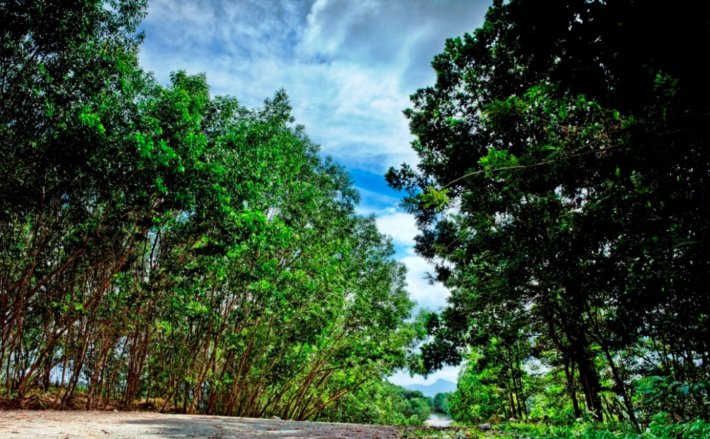
- Lush foliage. Trees flourish in the former airstrip of TVIRD. These fast growing trees serve as canopy for the hard premium trees which are endemic in Canatuan prior to the mining operations of the company.
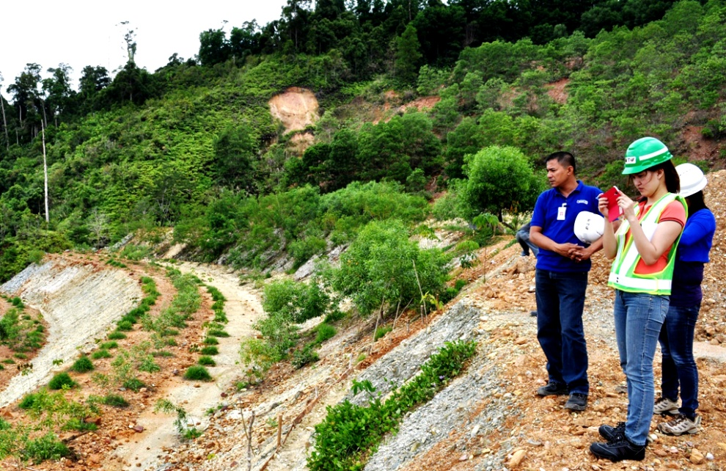

- Environmental audit. MGB’s Engr. Hazel Tanabe-Puyales inspects the areas reforested by TVIRD. Engr. Puyales is part of the team that audits mining forest programs of various companies participating in the PMEA.

About TVI
TVI Resource Development (Phils.) Inc., is the Philippine affiliate of TVI Pacific Inc. (TSX: TVI), a publicly-listed Canadian mining company focused on the exploration and production of precious and base metals from district-scale large-system, high-margin projects located in the Philippines.

We are committed to exploration and mining practices that promote transparency, responsible stewardship of the environment, and the inalienable rights to life, dignity, and sustainable development of our host communities.
Connect with us: www.tviphilippines.com

Contact:
Kaycee Crisostomo
Director - Public Affairs
TVI Resource Development Philippines Inc.

Email: kaycee.crisostomo@tvipacific.com.ph
Phone: +63 2 728-8491 ext. 103
Mobile: +63 917 579-1528
Fax: +63 2 728-8515

