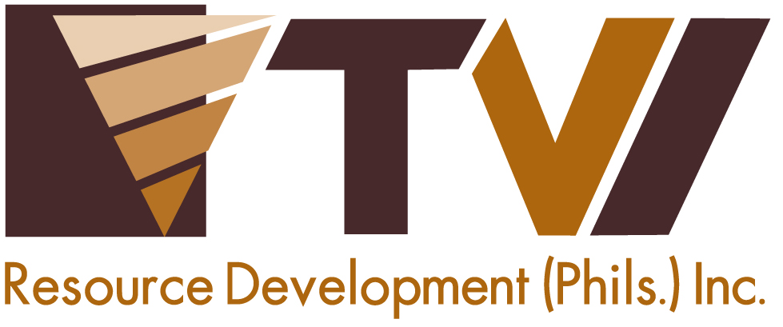
N E W S R E L E A S E

TVIRD Turns-over Health Centers to Siocon Barangays

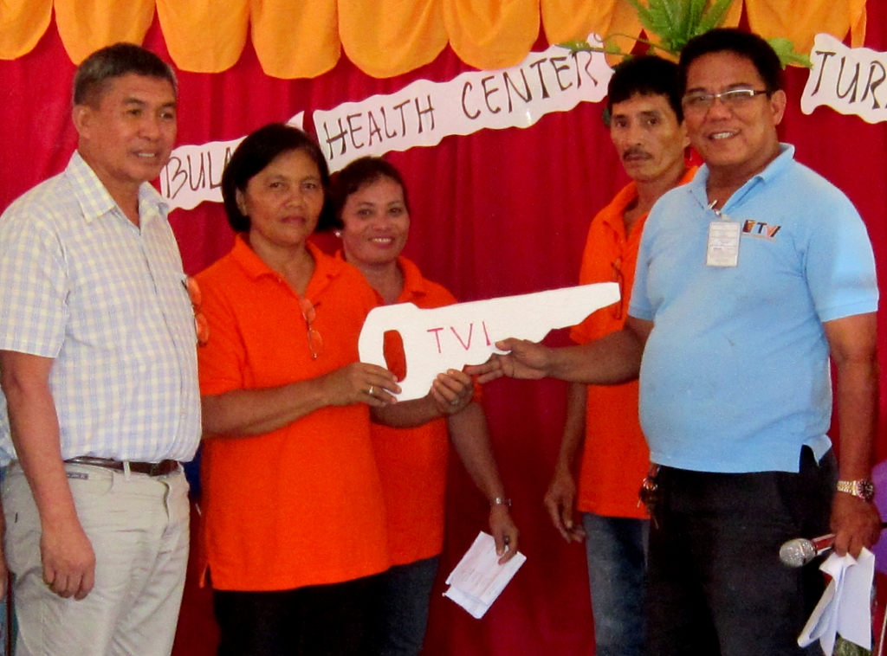
‘We are eternally grateful.’ Siocon Vice Mayor Nathaniel Usin and Bulacan Barangay Captain Corazon Molina (far Left and Right, respectively) receive the ceremonial key to their new barangay health center from TVIRD Mill Operations Manager Engr. Rey Carubio. TVIRD supported the construction of the new facility, including those of Barangays Tibangao and S. Cabral.

Siocon, Zamboanga del Norte / October 2013 – Whether in a far-flung area with limited access basic government services, or in a metropolitan area where a menu of amenities can be delivered right to one’s doorstep – public health is undoubtedly a vital part of every productive community. TVI Resource Development Philippines Inc. (TVIRD), a copper and zinc mining company in Sitio Canatuan of this town, subscribes to this philosophy and ensures not only the development of the immediate community, but also its access to basic health services.

Recently, TVIRD supported the construction and repair of community-based facilities in its host town of Siocion, particularly in Barangays Bulacan, S. Cabral and Tibangao.

“Even though TVIRD is closing its mining operations at end of the year, it still continues to provide us with aid and projects. We are eternally grateful,” expressed Barangay Bulacan Captain Corazon Molina after her village received the newly-constructed health center.

“It was distressing when our barangay health center was destroyed and the people suffered when they got sick. For a long time, our health center was deserted for we had no budget to have it repaired,” recalled Barangay S. Cabral Captain Roberto Cabral. In Cabral’s area, people would walk a few kilometers to seek out a health consultation.

“But now, our health center is just a stone’s throw away to address our needs,” he added, citing TVIRD’s support in repairing health centers for the community.

Health ensures development
After a series of consultations with the village council, traditional leaders, people’s organizations, and a thorough assessment of the needs of the community, TVIRD and the Coalition for Development in Sibugay (CODE-S) crafted individual Barangay Development Plans (BDPs) for each of the 26 communities in Siocon. These development frameworks now serve as the basis for improving overall living conditions in the area – an essential part of which is public health.

“The BDP contains the collective output of the consultations that the municipal development council and TVIRD can always refer to for the implementation of projects in the area,” Community Relations Manager Joel Alasco explained, adding that while overall development is the priority, health is the vital component that will ensure productivity.

Tibangao Barangay Captain Lorenzo Malabarbas recalled having a midwife deployed to their municipal health office but could not fully render medical care because the facility needed repairs.

“If not for TVIRD, our health center would still not be able to provide services to our people. Our deepest gratitude to TVIRD for making things possible,” Malabarbas expressed.

Since ramping-up its mining operations in 2004, the company provided the community – comprised of its indigenous Subanon hosts, and Christians and Muslims alike – with sufficient community support as allocated under the company’s annual Social Development Management Plan (SDMP).

SDMP for Canatuan’s long-term sustainability
“From 2004 to 2012, TVIRD has invested an average of over P13 million annually in line with its SDMP commitment – a large part of which is for community support facilities,” said Alasco.

The company also invested in roads, bridges and other infrastructure, including the 79-km Siocon-RT Lim Provincial Road. Along with the 45-km Baliguian Road and the 16-km Paduan-Candiz-Tungawan route, TVIRD maintains a road network of 140 km that mobilizes both people and goods – ultimately redounding to peace and progress in the region.

TVIRD also supports livelihood and the responsible management of Canatuan’s natural environment. Ongoing programs include the promotion of suitable crops, indigenous plants as well as the rehabilitation of mined-out areas.

“We are fervently hoping that TVIRD will extend its mine life here in our town so a lot of barangays will still be able to benefit from its SDMP,” said Siocon Vice-Mayor Nathaniel Usin after receiving the projects.

Set to conclude its current operations at the end of the year, TVIRD strengthens the foundation of its social and environmental programs for the overall long-term sustainability of Sitio Canatuan and its surrounding communities. Its ongoing support to education, including Canatuan Public School’s growing population of 850 students, further ensures that the community will continue to thrive beyond the life of the mine.
*******

Press Photos:
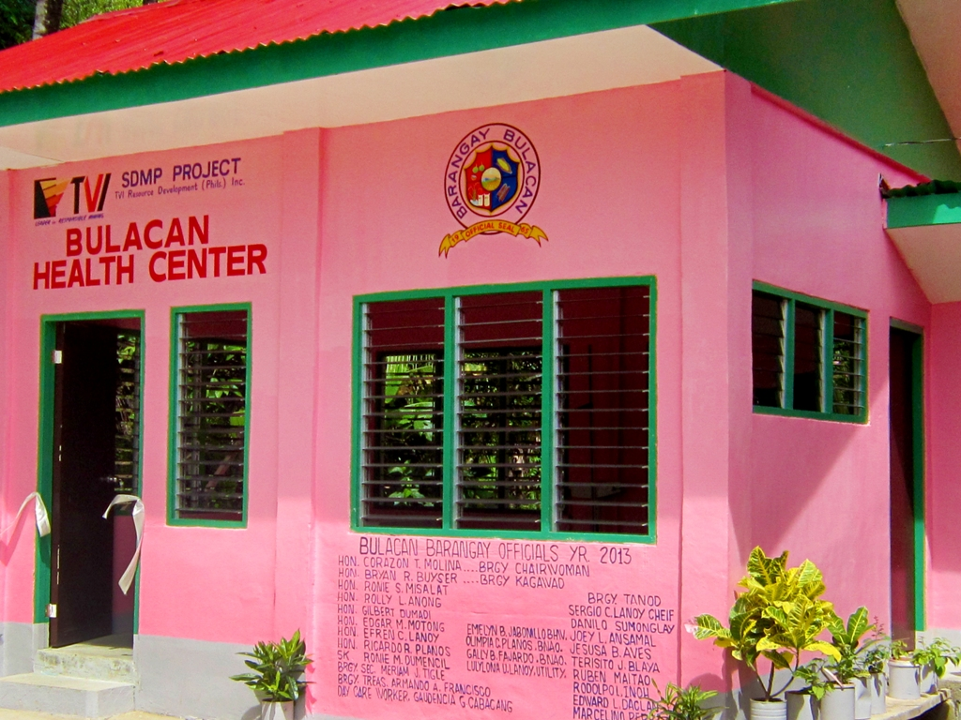

- In line with Barangay Bulacan’s Barangay Development Plan, TVIRD supported the construction of a community health center to address the community’s need for health services. The project costs nearly Php200,000 as budgeted in the company’s annual SDMP.

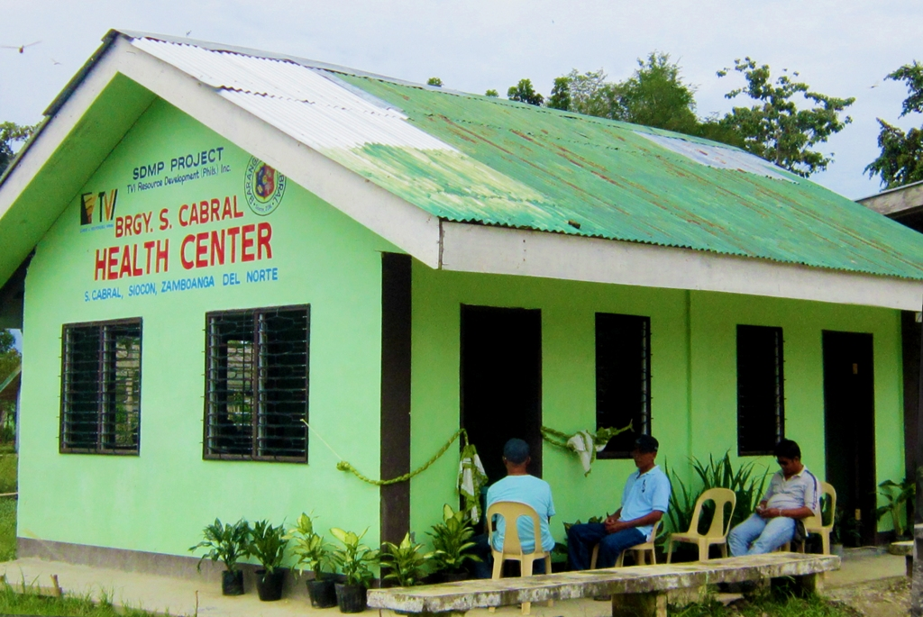

- TVIRD supported a similar facility in Barangay S. Cabral so residents need not travel to the nearby community to seek health consultations.

About TVI
TVI Resource Development (Phils.) Inc., is the Philippine affiliate of TVI Pacific Inc. (TSX: TVI), a publicly-listed Canadian mining company focused on the exploration and production of precious and base metals from district scale large system, high margin projects located in the Philippines.
We are committed to exploration and mining practices that promote transparency, responsible stewardship of the environment, and the inalienable rights to life, dignity, and sustainable development of our host communities.
Connect with us: www.tviphilippines.com

Contact:

Rianne Marie P. Miranda
Public Affairs Officer
TVI Resource Development (Phils.) Inc.

Email: rianne.miranda@tvipacific.com.ph
Mobile: +63 917 872-9425

