
N E W S R E L E A S E

Tools of Trade:
TVIRD Equips Livelihood of Siocon Fishermen

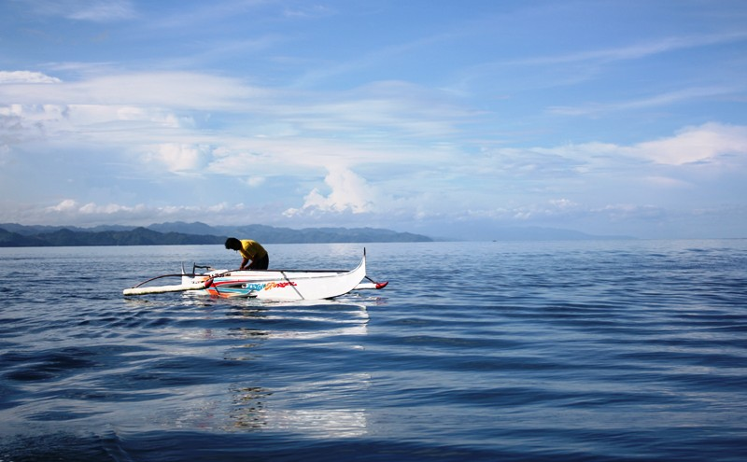Traditional livelihood. Fishermen of Pantukan have learned the art and trade of fishing through oral tradition and by the example of their fathers who were also fishermen before them. In an effort to enhance their traditional paddle boats and homemade fishing nets, TVIRD provided fishing gear and motorized engines to members of the Pantukan Fisherfolks Association.

Siocon, Zamboanga Del Norte / September 2013 – Fishermen of Pantukan in the town of Siocon, Zamboanga del Norte used to earn just enough for their family’s meals for the day using wind-powered vintas and paddled bancas. While the municipality teems with abundant fishing as its long stretch of coastlines front the Sulu Seas, any given day that a fisherman could not go out to sea would mean a strain on his family’s daily sustenance and would possibly have resulted in debt. This was the traditional livelihood passed on through generations of fishermen who inhabited the small village.
But things have changed now that the Pantukan Fisherfolks Association of Siocon (PFAS) received the proper tools of trade as well as organizational and financial training from TVI Resource Development Philippines Inc. (TVIRD), which operates a copper-zinc mine in the hinterlands of Canatuan, Siocon.
While using the same small boats, beneficiary fishermen of the association have managed to triple their income and even more. One fisherman even yielded an income of Php7 thousand from a single fishing trip – a far cry from the usual Php300 daily income.
Mobilizing progress
The much higher yield enjoyed by PFAS members today is attributed to the addition of modern technology: barely a month ago, their boats were outfitted with motorized engines and equipped with large fishing nets provided by TVIRD. Almost instantly, the little village situated near a marshland that connects to the sea was thriving with activity and very happy fishermen.
“I can’t thank the company enough for acknowledging my need for a reliable fishing net,” said Winnie dela Peña, one of the beneficiary fishermen in Pantukan, adding that he could not afford to buy fishing nets that cost around Php10 thousand in equipment stores.
Winnie is one of the 28 recipients of the equipment distributed by TVIRD to improve their income. This represents part of the company’s social contribution and ongoing commitment to sustainable livelihood for people living in the surrounding communities. Some 11 members received fishing nets while 17 were provided with motorized engines.
Multiplier
“It is in the form of a loan to the members,” said Florencio Dela Peña, brother of Winnie and the chairman of PFAS.
“In six months, the money will return to the association. This will then serve as our revolving fund for the rest of our members who may need similar equipment,” Florencio added. PFAS currently has 48 members.
“It took us eleven months to prepare for this. We went through much training to capacitate ourselves, to manage ourselves as an association and to realize this program,” he explained.
TVIRD Sustainability Team Manager Derkie Alfonso said that the trainings are for them to learn to stand on their own.
“This is our framework for sustainable development. Early on, we trained them in organizational development, and now, financial management because their group is beginning to realize income. We are empowering them to steer their own course,” Alfonso added.
Meanwhile, the fishermen continue to explore the limits of their small yet powerful boats. Belotsi Tabo-tabo, the fisherman who reeled-in Php7 thousand worth of fish on a single trip, was out for only half a day on his newly-rigged boat. Another fellow PFAS member caught Php4 thousand after fishing along the coast of Pantukan.
“With an engine and a large fishing net, one can go the distance. Now it all depends on luck and expertise in finding and catching commercial fish like yellow fin and tuna,” Florencio concluded.
*******
Press photos:
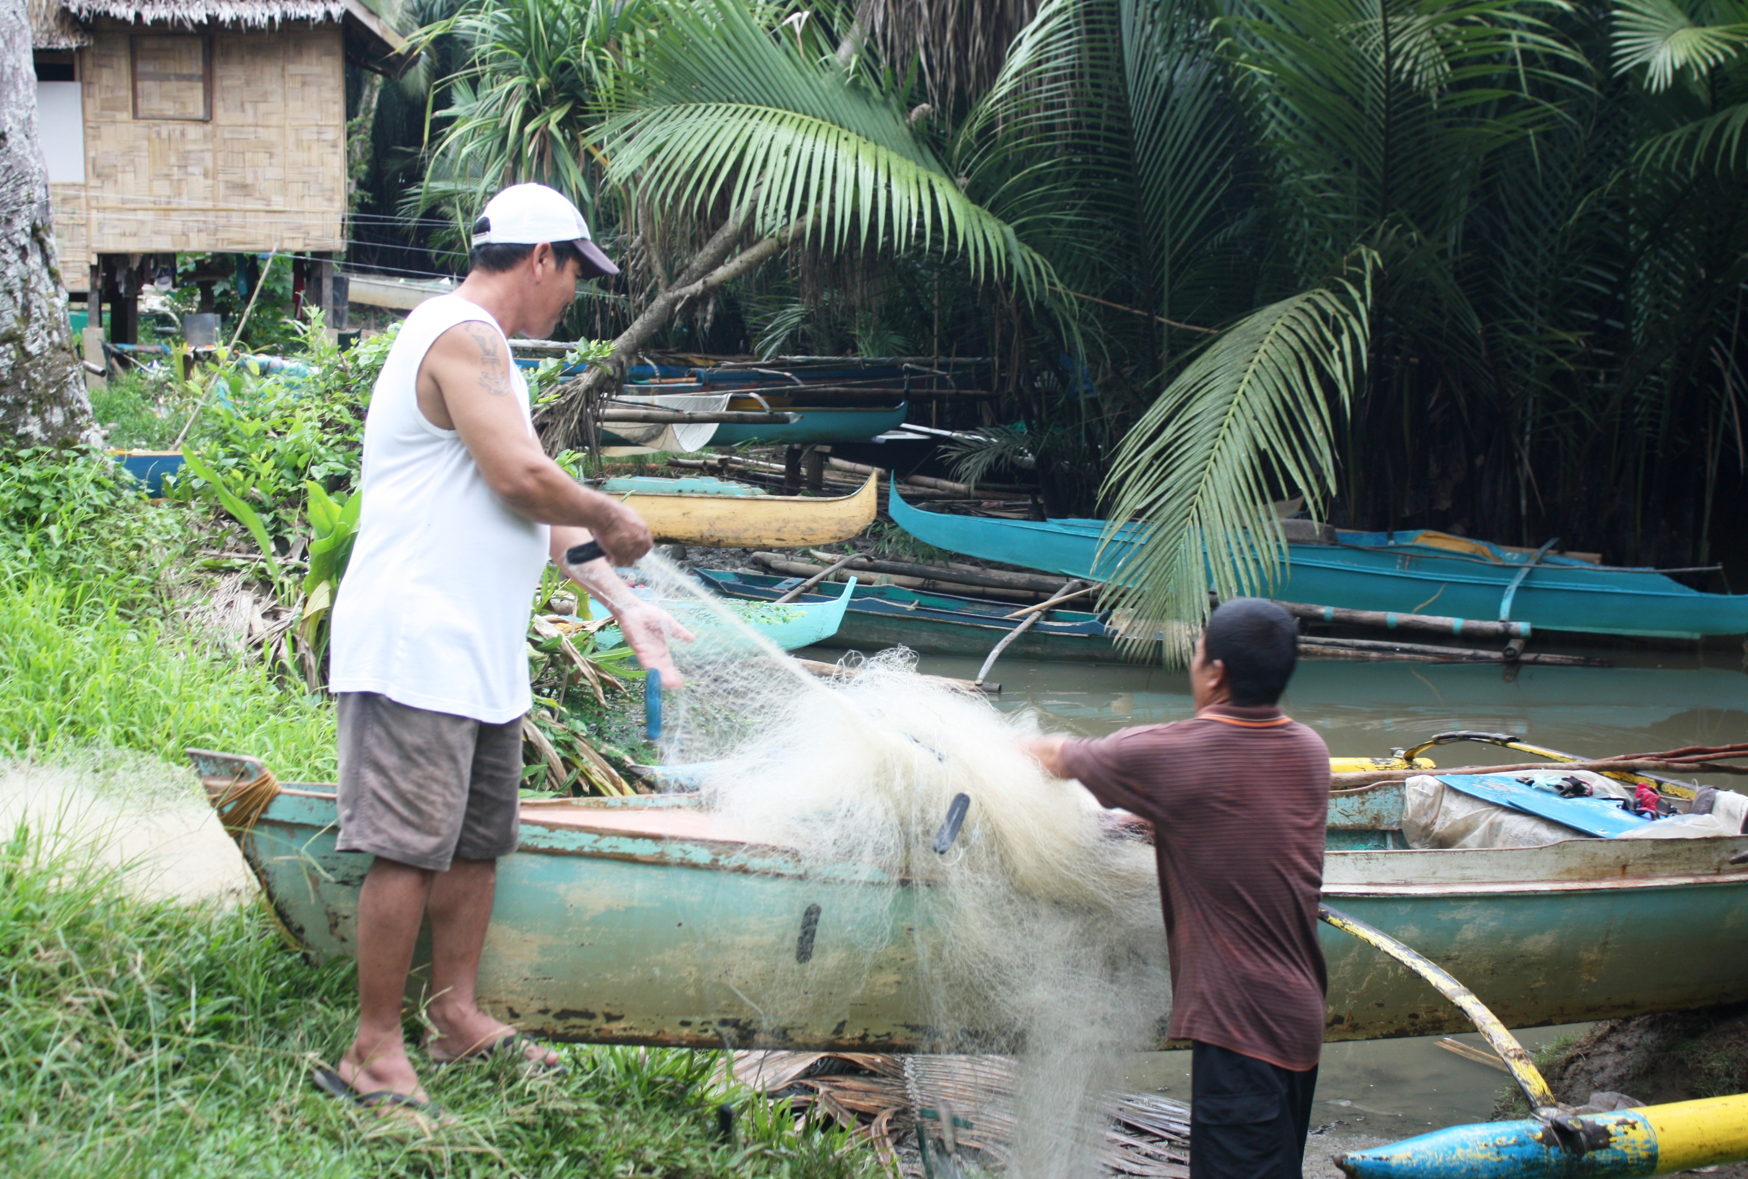

- Back to shore. Florencio and Winnie de la Peña tend to their boats after a day of fishing.

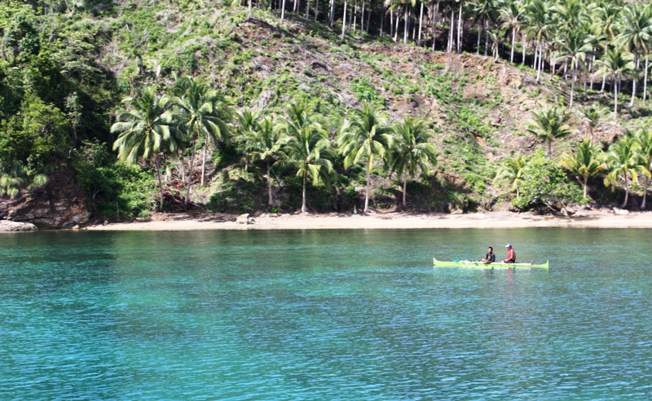
- Sustainable fishing. More than receiving modern tools of trade, Pantukan fishermen also received training on organizational development and financial management.

About TVI
TVI Resource Development (Phils.) Inc., is the Philippine affiliate of TVI Pacific Inc. (TSX: TVI), a publicly-listed Canadian mining company focused on the exploration and production of precious and base metals from district scale large system, high margin projects located in the Philippines.
We are committed to exploration and mining practices that promote transparency, responsible stewardship of the environment, and the inalienable rights to life, dignity, and sustainable development of our host communities.
Connect with us: www.tviphilippines.com

For media queries:

Joseph Arnel C. Deliverio
Public Affairs Officer
TVI Resource Development Philippines Inc.

Email: josepharnel.deliverio@tvipacific.com.ph
Mobile: 09177664205

