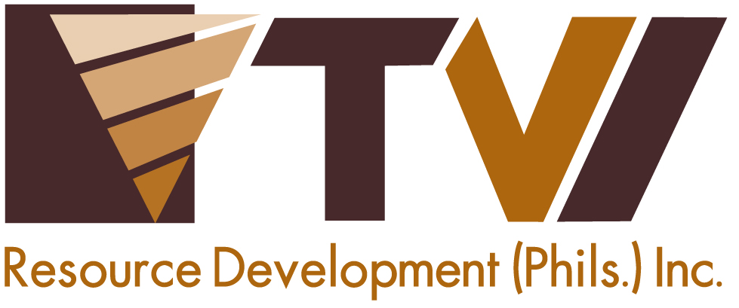
N E W S R E L E A S E

Mining Company Addresses Rural Water Problem

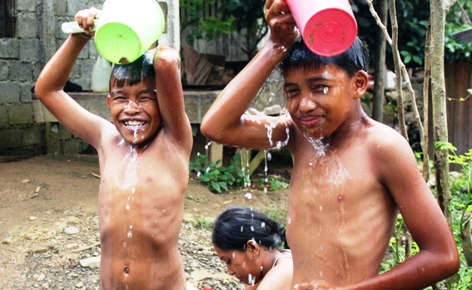Making a splash. Children in Candiz, a rural barangay in Siocon, Zamboanga del Norte, enjoy bathing with running water for the first time using the new water system provided by mining company TVI Resource Development Philippines Inc.

Siocon, Zamboanga del Norte / August 2013 - Village people of Barangay Candiz, town of Siocon in Zamboanga del Norte, get water for daily use from creeks, ponds and streams that sometimes turn murky during rainy days or arid during dry season. This has been the practice for many years. Today, the residents finally have a steady and clean supply made possible through the installation of a water system by mining company, TVI Resource Development Philippines Inc. (TVIRD).
Early this month, TVIRD formally turned-over a new water system to Barangay Candiz, finally ushering in the permanent solution to the water problem that has since overwhelmed the lives of farmers in this rural and isolated village for many years. The installation involved the construction of a catchment structure, which serves as a filter for the water source to remain clean, and a large reservoir to service an estimated 2,000 residents.
“For the first time in our barangay’s 36 years, we finally have our water system courtesy of TVIRD. First, the company repaired our road, which linked us to Siocon – and now, this new water system,” said Councilman Arturo Bascon after lamenting the inadequate, if not absent, attention of the past local government administration in helping his village.
TVIRD operates a copper and zinc mine in Canatuan, which is just a half hour ride from Candiz. Bascon also expressed regrets that the company will leave the place soon due to the depletion of its ore and the scheduled conclusion of its operations by the end of 2013.
“We can no longer expect the same developments to happen when the company is no longer around,” Bascon lamented.
Barangay Candiz, is the farthest among the 26 barangays of Siocon. Largely rural, residents earn their living through rubber tree and grain farming. Barangay Chairman Victoriano Pasumala and other officials have tagged the water system as one of their community’s priority projects under their Barangay Development Plan – this, owing to various occurrences of sicknesses due to the lack of clean running water.
Long time resident Julita Suico expressed the difficulties of getting water for drinking and laundry before. They had to walk to a creek or stream, which were located at a significant distance, carrying back heavy gallons of water for their daily use.
“Now, our new, clean and steady supply of water is just around the corner and we are really grateful to the company for giving it to us,” she said.
According to Community Relations Manager Joel Alasco, the funds for the water system project comes directly from TVIRD’s social development management plan (SDMP), as prescribed under the Philippine Mining Act of 1995.
“The mining act has stipulated that a company should institute social development projects to communities affected by its mining activities. This time, the company goes a little further to include all the 26 barangays of Siocon and some barangays of the neighboring town of RT Lim – whether affected by its operations or not,” Alasco said.
While it is the nearest barangay to Canatuan, Candiz is not affected nor disturbed in any way by the company’s mining operations.
*******
Press photos:
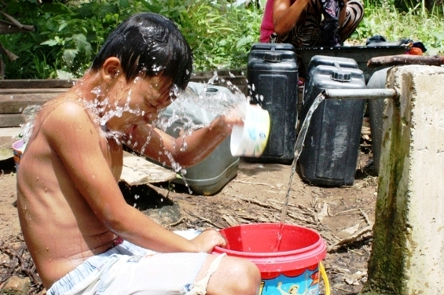


About TVI
TVI Resource Development (Phils.) Inc., is the Philippine affiliate of TVI Pacific Inc. (TSX: TVI), a publicly-listed Canadian mining company focused on the exploration and production of precious and base metals from district scale large system, high margin projects located in the Philippines.
We are committed to exploration and mining practices that promote transparency, responsible stewardship of the environment, and the inalienable rights to life, dignity, and sustainable development of our host communities.
Connect with us: www.tviphilippines.com

Contact:

JOSEPH ARNEL DELIVERIO
Public Affairs Officer
TVI Resource Development (Phils) Incorporated
Canatuan, Siocon
Zamboanga del Norte

Mobile: 09177664205
E-mail: josepharneldeliverio@tvipacific.com.ph

