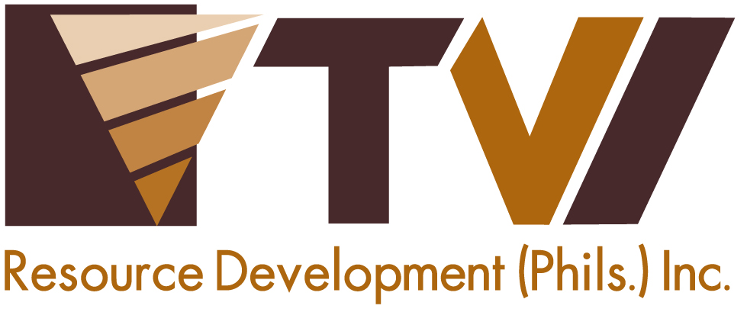
N E W S R E L E A S E

Zamboanga del Norte Press Club Brings Responsible Journalism to Siocon Campus
TVIRD supports truthful journalism for the youth
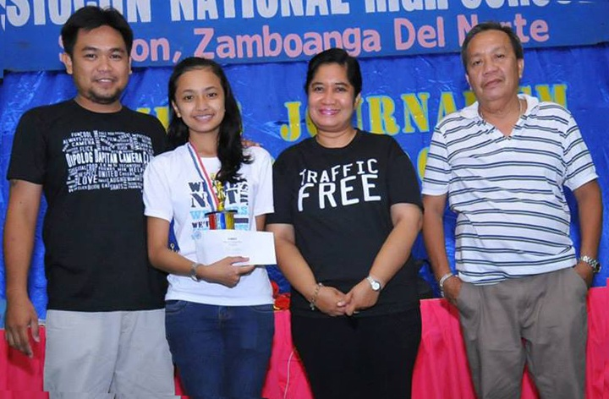
Responsible journalism. Siocon National High School senior Justine Grace Fronda lands first place in feature writing during the annual Campus Journalism Seminar of the Zamboanga del Norte Press Club. Flanking her are (from L to R): photojournalism lecturer Dave Magdayao, club president Rosemarie Miranda and Siocon National High School principal Javier Salvador.

Siocon, Zamboanga del Norte / July 2013 - Unmindful of the long journey to the hinterlands of Siocon, the farthest town of Zamboanga del Norte, members of the Zamboanga del Norte (ZN) Press Club once again brought the annual campus journalism seminar workshop closer to schools of the isolated clustered municipalities of Siocon, Sibuco, Sirawai and Baliguian. The ZN Press Club has been travelling across the region to play a very important role in honing journalism skills among students. 240 participants from the four towns recently joined the campus workshop held at Siocon National High School, which is located adjacent to the mine site of TVI Resource Development Philippines Inc. (TVIRD).

For six consecutive years, the press club and TVIRD, a copper and zinc mining company in Canatuan, town of Siocon, have advocated responsible journalism to the students in the region.

“We are truly appreciative of the help that TVIRD has extended to the ZN Press Club for the past six years. This is a very significant contribution to the club because this will always redound to the benefits of our campus writers,” said ZN Press Club President Rosemarie Miranda.

The organization was established in 1965 by Isagani S. Amatong - a newspaperman who later on became a governor of Zamboanga del Norte. In the late 1990s, the Department of Education was tapped by the press club to institutionalize its campus journalism program. The government agency’s Zamboanga del Norte Division Schools Superintendent then issued a memorandum to allow campus journalists from different schools to participate.

“This way, schools are able to determine who are their writers and contestants for the provincial, regional, and national schools press conference,” Miranda shared.

From responsible mining to responsible writing
The two-day workshop tackled topics on features, news, editorial, editorial cartoons, sports writing, copywriting and headline writing, media ethics, photojournalism, and broadcasting.

“In partnership with TVIRD, we exceeded our expectations in terms of information dissemination about current issues, environmental concerns and other social problems. This time, we create a ripple effect. This means that a certain student will know what TVIRD and responsible mining is, and on our side, we will also be able to know and disseminate the information that mining per se is not really what many people think,” Miranda disclosed.

TVIRD has been operating in the Subanon host community since 2004. Its development projects give equal attention to providing education for the indigenous Subanons. Other components that comprise the company’s Four Quadrants of Development include health and sanitation, sustainable livelihood, and infrastructure projects.

“Every year, the ZN Press Club never neglects the (four municipalities) as its first stop. The students are very eager to learn journalism which always makes us land in national press conferences,” shared Siocon National High School Principal Javier Salvador.

Trailblazers
“The press club’s arrival here in our place has greatly improved our abilities in writing, in expressing our ideas, and most of all, our self-confidence,” said fourth year high school student Justine Grace Fronda.

“We are indeed grateful that no matter how far our place is, the press club has weathered all storms to impart their knowledge in journalism. We feel we are just as competent as the other young writers in the city,” she added. Justine is an aspiring student writer who made it to first place in feature writing during the workshop.

Like any other ordinary students, Justine has also her share of butterflies in the stomach when joining writing contests like this.

“In my four years of joining the campus journalism program, I’ve been both thrilled and pressured. On the other hand, nothing can beat the feeling of being able to express one’s self - and in return - winning in the contest. I am sure my fellow young writers share the same feelings as I do,” she expressed.

The ZN Press Club also reaches eight other clusters and districts of Zamboanga del Norte to teach students to speak out and be independent-minded.

Siocon’s Pride
A 3rd class municipality prior to TVIRD’s entry, Siocon rose to become a 1st class municipality in 2011, owing to the economic activity spurred by its operations.

“In an era where information is as valuable as gold, our student journalists can be seen as the miners. It is up to them to mine the information, sift out the uninteresting, craft it into a concise and easily understood form, and finally, to disseminate this precious and refined information to the student population,” Siocon Mayor Julius Lobrigas shared. Siocon has already produced many good writers; some of them reaching the national level in press conferences.

“This will be my last time to join campus journalism because I will be graduating next year. I am also the last of the Fronda sisters to join the program because I am the youngest in the family,” shared Justine, who is also the president of the Supreme Student Government in their campus.

“My elder sisters always made it to the regional and national press conferences. And this is all because of the ZN Press Club’s initiative to teach us,” she said.

“We might give the same lectures every year, but it is the pride that we feel when many students come and say that you have made a difference in their lives for the past years because of campus journalism,” Miranda shared.

“Some may not have become journalists, but in one way or another, writing made a difference in them,” she added. Siocon leaders, together with TVIRD and the other leaders from nearby municipalities, continue to support the students’ endeavors in the field of responsible journalism.

Commitment to Education
TVIRD allocates over P4 million annually for responsive education as one of the major components of the company’s Social Development and Management Program (SDMP). This has assisted more than 20 public schools with over 5,000 students inside and outside the Certificate of Ancestral Domain Title (CADT) area. The company also provided computer sets and other instructional materials to public schools within the Municipality of Siocon.

The company also supports and currently maintains 24 college scholarships under its SDMP - many of whom are studying in Siocon – as well as 6 scholarships under the Development of Mining Technology and Geosciences course. .

“TVIRD strongly advocates education that is responsive to the needs of the communities because it is through education that we can emancipate people from ignorance, backwardness, stagnation, and the vicious cycle of extreme poverty. No less than our CEO, Mr. Clifford M. James emphasized education as the core quadrant of sustainable development in Canatuan,” expressed Community Relations and Development Manager Joel Alasco.

In one way or another, after all these years, the ZN Press Club and TVIRD has enlightened, not only the students themselves but also the entire community of Zamboanga del Norte, on the essence of responsible mining through responsible and truthful journalism.

*******

Press photos:
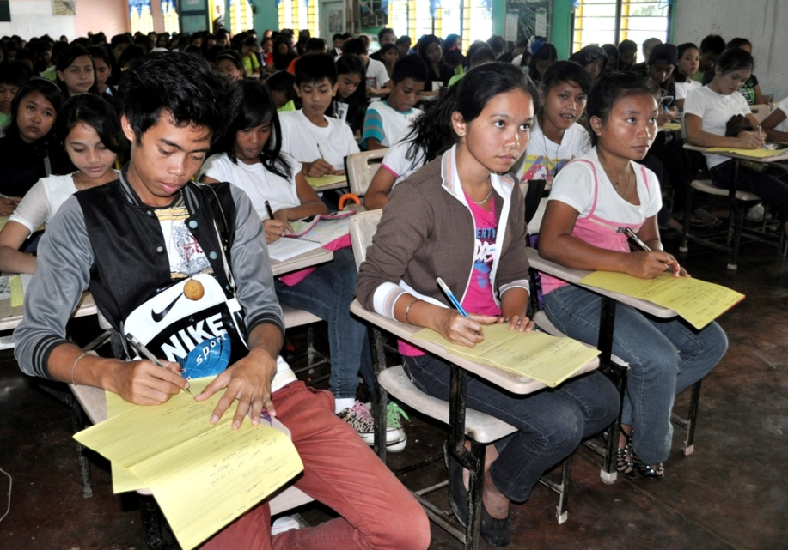

- 240 participants from the Triple S-B towns recently join the campus workshop held at Siocon National High School.

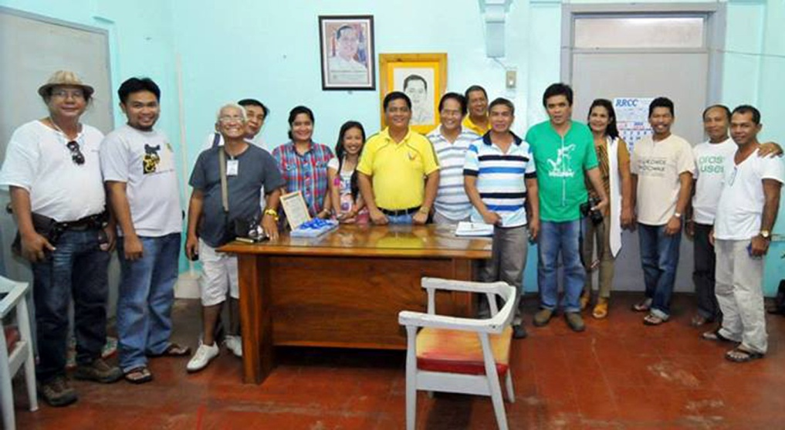

- Siocon Mayor Julius Lobrigas (center, in yellow) and Vice Mayor Nathaniel Usin (in blue stripes) thank the members of the ZN Press Club, Inc., for bringing the campus journalism seminar workshop once again to the schools of the isolated clustered municipalities of Siocon, Sibuco, Sirawai and Baliguian.

About TVI
TVI Resource Development (Phils.) Inc., is the Philippine affiliate of TVI Pacific Inc. (TSX: TVI), a publicly-listed Canadian mining company focused on the exploration and production of precious and base metals from district scale large system, high margin projects located in the Philippines.
We are committed to exploration and mining practices that promote transparency, responsible stewardship of the environment, and the inalienable rights to life, dignity, and sustainable development of our host communities.
Connect with us: www.tviphilippines.com

