Visiting Delegates Confirm:
Canatuan is a Model for Responsible Mining
Representatives of the DENR, MGB and Northern Cement imbibe on official tour of TVIRD in Zamboanga
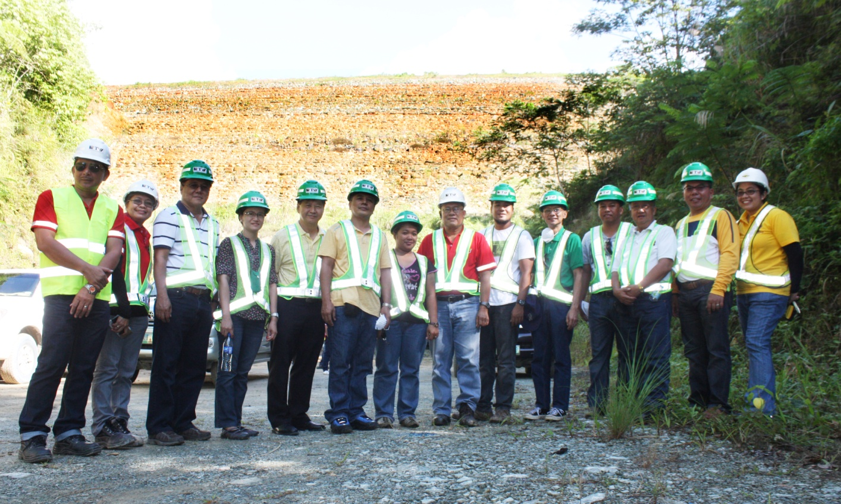
Official visit. Regional Director Carlos Tayag of MGB Ilocos Region (second from right) and his team, together with key TVIRD officers headed by Engr. Ely Valmores (in red, middle) at the foot of the company’s massive sulphide tailings facility. RD Tayag and his group composed of DENR, EMB and MGB officials, members of its Multi-Partite Monitoring Team and Northern Cement Corporation executives recently visited TVIRD’s Canatuan mine site to see and learn from its best mining practices.

Siocon, Zamboanga del Norte / July 2013 – A delegation headed by Mines and Geosciences Bureau (MGB) Regional Director Carlos Tayag, along with officials from the Department of Environment and Natural Resources (DENR) and executives of Northern Cement Corporation in Pangasinan, recently conducted an official visit to the Canatuan mine of TVI Resource Development Corporation Inc. (TVIRD). Coming from the farthest northern region of the country in Luzon, the group was searching for a viable model for responsible mining and sustainable development – only to find it at the country’s opposite southern end at the western tip of Mindanao: the mine site of TVIRD in the town of Siocon, Zamboanga del Norte.
“We have been on the lookout for a company that really exemplifies the best implementation of environmental laws and Social Development and Management Plans. We have finally seen it here,” expressed Carlos Tayag of MGB Region I in Ilocos.
The visitors included Region I officials from the Environment Management Bureau (EMB), the DENR and members of the region’s Multi-Partite Monitoring Team (MMT) who were particularly interested in the TVIRD programs due to their role of environmental and social monitoring on a quarterly basis.
In addition to an active exchange of industry best practices, the group also participated in an educational tour of various locations within the TVIRD mine site, culminating in an agreement for future technical consultations.
On sustainability and life after mining
“When we heard about TVIRD’s best practices, we did not hesitate to come over despite the distance. I am impressed by what I have seen here,” according to Alfredo Ballesteros of the Northern Cement. He further added that his company has been searching for a good sustainability program that they could duplicate.
“There is life after mining,” declared Tayag after a briefing on the company’s agribusiness program, which has been conceived for the community’s sustainable livelihood after TVIRD concludes its current mining operations.
In January this year, TVI Agriproducts Inc., wholly-owned subsidiary of TVIRD, and contract farm operator Kennemer Foods International (KFI) signed a Memorandum of Understanding for the establishment of a joint agri-enterprise for cacao production in the municipalities of Siocon and nearby Baliguian. The joint venture is based on developing and establishing contract growing agreements for small farmers, technology and knowledge transfer, and capital investments for infrastructure and equipment.
Based on a development roadmap culled from a study conducted by the University of Asia and the Pacific (UA&P), the project is expected to expand over the next four years from a 200-hectare cacao plantation to 1,600 hectares. The project has the potential to generate nearly 1,300 jobs for the local community.
“These are the kind of things we want to show to our stakeholders back home. Because in their minds, after it has made profits, the company just walks right away and the place they leave behind becomes a ghost town. This may be true before, but this is no longer true now, especially here in Canatuan,” Tayag added, referring to some communities left with limited livelihood.
On preserving indigenous cultural communities
The delegation was also hosted by MGB Region IX Director Alfredo Relampagos. The itinerary of the group included the surface mine facilities, the immediate community, company-supported public schools and the TVIRD-Gawad Kalinga Village in Tanuman. The latter is a newly developed community for the indigenous Subanons who were provided with single-family detached residential houses as part of the Canatuan Project Development Plan.
“I am really impressed by the homes and livelihood that the company extended to the Subanons,” said Inocencio Carganilla, a resident of Sison, Pangasinan and member of the Region I MMT. He further noted that he was also greatly impressed with the improved lives of the Subanons, who comprise some 30 percent of the company’s Canatuan workforce.
The visit and tour provided a good exchange of ideas and practices in a real world environment. Moreover, it gives promise that the ideas, commitments and sustainable actions of mining companies can be replicated throughout the country.
TVIRD is the Philippine affiliate company of Canada-based TVI Pacific Inc. It has been in the ancestral lands of the Subanons since 1995 and commenced its gold-silver mining operations in 2004. While currently mining copper and zinc, the company is set to conclude operations on its current ore body by the end of the year. However, additional mineralized prospects in nearby Sitio Malusok can potentially extend Canatuan operations as well as the continued delivery of benefits to the host communities.

******

About TVI
TVI Resource Development (Phils.) Inc., is the Philippine affiliate of TVI Pacific Inc. (TSX: TVI), a publicly-listed Canadian mining company focused on the exploration and production of precious and base metals from district scale large system, high margin projects located in the Philippines.
We are committed to exploration and mining practices that promote transparency, responsible stewardship of the environment, and the inalienable rights to life, dignity, and sustainable development of our host communities.
Connect with us: www.tviphilippines.com

For media queries:

Kaycee Crisostomo
Senior Manager - Public Affairs
TVI Resource Development (Phils) Inc.

Email: kaycee.crisostomo@tvipacific.com.ph
Phone: +63 2 728-8491 ext. 103
Mobile: +63 917 579-1528
Fax: +63 2 728-8515

