Craft and Poetry:
Young Subanons Commemorate Environment Month


Best friends in life. (From L to R): Subanon students May Anne Lumanjal and Angelica Tumangkis are aware of their responsibility to protect the environment and understand that it should start from one’s self - to avert climate change.

Siocon, Zamboanga del Norte / June 2013 - As members of the Subanon tribe, they lovingly call themselves children of the earth. Their ancestors thrive on hunting and farming since time immemorial. However, 16-year old Mary Anne Lumanjal, a Subanon and fourth year high school student has only just realized that the kaingin method of farming the tribe is using is destructive to the environment and is contributing to climate change.
With kaingin, a farmer discriminately cuts trees and burns it down to create a clearing that enables him to plant upland rice and root crops. The Subanons, like a lot of rural farmers in the country, have been practicing the method for centuries now.
Mary Anne and 59 other young Subanons are members of the Youth for Environment in School Organization (YES O), a group of students organized by teachers of Canatuan National Elementary and High School through a memorandum order released by the Department of Education (DepEd). Its objective is to instill love and care for mother Earth in the minds of the youth.
Guiding the youth
A week ago, YES O members underwent a three-day seminar workshop and camp conducted by the Community Relations and Development Office (CreDO) of TVI Resource Development Philippines Inc. (TVIRD), in collaboration with the company’s Environment Department, Department of Environment and Natural Resources (DENR) Mines and Geosciences Bureau (MGB) and Mindanao Tripartite Youth of the Ulama-Bishops Conference - a Non-Government Organization in Zamboanga Peninsula. The activity was in celebration of Environment Month.
Through songs, dances and poems written both in Filipino and English, the students dramatized their commitment to protect the environment. They were also taught how to make handicrafts using recyclable waste materials.
Mary Anne shared that before the entry of TVIRD and during the regime of the illegal miners, kaingin was rampant in Canatuan.
“This was reduced since many of my relatives now work with the company. However, many are still practicing it despite the company’s education campaign that showed its ill effect to the environment,” she said.
“Our elders should understand that deforestation is one of the causes of climate change. In fact, 15% of carbon emission is to due to deforestation and kaingin contributed a lot to this,” she added.
Heavenly Grace Herbadon, a classmate of Mary Anne shared her view as well:
“Kaingin will reduce the remaining forest patches that we have, aside from those who wantonly cut trees for cooking purposes. Many of our elders refused to understand its ill effects. We must intensify our education campaign to let them understand,” she lamented.
“We must intensify our education campaign to let them understand that heavy storms cause incessant rains, flooding, and landslides. It also endangered the natural habitat of wild animals and plants. It is contributing to climate change,” Herbadon added.
Angelica Tumangkis, another classmate of Mary Anne emphasized the importance of correct solid waste disposal as one measure that saves ‘dying’ rivers and environment in a poem she wrote.
“When I wrote that poem, I wanted to convey the message that environmental protection is urgent and that it should be done now. I hope that our Elders understand how urgent it is,” she said.
At the end of the training, Jana Jane Dacubor, regional coordinator of the Mindanao Tripartite Youth of the Ulamah-Bishops Conference commended the youth for their commitment to help in environmental protection.
“I hope to see you successful in your avowed duty to preserve nature,” she told the students.
Georgina Fernandez, Ecosystem Management Specialist from the DENR told the students that wild animals and micro-organisms living in forests balance the biodiversity.
“If people continue to practice kaingin wild animals and even insects perish. Nothing will balance our biodiversity,” she told them.
Saving forests first
Lumanjal whose father works for the Maintenance Department of TVIRD is bent on saving the forest in Siocon and in the adjacent town of Baliguian where she learned that a nesting ground of the Philippine Eagle was discovered by the Wild Life and Park Bureau (PAWB) of the DENR in 2007
“I want this to be stopped. It endangers the natural habitat of the eagle. I want the Eagles to be protected,” she said.
In its report and supporting photos, PAWB identified the forest of Barangay Linay, in Baliguian as nesting ground of the Philippine Eagle. In August 11, 2007 a breeding pair of Philippine Eagles was discovered nesting in an old tree in Barangay Linay, according to the report. It also said that the nesting site is just 369 above sea level - the lowest recorded for Philippine Eagles. The DENR declared the area as a Philippine Eagle “critical habitat” through RA 1947 or the Philippine Wildlife Act.
Forester Hiya Jaapar, of the DENR also revealed that another nesting site of the Philippine Eagle was found in Sibuco, another town adjacent to Siocon.
“The more that we should protect our forests here,” Herbadon quipped.
Reforestation
Gemma Tolentino, TVIRD’s Subanon forester remarked that at the moment the company has already planted and grown a total of 360,000 trees of diverse species inside and outside its 508-hectare mining concession area.
The company operates its copper-zinc project in Canatuan, the ancestral lands of the Subanons. Canatuan is a sub-village of Tabayo, in Siocon municipality, Zamboanga del Norte province.
“The number of trees we’ve planted is five times in density compared before our entry in Canatuan, which was a haven of illegal miners before,” she disclosed.
Tolentino said that as the company prepares the community and its employees for the pending conclusion of its mining operations by the end of the year, the Environment Department has almost revegetated the remaining 64-hectare affected areas.
“We’ve only affected about 199 hectares within our Mineral Production Sharing Agreement (MPSA) area, and another 26 hectares that belong to our Certificate of Ancestral Domain Title (CADT) lands. These remaining affected areas have yet to be planted with trees intercropped with natural grown trees found in Canatuan. Funds for the final rehabilitation phase are already placed in a government-owned Bank,” she disclosed.
As highlight, participants and organizers participated a tree planting activity conducted at K. Mais Primary School, a newly-opened school at Sitio Solonsangan, just a kilometer from the company’s process plant.
Mary Anne, Angelica and Gemma are Subanons. All firmly believe that environmental protection start from one’s self. They belong to the tribe’s young generation who are conscious that while it is just and right to mine their mineral-rich lands, it is also their avowed responsibility to rehabilitate what were disturbed not only for future Subanons but for Mother Nature as well. All are aware that their land is a source of life, and that one cannot exist without the other.

*******

Press photos:
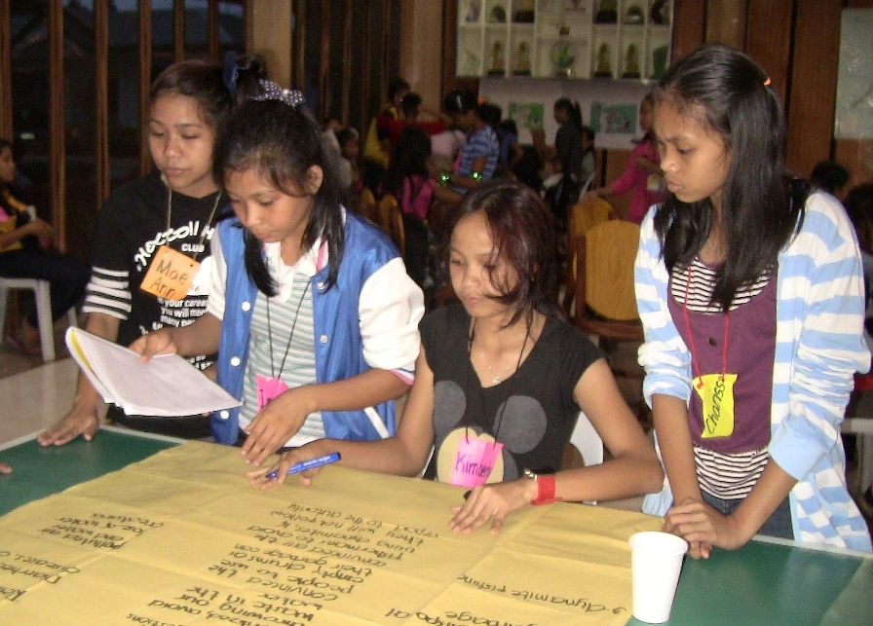

- Student-participants wrote poems to express their concern for Mother Earth.

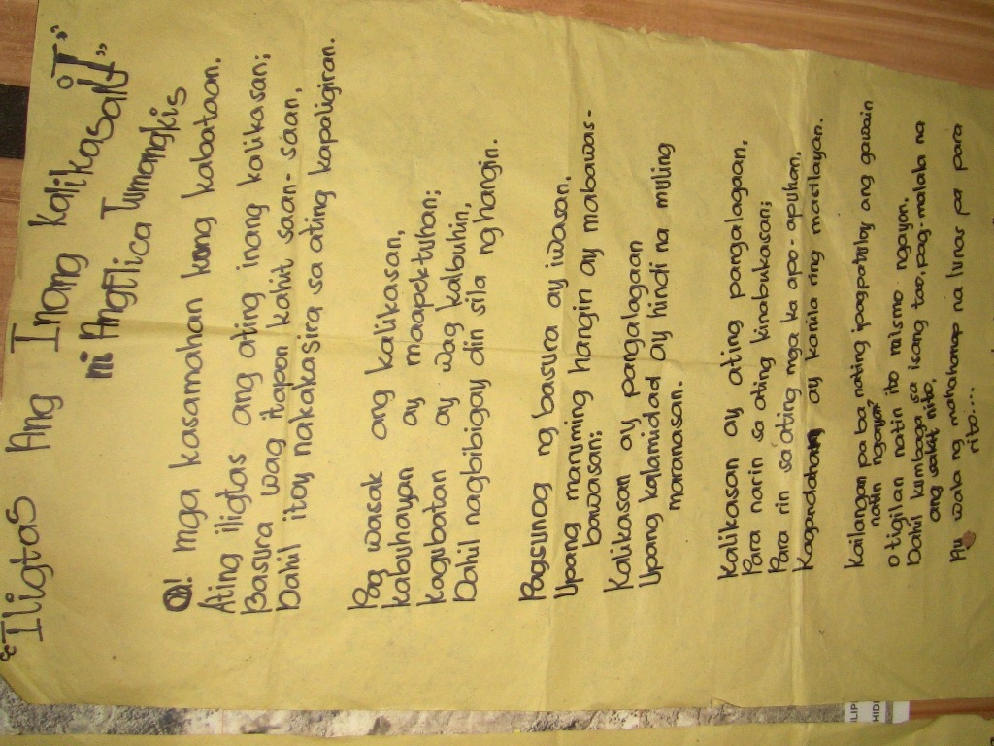

- Winning piece. The poem written by Angelica Tumangkis tells of her urgent call to the youth to protect the environment.

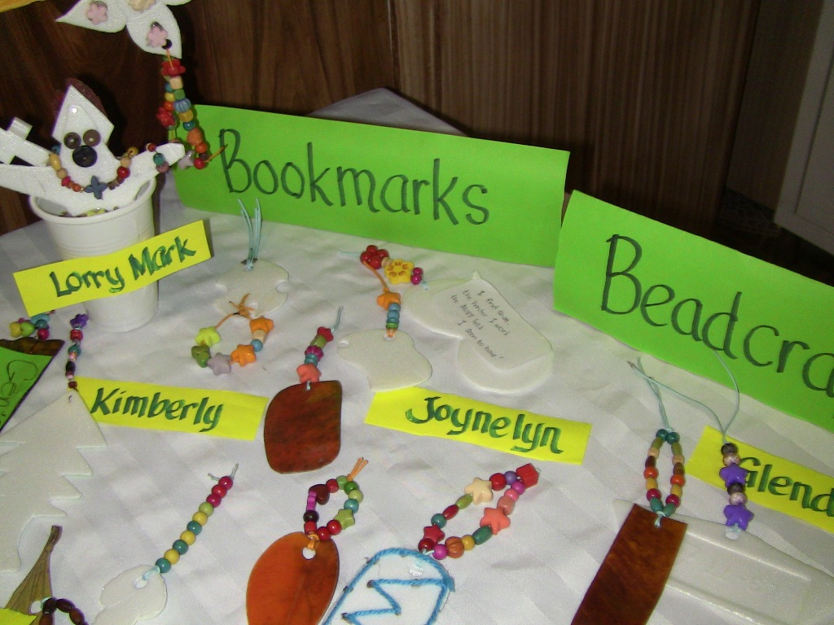

- Little knick-knacks made by the student-participants from recyclable waste materials. Making stuff from waste materials was taught during the three-day activity.

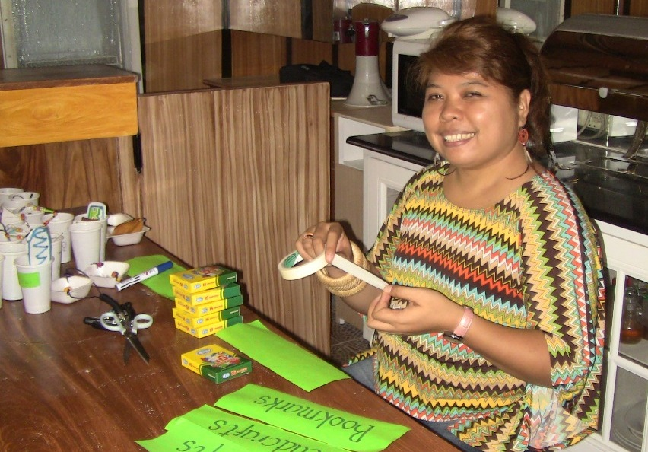

- Jana Jane Dacubor, regional coordinator of the Mindanao Tripartite Youth of the Ulamah-Bishops Conference taught the student-participants on how to make stuff from recyclable waste materials – for mother Earth

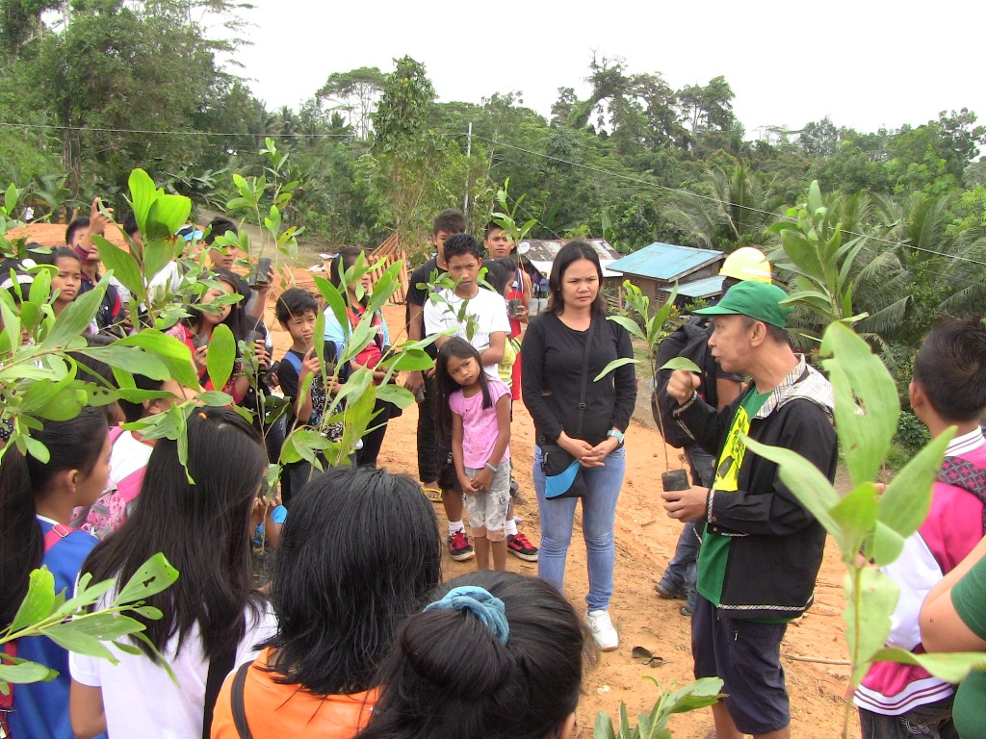

- Forester Hiya Jaapar of the DENR-Youth Desk Officer and focal person of the activity taught student-participants the correct distance between planted seedlings. TVIRD Forester Gemma Tolentino joins the activity.

About TVI
TVI Resource Development (Phils.) Inc., is the Philippine affiliate of TVI Pacific Inc. (TSX: TVI), a publicly-listed Canadian mining company focused on the exploration and production of precious and base metals from district scale large system, high margin projects located in the Philippines.
We are committed to exploration and mining practices that promote transparency, responsible stewardship of the environment, and the inalienable rights to life, dignity, and sustainable development of our host communities.
Connect with us: www.tviphilippines.com

For media queries:

Lullie A. Micabalo
Public Affairs Manager
TVI Resource Development (Phils) Inc.

Email: lullie.micabalo@tvipacific.com.ph
Mobile: +63 917 883-7074

