Canadian Firm Bags Top Honors at Mining Safety Summit
TVIRD reaps the Platinum Environmental Excellence and Safest Mining Operations Awards by PSMEA

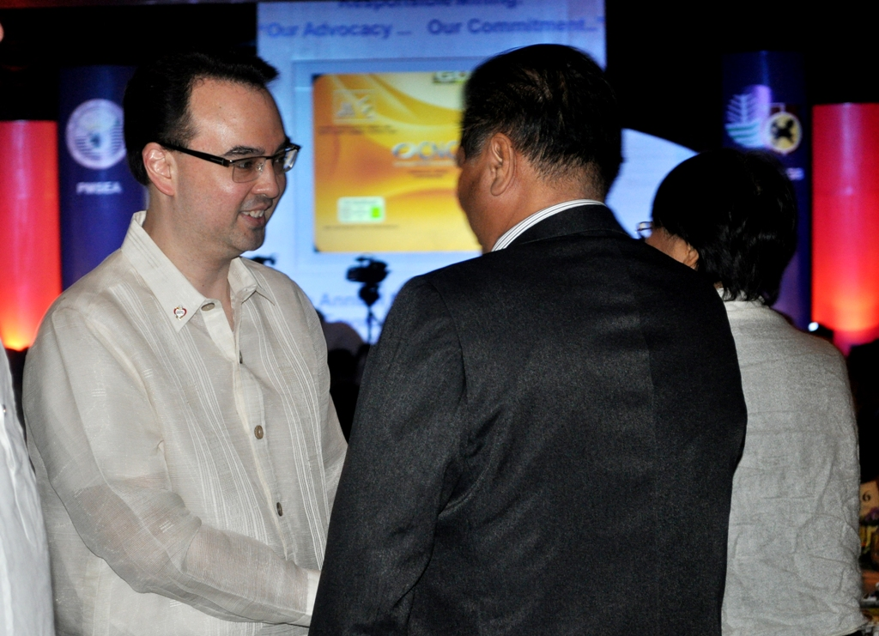
A commendation for responsible mining. Guest of honor Senator Alan Peter Cayetano is congratulated by TVIRD President Atty. Eugene T. Mateo, following the Senator’s keynote message urging local mining to address the industry’s challenges. The legislator also earlier commended industry players for their staunch fortitude in the face of adverse criticism.

Baguio City / November 2012 - TVI Resource Development, Inc. (TVIRD), Philippine flagship company of Canadian mining firm TVI Pacific, Inc., received top honors at the recently-concluded Annual National Mine Safety and Environment Conference in Baguio City. For the second consecutive year, the company bested other large local mining companies in its respective metallic category, garnering the Safest Mining Operations Award and the Platinum Award for excellence in environmental management – the highest accolade received under the surface mining operations category. The yearly summit is organized by the Philippine Mine Safety and Environment Association (PMSEA).
TVIRD President Atty. Eugene T. Mateo received the awards from PMSEA President Louie R. Sarmiento and colleagues, Vice President of Environment and Civil Works Jay Nelson, Environment Manager Nilda Callora, Safety Department Manager Arturo Abad, Assistant General Manager Germidas Las Pinas and Security Director Emmanuel Cayton. They are joined by guest of honor Senator Alan Peter S. Cayetano.
A testament to responsible mining
In his keynote message, Cayetano criticized the negative perception on local mining and encouraged industry representatives to foster dialogue with its relevant stakeholders.
“When you are right, you can boldly fight for it. True believers persevere,” said Cayetano, urging the delegation to “Patiently (correct) the false information and lies being spread.” He also identified the need to carefully evaluate the industry’s challenges and craft solutions to address the root cause.
The senator expressed his acceptance over public expressions of anti-mining and sectors that believe it is inherently wrong. But he added: “Prove to me that really you’re anti-mining. Stop using products that are brought about by mining. Do we have computers, cellphones and microphones if we don’t have mining?” he asked rhetorically.
As the first foreign mining company to earn a license to operate, following the enactment of the Philippine Mining Law in 1995, TVIRD has conducted its activities with an unblemished track record to date.
“(This) recognition will speak for our perseverance in demonstrating responsible mining becoming a benchmark in the country,” Atty. Mateo added after Cayetano’s speech.

“(The award) also reflected TVIRD’s genuine interest in giving back to the community as we placed above all others the welfare and safety of our employees,” concluded Atty. Mateo.
Investing beyond business
Along with the major awards, the company also received the Safest Surface Mining Operation and Safest Mineral Processing-Concentrator Awards, and came in as 3rd runner up for the Best Mining Forest in the metallic category. The firm cornered the most number of awards among competing companies with five (5) major citations in the surface metallic mining category.
TVIRD directly operates its Canatuan, Tabayo mine site in Siocon, Zamboanga del Norte where it has established itself as a community development partner in the Subanon ancestral domain more than ten years ago.
In 2011, TVIRD received the Titanium Award for Environmental Management and three other safety awards. It was also previously conferred with Best Employer awards by the Department of Labor and Employment (DOLE) in 2010 and 2011.

*******
Press photos:
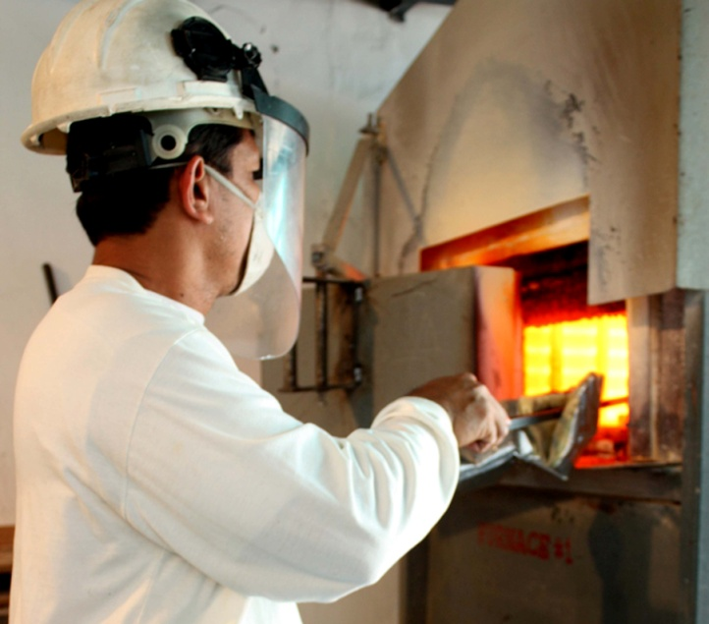
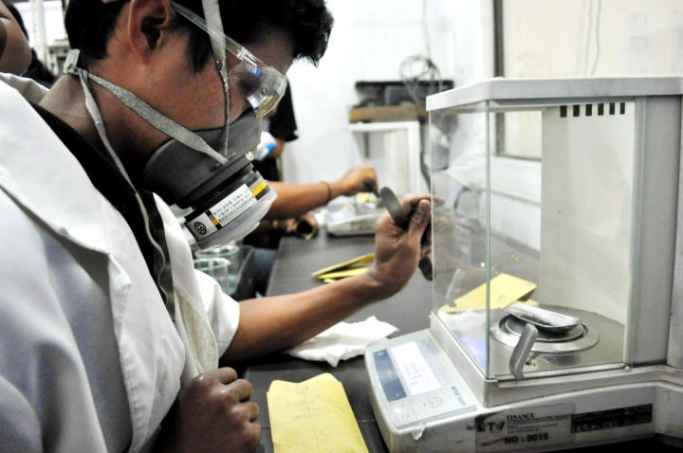
  - Mineral Analysis. (Top): The ore samples are subject to extremely high temperatures to determine its mineral content. TVIRD chemists are mandated to wear protective equipment like full-face masks to protect them from gas-fire spatters. (bottom) Respirators are compulsory for chemists, even when weighing materials prior to analysis.

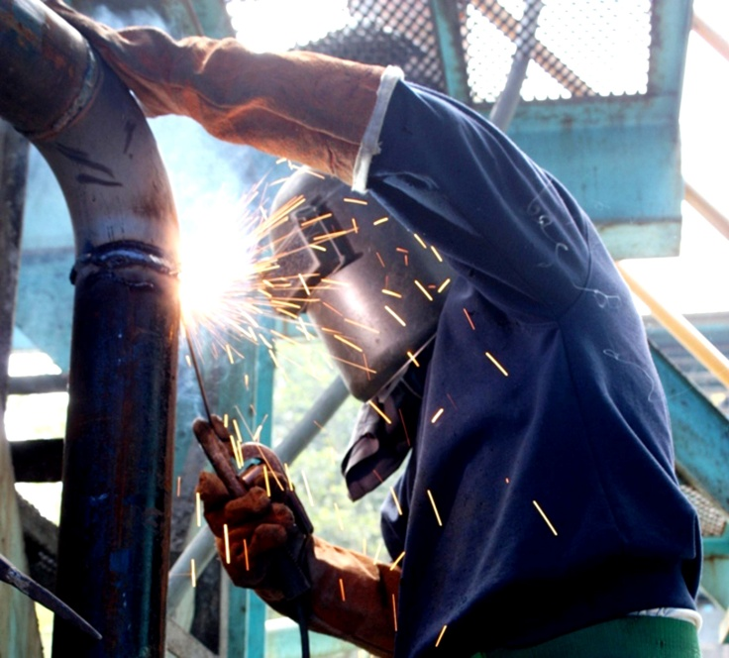
- Welding, fabricating and repair. Field Technicians and skilled workers are equipped with special welding masks that protect against glare and spatters as well as heat-resistant gloves.

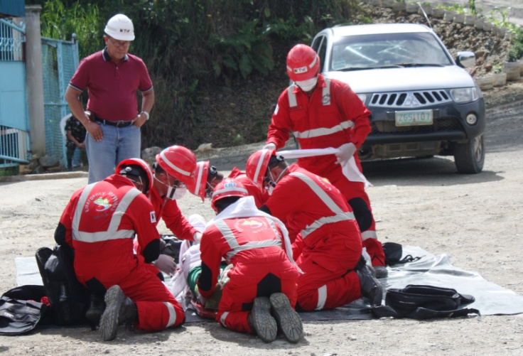
- Emergency response. TVIRD’s Emergency Response Team undergoes frequent safety drills to maintain a high level of readiness at all times. In photo, ERT simulates an onsite rescue procedure.

About TVIRD
TVI Resource Development (Phils) Inc., is the Philippine affiliate of TVI Pacific Inc. (TSX: TVI), a publicly-listed Canadian mining company focused on the exploration and production of precious and base metals from district scale large system, high margin projects located in the Philippines.
We are committed to exploration and mining practices that promote transparency, responsible stewardship of the environment, and the inalienable rights to life, dignity, and sustainable development of our host communities.
Connect with us: www.tviphilippines.com

For media queries:

Kaycee Crisostomo
Senior Manager - Public Affairs
TVI Resource Development (Phils) Inc.

Email: kaycee.crisostomo@tvipacific.com.ph
Phone: +63 2 728-8491 ext. 103
Mobile: +63 917 579-1528
Fax: +63 2 728-8515

